**The British College**

**KATHMANDU**

**Coursework Submission Coversheet**(individual coursework only)

**Faculty of Arts, Environment and Technology LBU Student Id:**

77227253

**For checking by the student:**

Please ensure all information is complete and correct and attach this form securely to the front of your work before posting it in a coursework collection box.

Award name: Bsc Hons in Computing

Module code: 14806-LTP-202010

Module name: Production Project

Module run: 2022

Coursework title: Production Project Final Report

Due Date: 06/05/2022

Module leader: (In LBU): Rohit Raj Pandey

Module tutor: (In TBC): Rohit Raj Pandey

**TURNITIN** Checked: YES NO ***(please circle)***

Submission date& time: Date: 06/05/2022 Time: Midnight

**Total Word Count: 9407 Total Number of Pages (including this front sheet): 147**

**In submitting this form with your assignment, you make the following declaration:**  
I declare, that the coursework submitted is my own work and has not (either in whole or part) been submitted towards the award of any other qualification either at LBU or elsewhere. I have fully attributed/referenced all sources of information used during the completion of my assignment, and I am aware that failure to do so constitutes an assessment offence.

Signed: Akshobhya Sharma Date: 06/05/2022

**You are strongly advised to retain a second copy of your work in case of any query about the assignment.**

**For completion by the faculty:**

**This mark is provisional and subject to moderation and approval by the relevant examining board**

**Teacher's Feedback**

**Teacher's Signature: __________________________________ Date: _________________**

**This mark is provisional and subject to moderation and approval by the relevant examining board**

**Teacher's Feedback**

**This mark is provisional and subject to moderation and approval by the relevant examining board**

**Teacher's Feedback**

1. **Abstract**

The project revolves around the use of object detection in a video so that the desired splices can be achieved from the video. Following our literature review we concluded that CNN would be the best suitable model for the purpose of real time object detection.

The rest of the report follows various project stages to create a product with a client and a service model. We have used the agile methodology to produce an application based on C# frontend and flask backend.

1. **Keywords**

**CNN**, **DNN, REST, API, MVVM, Model**, **View**, **ViewModel**, **NuGet**, **JSON**, **Serialize**, **Deserialize**

1. **Table of Content**

Contents

**1.** **Introduction** 9

**2.** **Review of Literature** 10

**2.1** **Brief History to Convolutional Neural Network** 10

**2.2** **Convolutional Neural Network (CNN)** 10

**2.3** **Real World Applications of CNN** 12

**2.4 Suitability of CNN for Object detection** 13

**2.5 Project Contribution** 14

**2.6 Use of CNN in the project** 15

**3.** **Review of Technology** 16

**3.1** **Hardware** 16

**3.1.1** **Nvidia GeForce 1650Ti** 16

**3.2** **Software** 16

**3.2.1** **Operating System** 16

**3.2.2** **Word Document** 17

**3.2.3** **Presentation program** 17

**3.2.4** **Project Management** 17

**3.2.5** **Web Browser** 17

**3.2.6** **Database** 18

**3.2.7** **Development Environment** 18

**3.2.8** **Language, Framework and Libraries** 19

**4.** **Methodology** 21

**5.** **Software Requirement Analysis** 23

**6.** **Product Design** 26

**6.2** **General Overview** 26

**6.3** **Context Diagram** 28

**6.4** **Level 0 DFD** 29

**6.5** **Level 1 DFD** 30

**6.5.1** **Upload Video** 30

**6.5.2** **Analyze Video** 30

**6.5.3** **Login/Sign Up** 31

**6.6** **ERD** 32

**6.7** **Use Case Diagram** 33

**6.7** **Flow Charts** 35

**6.7.1** **Video Detector** 35

**6.7.2** **Video Splicer** 36

**6.7.3** **Sending Splice through TCP** 37

**6.7.4** **Video Listener** 38

**7.** **Implementation and Testing** 39

**7.2** **Set up Guidelines** 39

**7.2.1** **VS Code** 39

**7.2.2 MySQL database** 40

**7.2.3** **Installation of Docker** 41

**7.2.4 Backend Setup** 43

**7.3 Codes** 45

**7.3.1** **Frontend** 45

**7.3.2** **Backend Codes** 57

**7.4** **Functional and non-functional testing** 69

**7.4.1** **Index View** 69

**7.4.2** **Video Library View** 72

**7.4.3** **Video Analyze View** 74

**7.4.4** **User Information View** 74

**7.4.4** **Non-functional testing** 77

**8.** **Product Evaluation** 79

**8.1** **Functional Requirements** 79

**8.2** **Non-functional requirement** 81

**8.3** **Product Limitations** 82

**8.4** **Product Potential** 83

**9.** **Project Management and Evaluation** 84

**9.1** **Project management tools** 84

**9.1.1** **Timeline** 84

**9.1.2** **Gantt Chart** 85

**9.1.3** **Task Sheet** 86

**9.1.4** **Resource Sheet** 87

**9.1.5** **Project Evaluation** 87

**10.** **Conclusion** 88

**11.** **Appendix** 90

**11.1** **Bibliography** 90

**11.2** **Feasibility Study** 92

**11.2.1** **Technical Feasibility** 92

**11.2.2** **Operational Feasibility** 92

**11.2.3** **Economic Feasibility** 92

**11.2.4** **Legal Feasibility** 92

**11.2.5** **Schedule Feasibility** 93

**11.3** **Software requirements specification** 93

**11.3.1** **Purpose** 93

**11.3.2** **Intended Audience** 93

**11.3.3** **Intended Use** 93

**11.3.4** **Scope** 93

**11.3.5** **Definitions and Acronyms** 94

**11.3.6** **Product Functions** 94

**11.3.7** **Operating System overview and software system** 97

**11.4** **Project Management: Work Breakdown Structure** 98

**11.4.1** **Timeline** 98

**11.4.2** **Gantt Chart** 98

**11.4.3** **Task Sheet** 99

**11.4.4** **Resource Sheet** 100

**11.5** **Record Sheet** 101

**11.5.1** **Meeting 1** 101

**11.5.2** **Meeting 2** 102

**11.5.3** **Meeting 3** 103

**11.5.4** **Meeting 4** 104

**11.5.5** **Meeting 5** 105

**11.5.6** **Meeting 6** 106

**11.6** **Ethical Consent Form** 107

**11.7** **Codes for functions shown** 112

**11.7.1** **Get Video List command class** 112

**11.7.2** **Login Command Class** 113

**11.7.3** **Splice command class** 114

**11.7.4** **Upload Video Class** 117

**11.7.5** **Backend API Resources** 120

**11.8** **User Guideline** 126

**11.8.1** **Prerequisites** 126

**11.8.2** **Index Page** 127

**11.8.4** **Navigation Bar** 137

**11.8.5 Analyze Video View** 138

**11.8.5.5** **User Info View** 144

1. **Table of Figures**

Figure 1 Working of YOLO algorithm (Redmon, Divvala, Girshik, & Farhadi) 17

Figure 2 Agile Methodology 24

Figure 3 Project Overview 29

Figure 4 Context Diagram 31

Figure 5 Level 1 DFD for process 2 33

Figure 6 Level 1 DFD for process 6 34

Figure 7 User Management 35

Figure 8 ERD 35

Figure 9 UML use case diagram 37

Figure 10 Video Detector Flowchart 38

Figure 11 Video splicer flowchart 39

Figure 12 Splice Sender 40

Figure 13 Video receiver flowchart 41

Figure 14 Downloading installation file for visual studio 42

Figure 15 Installing vs support for .net development 43

Figure 16 Installation of Docker 44

Figure 17 Enabling Hyper-V 44

Figure 18 Python 3.7 can be downloaded from python's official site 46

Figure 19 Installing PIP 46

Figure 20 Installing VS Code 47

Figure 21 Method to obtain video list 49

Figure 22 method to analyze video 51

Figure 23 Command to Display info based on video selected 52

Figure 24 Method to upload the video 53

Figure 25 Navigation Store class 54

Figure 26 Navigation service class 55

Figure 27 Function to update user information 56

Figure 28 apiReq Class 57

Figure 29 NavigationCommand class 58

Figure 30 Get video list command class 59

Figure 31 video sender class 60

Figure 32 Video Detector class 61

Figure 33 Video Listener Script 62

Figure 34 Video Splicer Class 64

Figure 35 Importing all the dependencies as well as describing the connection 66

Figure 36 Declaring ORM schema 67

Figure 37 Creating arguments for the request 68

Figure 38 Creating structures for return value serialization 69

Figure 39 Declaring resources that can be used through end points 70

Figure 40 Attaching resources to the endpoints 71

Figure 41 Empty Fields Validation 72

Figure 42 User doesn't exist 73

Figure 43 Wrong password entered 73

Figure 44 Empty signup fields 74

Figure 45 Mismatching password 74

Figure 46 Invalid email 75

Figure 47 Invalid video path 75

Figure 48 Delete button validation 76

Figure 49 Empty fields prompt 76

Figure 50 Analyze button message 77

Figure 51 Empty field validation 77

Figure 52 Old password not matching 78

Figure 53 Password not matching validation 78

Figure 54 Used Email validation 79

Figure 55 Changing username 79

Figure 56 Changing to invalid email 79

Figure 57 Testing responsiveness 80

Figure 58 Testing Tooltips 80

Figure 59 Inputting signup fields 81

Figure 60 Encrypted password in database 81

Figure 61 Project Timeline 87

Figure 62 Gantt Chart 88

Figure 63 Gant Chart 89

Figure 64 Resource Sheet 90

Figure 65 Project Timeline 101

Figure 66 Gantt Chart 101

Figure 67 Gant Chart 102

Figure 68 Resource Sheet 103

Figure 69 Group meeting 1 104

Figure 70 Group meeting 2 105

Figure 71 Group meeting 3 106

Figure 72 Group meeting 4 107

Figure 73 Group meeting 5 108

Figure 74 Group meeting 6 109

Figure 75 Ethical consent part 1 111

Figure 76 Ethical consent part 2 112

Figure 77 Ethical consent part 3 113

Figure 78 Ethical consent part 4 114

Figure 79 Getvideolistcommand class 115

Figure 80 Login command class 116

Figure 81 Splice Command 119

Figure 82 Upload Video Class 122

Figure 83 Backend Resources 127

Figure 84 Resource End Point 128

Figure 85 Fig Index Page 130

Figure 86 Sign Up section 131

Figure 87 Account Creation 132

Figure 88 Inputting the created credentials to log in 133

Figure 89 Video Library Page 134

Figure 90 Upload Video Section 135

Figure 91 Upload the File 135

Figure 92 File selection prompt 136

Figure 93 Preview button 136

Figure 94 Upload Button 136

Figure 95 Video Preview Panel 137

Figure 96 Upload of video 138

Figure 97 Uploaded video in video list panel 138

Figure 98 Selected Video 139

Figure 99 Delete Button 139

Figure 100 Edit Button 139

Figure 101 Video Information update model 140

Figure 102 Navigation Bar 141

Figure 103 Video Selector Panel 141

Figure 104 Parameter selector Panel 142

Figure 105 Detection tab 142

Figure 106 Analyze button 143

Figure 107 Spinner showing the backend analysis. 143

Figure 108 Video Splice Panel 143

Figure 109 Video details tab 143

Figure 110 Objects tab 144

Figure 111 Folder Button 144

Figure 112 Splice Viewer Panel 145

Figure 113 The video player in action 146

Figure 114 Change details panel 147

Figure 115 User information changed 147

Figure 116 Account Info Panel 148

Figure 117 Delete account panel 148

1. **Table of Table**

Table 1 Login and signup interface 25

Table 2 Video upload interface 25

Table 3 Video analyze interface 26

Table 4 user information interface 26

Table 5 Group interface 27

Table 6 Nonfunctional requirement 27

Table 7 Functional requirement evaluation 82

Table 8 Nonfunctional requirement evaluation 84

Table 9 Conclusion test 90

# **Introduction**

The project is based around the concept of creating a client service architecture. It involves the creation of a client-side application capable of allowing a logged user to upload a video to the server. The client can then select the parameters according to which the video is to be analyzed and receive back splices of the saved videos based on those parameters. These processing will be based on an object detection model and be carried out in the backend service which will also help the client side manage the CRUD requests.

The idea of using object detection to extract relevant splices from the video was initially thought of as an efficient way to aid the law enforcers like police or any organization dealing with digital forensics with primary consideration to video. It would aid them in the process of crime detection by speeding up the process of clue detection. This project aims to aid them in this task by reducing the amount of time they have to spend in finding this relevant information. They can select the objects they want to detect on the video and leave the software while they use their precious time in some other tasks. This will not only increase their productivity but also save the resources of the organization as whole.

The following report will start with research of the object detection model and conclude with the most suitable one for our project. Following that we will review the technologies that we will use throughout the course of the project. This section will be followed by the choice of the methodology for the project completion as well as the definition of the requirements we want the product to fulfill. We will follow this up with the demonstration of use of various tools to design our product. We will demonstrate how the product development environment has been set up as well as a brief explanation on how the product has been implemented. This is followed up by testing of the product and evaluating the product as well as the project as whole. The report will end with the conclusion with the appendix having furthermore information on various aspects of this report.

# **Review of Literature**

This chapter will be dedicated on the literary exploration of primary concept around which this project is developed on, the CNN. This will include a brief historical context to the development of the CNN architecture.

We will also look at the most prominent use cases of CNN architectures in the field of video analysis, object detection and surveillance.

## **2.1 Brief History to Convolutional Neural Network**

The development of the Convolutional Neural Network is preceded by the development of the Neural Networks themselves which can be traced back to 1943 to a paper where a possible architecture for neurons was described based on propositional logic (Warren & Walter, 1943).

The first practical application of a digital neuron was called perceptron which although promising was incapable of solving an XOR problem (Aurelien, 2017). This problem was alleviated by the use of multi-layer perceptron which stacked a layer of perceptron over another and the use of a back propagation algorithm to train the model (Aurelien, 2017).

This use of multilayered neural networks would prove to be more suitable for solving complex problems and would go on to be adopted for the purpose of object detection in image in form of CNN.

## **2.2 Convolutional Neural Network (CNN)**

The CNN uses some elements of the Deep Neural Networks, like activation function as well as connected layers but it adds on to that the concept of convoluted layers as well as pooling layers. It was first suggested by Kunihiko Fukushima in 1988. (Fukushima, 1988) However, due to the limitations of the hardware at the time, its potential couldn’t be exploited. The decade of the 90s saw the application of gradient-based learning algorithm to CNN architecture from which a moderately successful result in recognition of handwritten numbers could be derived (Leecun, Bottou, Benigo, & Haffner, 1998).

The major elements of the CNN architectures are (Yamashita, Nishio, Do, & Togashi, 2018):

1. Convolution Layer

The convolution layer is the signature layer of the CNN architecture which performs the key role of feature extraction. It does this with a help of a linear operation where filters or kernels are applied across the input tensor, which is an array of number based on the input image and an output matrix is obtained. This output matrix is called a feature map. Different filters are applied to generate several feature maps which represent different features of the input image. There are two important parameters here, which is the size of the kernel and the no. of kernels used. The size of the kernel can be represented by its height and width (e.g., 5x5).

1. Activation function

The activation function is then used on the output produced from these linear functions. Traditionally activation functions that compressed the values were used like sigmoid or hyperbolic tangent, but recently rectified linear unit (Relu) has been more popular due to vanishing gradient problem of the prior functions.

1. Pooling layer

Pooling layer basically down samples the feature maps, reducing the number of parameters, which results in increased computational performance. It also provides translational invariance which is useful in the process of object detection.

1. Fully connected layer

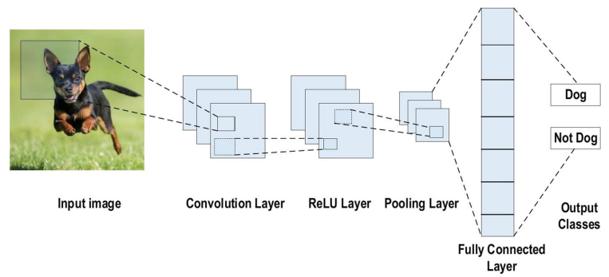The fully connected layer firstly flattens the feature maps obtained after down sampling into a single dimensional array of numbers. These numbers are then fed into one or many fully connected layers where every input forms a connection to every output with a specific weight for each connection. The output nodes provide us probabilistic values which we can use for classification.

Figure 1 CNN architecture (Alzubaidi, et al., 2021)

## **2.3 Real World Applications of CNN**

CNN offer a multitude of real-world applications. One of the primary applications of CNN is classification of digital image. We have already discussed in lengths regarding that above. Ever since the inception of AlexNet, CNN architectures have been dominant in the field of image classification. It has also been used in the field of Natural Language Processing for the purpose of answer selection and question-relation matching (Kann, Yu, Schutze, & Yin, 2017).

It has also found a use on the field of anomaly detection, being used by Microsoft for the purpose of time-series anomaly detection task, used by multiple services in Microsoft including Bing, Office, and Azure. (Ren, et al., 2019)

The field of pharmaceutical has also seen the use of CNN. The model Atom Net was created in 2015 which used a convolutional architecture for the purpose of drug discovery by forecasting the bioactivity of minute molecules (Wallach, Dzamba, & Heifets, 2015).

CNN model has also been trained to play games like checkers and GO. The famous AlphaGo program which managed to defeat the number one ranked GO player in 2017. This program also uses CNN in its architecture for the purpose of representing the board (Silver, et al., 2016).

## **2.4 Suitability of CNN for Object detection**

Although the DNN (Deep Neural Network) algorithms could be used for the purpose of image recognition, it is not suitable for large image files. An image of size 100x100 for example would have 10,000 pixels all of which would be an input. This would result in about 10 million connections in just the first layer of the Neural Network. (Aurelien, 2017)

The CNN is better suited for the process of object detection, as its design based on the visual processing system of an animal. There are 3 elements of CNN which makes it more appropriate for processing a visual data. They are (Alzubaidi, et al., 2021):

1. The weight sharing feature of CNN reduces the no. of network parameters that must be accounted while training the model. It helps make the model more general and reduces overfitting.
2. The filter layers and the fully connected layers or the classification layers are trained in a synchronized manner. The model output is therefore very reliant on feature extraction and are highly organized as well.
3. Application of large-scale network is simpler with CNN in contrast to other networking architectures.

## **2.5 Project Contribution**

The use of algorithms like YOLO for real time smart surveillance in an IOT architecture has already been explored (Nguyen, Ta, Nguyen, & Bui, 2021). This type of architecture however requires a computational hardware like Raspberry pie for every security system. For a large organization deploying numerous security systems, such costs can quickly add up.

This project explores a system where videos can be uploaded to a server through a client. The backend server can run algorithms like YOLO and provide the user with analytics as well as spliced videos based on parameters they have selected and the footages they have selected back through the client itself.

The implementation of the model will be done using TensorFlow whether by selecting an already built suitable model, making suitable adjustments as per our requirement. We will also be using OpenCV so that we can carry out real-time video operations with our model.

The project will provide 2 major benefits. The first benefit is that the client server architecture will save computational resources as an organization can upload multiple videos from variety of systems to be analyzed. This will save the use of multiple computational units like raspberry Pi on multiple disconnected security systems. The company would also not need to worry about implementation of software structures as all the services would be provided in the server side. The other benefit would be an inherent one provided due to the use of deep neural nets, which would save both time and human resources in analyzing lengthy security footages.

From my research I have found two software which has client server architecture like the one described above. The first software is called Kinesense Advanced Analytics which focuses on face detection (kinesense-vca, 2022). The other product SENSTAR video analytics provides a wide array of functionalities from license plate identification to face recognition and more features (senstar, 2022). This project will primarily focus on vehicle identification which hasn’t been properly explored in the above-mentioned products.

## **2.6 Use of CNN in the project**

This project revolves around analyzing the security footages using the TensorFlow; however, TensorFlow is only a library for building a machine learning model. The object detection technology that we will use for the purpose of analyzing the security footages will be a CNN architecture.

The CNN architecture during its inception and development was used primarily for the purpose of image classification. It has now also been adapted for the purpose of object detection as well. One of the notable examples of implementation of CNN for object detection is YOLO (You Only Look Once) algorithm (Redmon, Divvala, Girshik, & Farhadi). The YOLO algorithm interprets the problem of object detection as a regression problem.

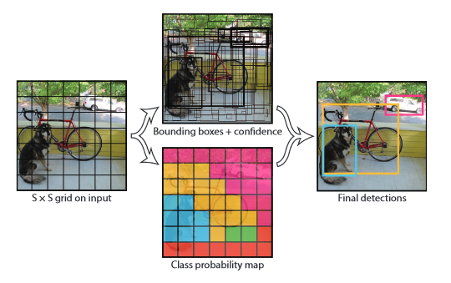As the name states, this algorithm looks once at the image to deduce where the objects are. This is accomplished with the help of a convolutional layer, which predicts numerous bounding regions and class probabilities for those bounding regions. This is done by grid like division of an image, where each grid is responsible for a prediction of a boundary box. The boundary box can only deduce one object at a time and has a confidence score associated with it.

Figure 1 Working of YOLO algorithm (Redmon, Divvala, Girshik, & Farhadi)

# **Review of Technology**

This section explores the tools and technologies that will be used to develop the project. It includes name and description of software tools, programming languages as well as hardware that may be used to develop this product.

## **3.1 Hardware**

### **3.1.1 Nvidia GeForce 1650Ti**

The graphics card comes integrated with the laptop, but I felt it important to highlight it here as the graphics card is used by the backend process for carrying out the object detection process. In using graphics card, the object detection process Is reduced to some degree.

## **3.2 Software**

This section of technological review includes all of the software we have made use of throughout the course of the project along with a brief explanation on why their use is relevant in this project.

### **3.2.1 Operating SystemIntroducing Windows 11 – Press materials for Windows 11 news announcement**

The windows 11 operating system provides us with an environment on top of which we can develop all our product. It is relevant for the development of this product because the front-end framework that we will be using, WPF is based on windows application, hence the process of developing and testing the product will be better accomplished in this operating system. Furthermore, for the purpose of researching and implementing the technologies, windows far more online resource as it is the most prevalent operating system in the desktop market.

### **3.2.2 Word Document**

The word document gives us a platform to write out a well formatted textual document. It is a de facto standard for text formatting in today’s world and will serve us well in multiple documents we have to create including this report. Any type of text formatting and report creation throughout the course of this project will make use of MS Word.

### **3.2.3 Presentation programMicrosoft PowerPoint - Wikipedia**

For the purpose of the final demonstration of the project, we will require a presentation software to create our slides as well modify them according to our needs. For this purpose, we will make use of MS Power Point.

### **3.2.4 Project Management**

The planning of a project is a complex task and will require a variety of project management tools to accomplish. We will use MS Project as our software for accessing those tools. MS Project provides us with tools like Gantt chart, Task sheet, Timeline and Resource sheet which are crucial in planning out our project systematically.

### **3.2.5 Web Browser**

Mozilla Firefox is a browser that will be used throughout the course of this project for browsing through the internet for all kinds of research purpose. The use of Firefox is preferred because of an excellent bookmarking feature which makes the process of collecting the resource for this project very effortless.

## **3.2.6 Database**

The database used for this project is MySQL. MySQL was suitable for this project as it is a relational database through which we can manage the relation between the entities. Furthermore, it works well with our flask API with the SQL Alchemy ORM. It can also be used with PHPmyadmin to quickly preview our database for testing purpose.

### **3.2.7 Development Environment**

Multiple development environments will be used for this project as it revolves around both the front end and the backend, all of them are described below.

#### **3.2.7.1 Visual Studio 2019**

Visual Studio is an integrated development environment developed by Microsoft. The use of VS in context is appropriate as it provides us with all the necessary features for the development of a C# frontend. It includes features like hot reloading, debugging, package managing as well as in-built command prompt which provides us with all the necessary tools for the product development.

#### **Icon Description automatically generated3.2.7.2 Visual Studio Code**

The vs code is a text editor with a rich variety of plugins with support for python language. We will make use of visual studio code for the development of our backend code with python scripts. The vs code is lighter on resource than visual studio code and is less intensive on our computer when developing the C# application and the flask service simultaneously.

#### **3.2.7.3 Docker**

The docker is a virtualization environment software that makes use of an already existing kernel in our system to provide us with soft virtualization of systems that we require in form of containers. In our case, it has been used to create a container of MySQL to run it in an isolated environment.

### **3.2.8 Language, Framework and Libraries**

#### **3.2.8.1 C#**

C# is an object-oriented language maintained by Microsoft, which will allow us to develop a modular, robust application. It is one of the languages supported by dotnet framework which has a number of libraries fundamental to building an application in a rapid pace. It supports object-oriented development very suitable to our development methodology of agile.

#### **3.2.8.2 PythonPython (programming language) - Wikipedia**

Python is a high-level scripting language will be used for back end as the libraries for machine learning are easily available in this language. Libraries such as ImageAI and Flask can be implemented through Python.

#### **3.2.8.3 ImageAI**

ImageAI is a python library that makes use of multiple well-known python libraries like TensorFlow, NumPy and keras to provide us with an easy-to-use platform for programming our object detection codes. It allows us to set various parameters for object detection activities.

#### **3.2.8.4 .NET**

Dot net is a framework developed by Microsoft for cross-platform application development. It is used for the development of our WPF based frontend. The use of .net framework provides us with easy access to asynchronous functions for carrying out various http-based requests like push and pull to our restful API as well as deserialize the responses of those requests. It also allows us to make use of a large pool of NuGet packages.

#### **3.2.8.5 SQLAlchemy**

The SQL alchemy is an ORM tool which allows us to access the database from our code in form of objects and all the data transfer resulting from the change in objects is handled by the ORM tool. It allows us to reuse the mapped objects repeatedly for multiple queries throughout our application.

#### **3.2.8.6 WPF**

WPF is a frontend technology for the development of a desktop application supported by Visual Studio. It is developed using C# language and supports the agile philosophy of incremental development with the use of MVVM pattern.

#### **3.2.8.7 Moviepy**

The moviepy is a python library that allows various types of video processing on a video passed to it. It is used in our backed to create splices of the videos after the videos have been processed in our object detection model.

# **Methodology**

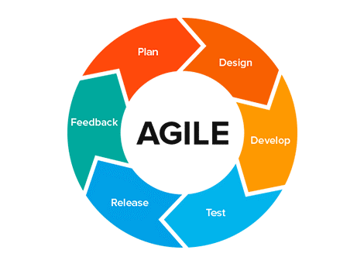Selection of a methodology is an important step in any product development. It will give developers a direction on approaching the development of the product. It will make the daunting task of developing a software more manageable by providing a sequence in which the development can be accomplished.

Figure 2 Agile Methodology

There are various methods of product development. There are traditional methods like waterfall which consists of a set of steps one after another, where a subsequent step relies on the completion of previous step. However, nowadays, Agile is a popular approach to developing a product. We will also be using Agile as the development methodology owing to its suitability for our project.

Agile is suitable for our project for several reasons, first, the iterative, incremental approach to product development that agile offers can easily be applied to our priority structure in our requirement analysis. We can incrementally develop the integral modules of our software one by one, test them and integrate them (Brush & Silverthorne, 2022). This is especially useful due to the time frame of the project; The use of agile can help us produce a working software even under a restrictive time structure.

Apart from that the agile methodology can handle the changing requirements of a product very well which can be used to integrate supervisor feedback. The method thought out for solving the problem initially can be adjusted and tuned throughout the process of development which is useful because this project uses a lot of technologies that I am unfamiliar with.

All these reasons make agile a superior choice than other development methodologies as it allows us to development in manner that is resilient to changing needs and requirements and produce a working product in a timely fashion.

# **Software Requirement Analysis**

The software requirement analysis is done so that we can divide the requirements of our applications according to the priority we have for them in our final application. They are divided into functional and non-functional sections.

**Functional Requirements**

|  |  |  |
| --- | --- | --- |
| No. | Requirements | Priority |
| A | **Login and Sign-Up Interface** |  |
| A1 | Login and Sign-Up Forms to collect data | High |
| A2 | Validation of unique fields | High |
| A3 | Server-side validation | High |
| A4 | Validations to ensure valid fields | Medium |
| A5 | Email Verification | Medium |
| A6 | Remember the password | Low |

Table Login and signup interface

|  |  |  |
| --- | --- | --- |
| No. | Requirements | Priority |
| B | **Video Upload Interface** |  |
| B1 | Form to collect video information and path. | High |
| B2 | Video Player to preview video | Medium |
| B3 | List of Video to preview videos stored in the server | High |
| B4 | Model to update video information | Medium |
| B5 | Stream video from the server to preview saved video | Low |
| B6 | Validations to ensure proper fields while updating and uploading video | High |

Table Video upload interface

|  |  |  |
| --- | --- | --- |
| No. | Requirements | Priority |
| B | **Video Analyze Interface** |  |
| B1 | List view from which displays the videos stored in the server | High |
| B2 | Button to click the listed video and select it for analysis | High |
| B3 | Check boxes that allow user to select type of vehicles | High |
| B4 | Check boxes that allow user to select vehicle color | Low |
| B5 | Radio button for the user to select the pace of analysis | Medium |
| B6 | Panel for users to view analysis result | Medium |
| B7 | Video player for user to preview analysis result | High |
| B8 | List for user to select video splice | Medium |
| B9 | Button for user to navigate to video folder. | Low |
| B10 | Option for user to manage the analyze splices | Low |
| B11 | Option for users to share their splices | Low |

Table Video analyze interface

|  |  |  |
| --- | --- | --- |
| No. | Requirements | Priority |
| C | **User Information Interface** |  |
| C1 | Form for user to change their user information | High |
| C2 | Validation in the form for user information | High |
| C3 | Server-side validation for user information form | Medium |
| C4 | Panel for user to see their account information | Low |
| C5 | Option for user to delete their account. | Low |

Table user information interface

|  |  |  |
| --- | --- | --- |
| No. | Requirements | Priority |
| D | **Group Interface** |  |
| D1 | Functionality to create groups | Low |
| D2 | Form to add specific user to a group | Low |
| D3 | Interface to share splices with users in a group | Low |

Table Group interface

**Non-functional Requirements**

|  |  |  |
| --- | --- | --- |
| No. | Requirements | Priority |
| A1 | Make use of OOP, when possible, to ensure scalability if desired in future. | Medium |
| A2 | Adding support for multiple languages | Low |
| A3 | Optimizing feature for multiple users at the same time | Medium |
| A4 | Providing features for accessibility | Low |
| A5 | Providing dark and light theme | Low |
| A6 | Use of threading, to make application efficient | High |
| A7 | Password security features to ensure account security | High |
| A8 | Easily navigable user interface with intuitive tools. | High |
| A9 | Use of tooltip to make using the app easier. | Medium |
| A10 | Modern looking user interface. | Medium |

Table Nonfunctional requirement

# **Product Design**

## 6.2 General Overview

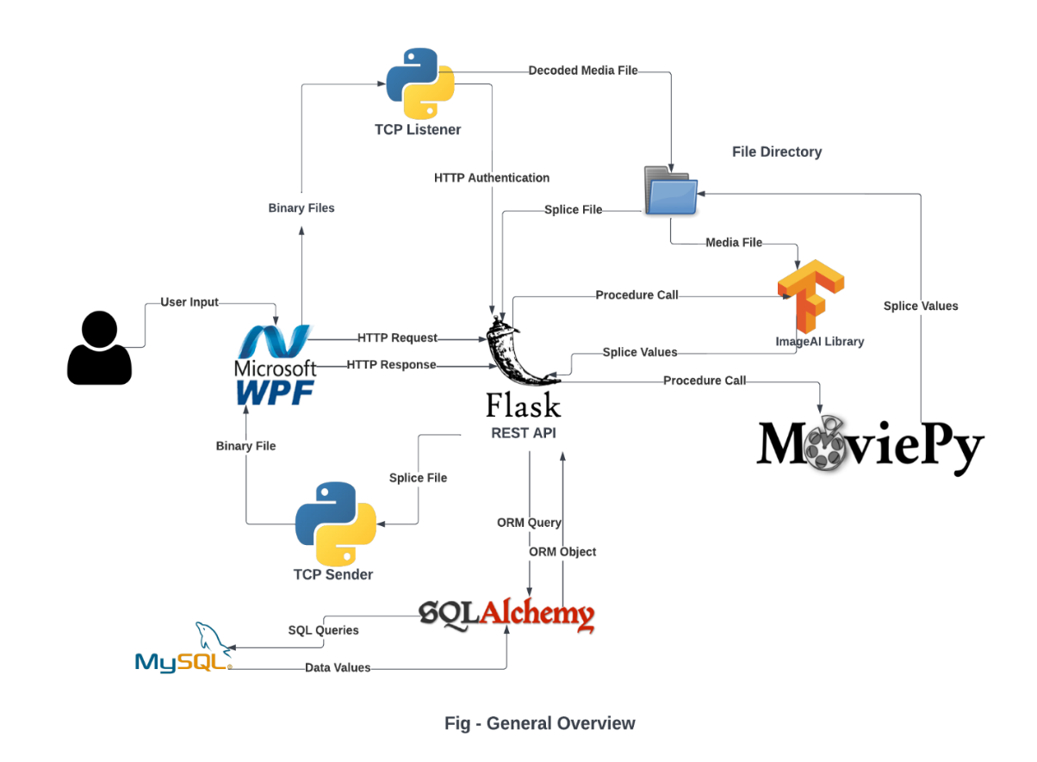

Figure 3 Project Overview

The above diagram gives us a brief overview of our entire project. The entry point of the product is the WPF based desktop client that the user can access through a windows desktop. The WPF application has all the implementation for the user to provide http request to a backend service as well as implementation to receive the http response of those requests and display it accordingly.

The centerpiece of our project is our Flask restful API, it not only manages all the request of the client, but also helps integrate various backend components to serve those requests. It has a bunch of endpoints associated with various resource that can be consumed by our front-end client. For the purpose of database queries, it makes use of SQL Alchemy an ORM mapper to send and receive SQL queries mapped to objects. These objects are used by functions defined in the rest API to send back the database information requested or changed to the client. The data accessed by this ORM is stored in MySQL server which manages the data in a defined relational structure.

Apart from textual data suitable for storage in the database, our system must also deal with huge binary files converted from the video files uploaded by the user. For this purpose, we will not directly use the restful API, but rather use a different process which listens to the port number 8848. This process establishes an authenticated TCP connection using the rest API suitable for fast video transfer to the backend directory.

The rest API also makes use of the ImageAI library so that the YOLO v3 object detection model can be used to perform the detection on a video file. It does this in response to a user request based on the parameters passed in the http request of the user. The time values are received using a class implemented from ImageAI library. These time values are then given to a class which uses the MoviePy library to carry out the splicing of the video and saving them to the specified directory.

On the client request, the rest API then opens up tcp ports for sending of the video files using the Video Sender class which has implementations written for sending a video file through a tcp connection. These video files are then received by the client and stored in a local file directory and displayed.

## **6.3 Context Diagram**

The context diagram represents the highest level of data flow in our system between the associated users. In our system, we have one external entity of a user which will interact with our application called SplicerAI to carry out all the illustrated activities.

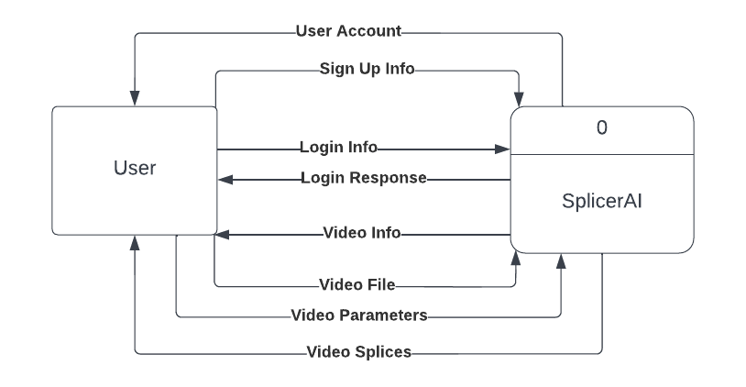

Figure 4 Context Diagram

## **6.4 Level 0 DFD**

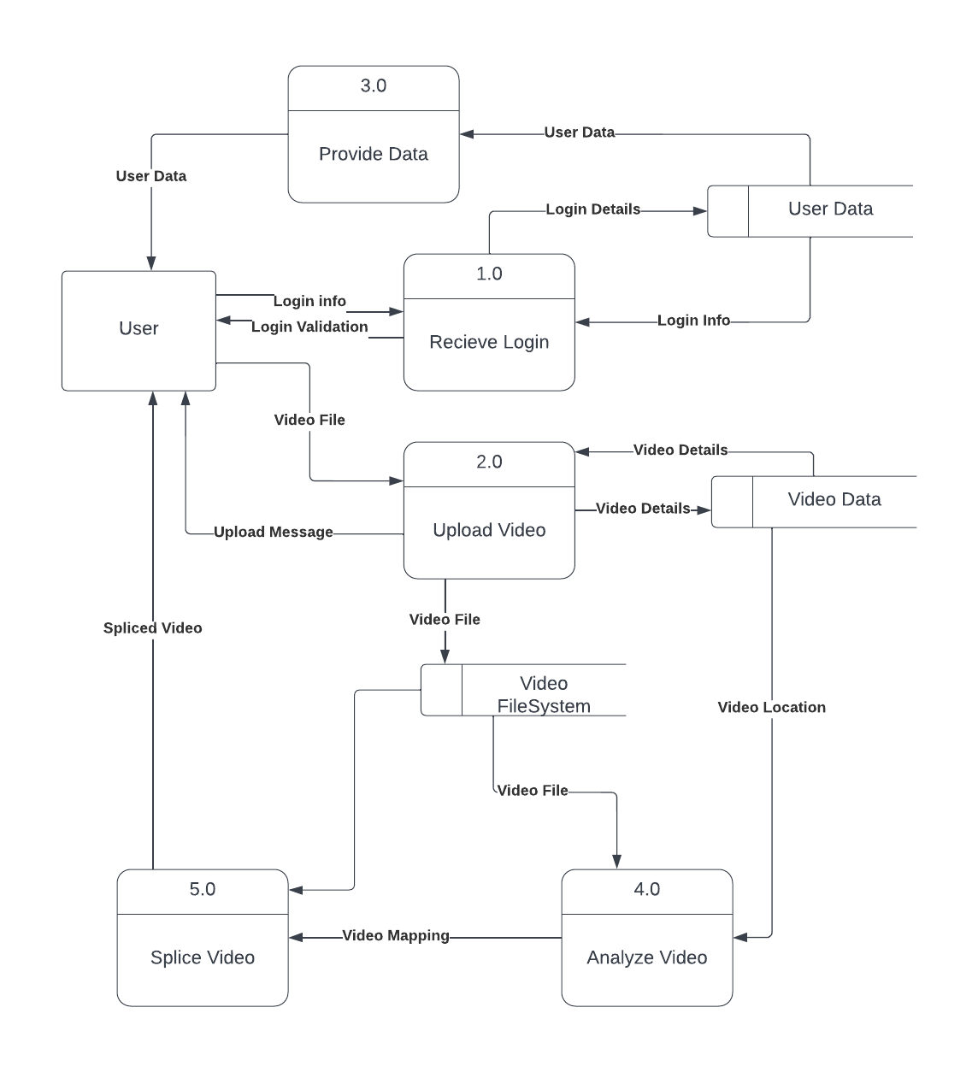

The level 0 DFD describes a high-level dataflow process in our system but is broken down into sub processes in the whole system. This diagram breaks the context diagram into multiple primary processes of our system. The process includes providing stored data to the frontend user, receiving the login information, uploading the video, splicing, and analyzing the uploaded videos. There are two data sources need for all of these processes, the user data source stores all the user related data present in textual form whereas the video file system stores the video files obtained from the user.

## **6.5 Level 1 DFD**

### **6.5.1 Upload Video**

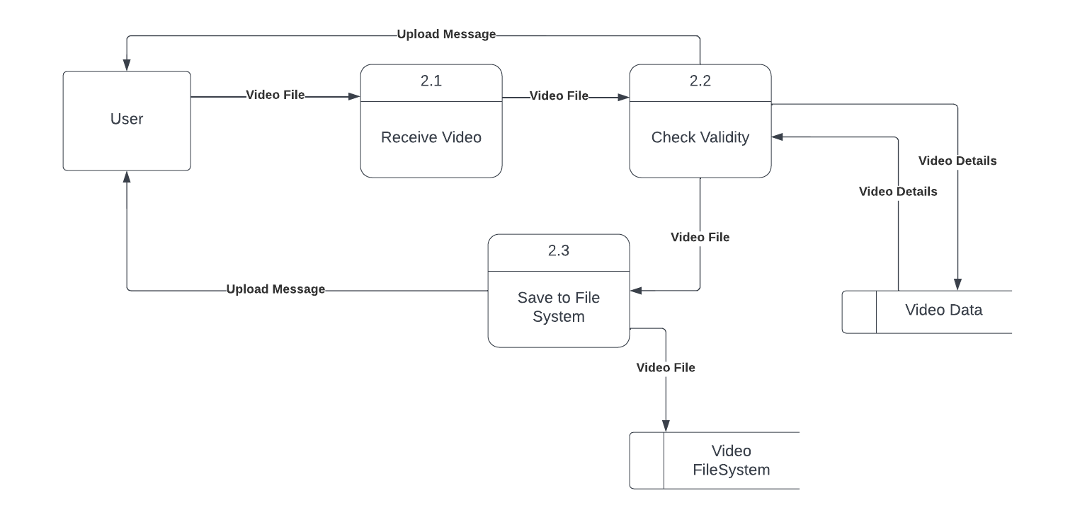The DFD below describes the data flow during video management in our application. The process includes receiving the videos uploaded by the users, checking their validity, sending the response of the validity back to the client and saving it to the video file system.

Figure 5 Level 1 DFD for process 2

### **6.5.2 Analyze Video**

The DFD below describes the data flow during video analysis in our system. This includes the process of receiving the parameters from the user and using that parameter to receive the data from video data storage as well as video file storage. The retrieved video is then passed through the model.

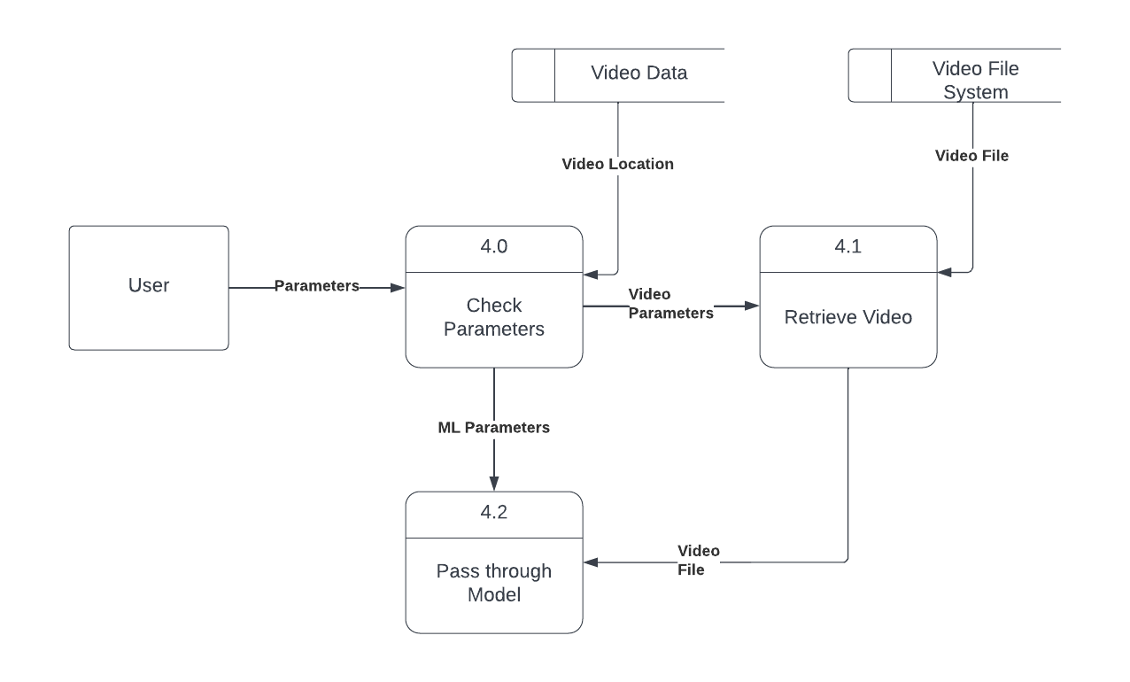

Figure 6 Level 1 DFD for process 6

### **6.5.3 Login/Sign Up**

The DFD below describes the dataflow during the process of user management in our system. The process includes receiving the login and validating it with help of user data store and either logging in or adding a user based on login or upload.

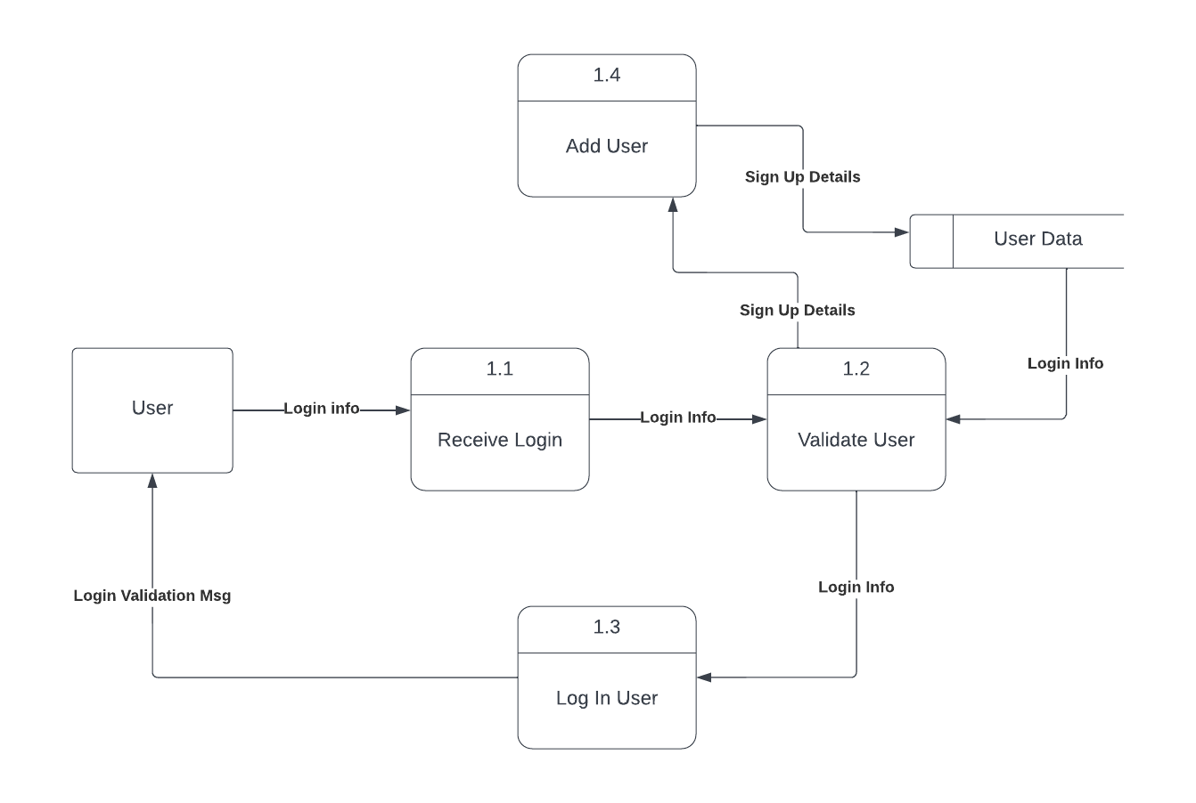

Figure 7 User Management

## **6.6 ERD**

The following ERD diagram describes the structure of our relational database for storing data. The user entity stores all the necessary information of the user’s account, and the video entity stores all the necessary information about the video file as well as the user it belongs to.

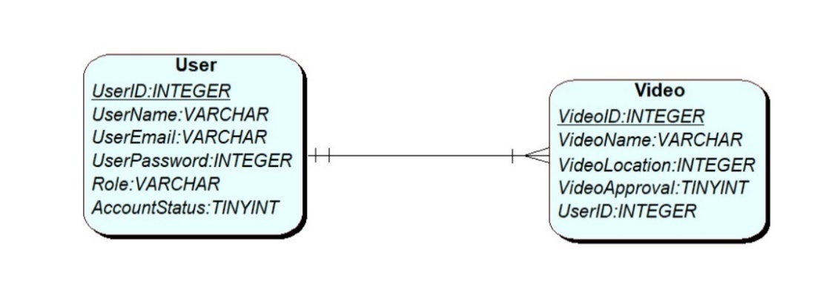

Figure 8 ERD

## **6.7 Use Case Diagram**

The use case diagram describes how the actors of the system, the users and the admin interact with the use cases and the even that it triggers. The users have four primary use cases. They can login or sign up to the system both of which includes a validation process and can extend a validation error. They can also upload videos which also has similar structure of validation and prompt. Finally, the users can analyze the video which includes feed the video to a model as well as return the analysis result.

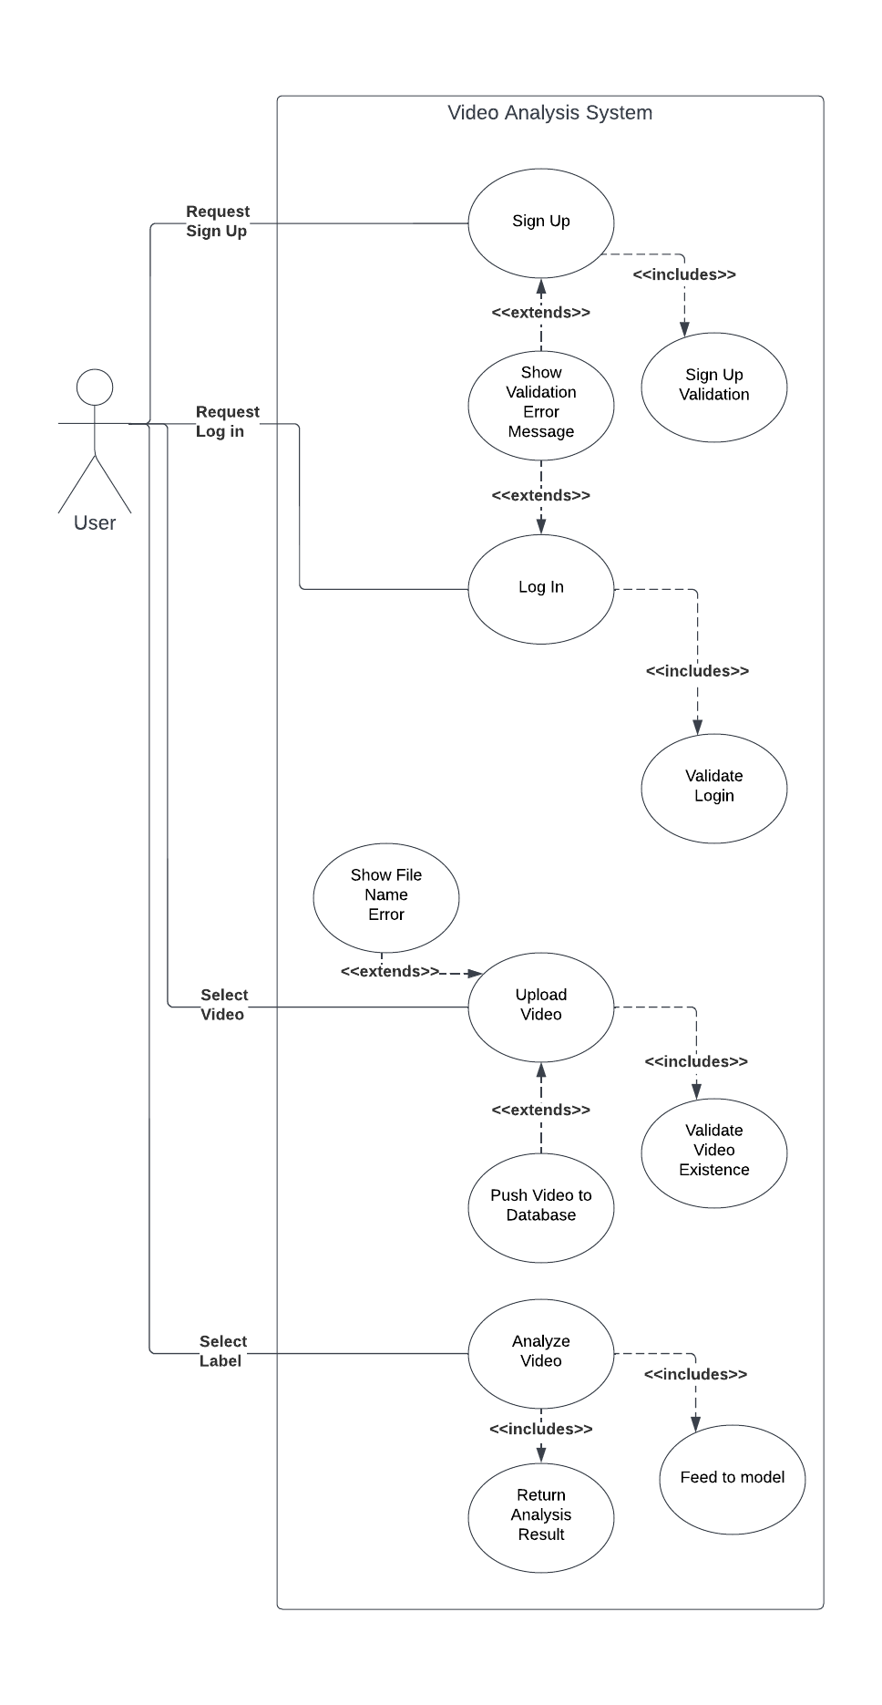

Figure 9 UML use case diagram

## **6.7 Flow Charts**

### **6.7.1 Video Detector**

The following flow chart represents the working of the video detector class. The process works on a loop for each frame present in the video file and detects objects until the loop is completed.

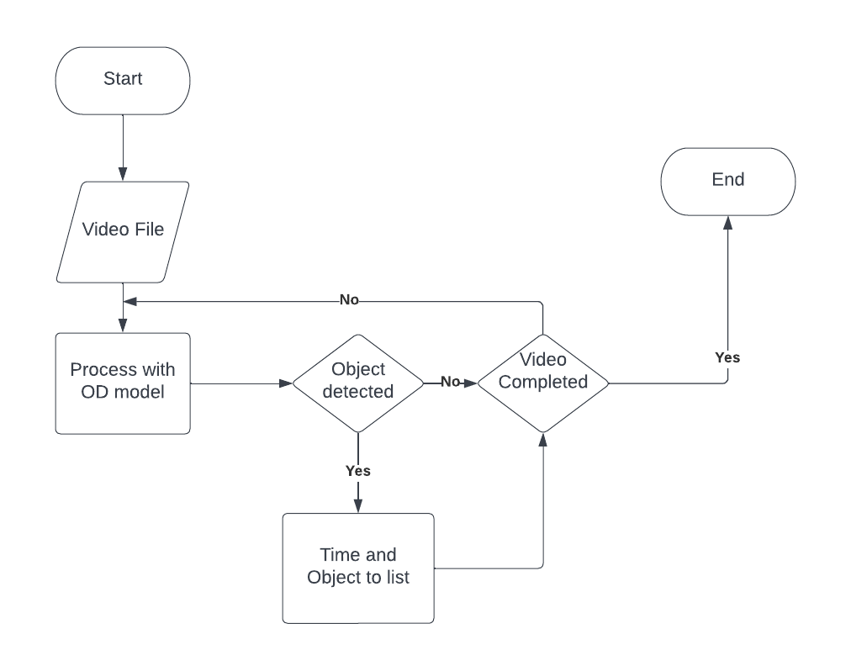

Figure 10 Video Detector Flowchart

### **6.7.2 Video Splicer**

The following flowchart provides us with process flow of the video splicer used to obtain both splice information as well as the actual spliced video files. The splice dictionary is obtained from the video detection process. The dictionary is iterated until its last element and the sequence of contiguous frames are classified as a single splice; the information is then stored in a dictionary as well as used to create splice at the same time.

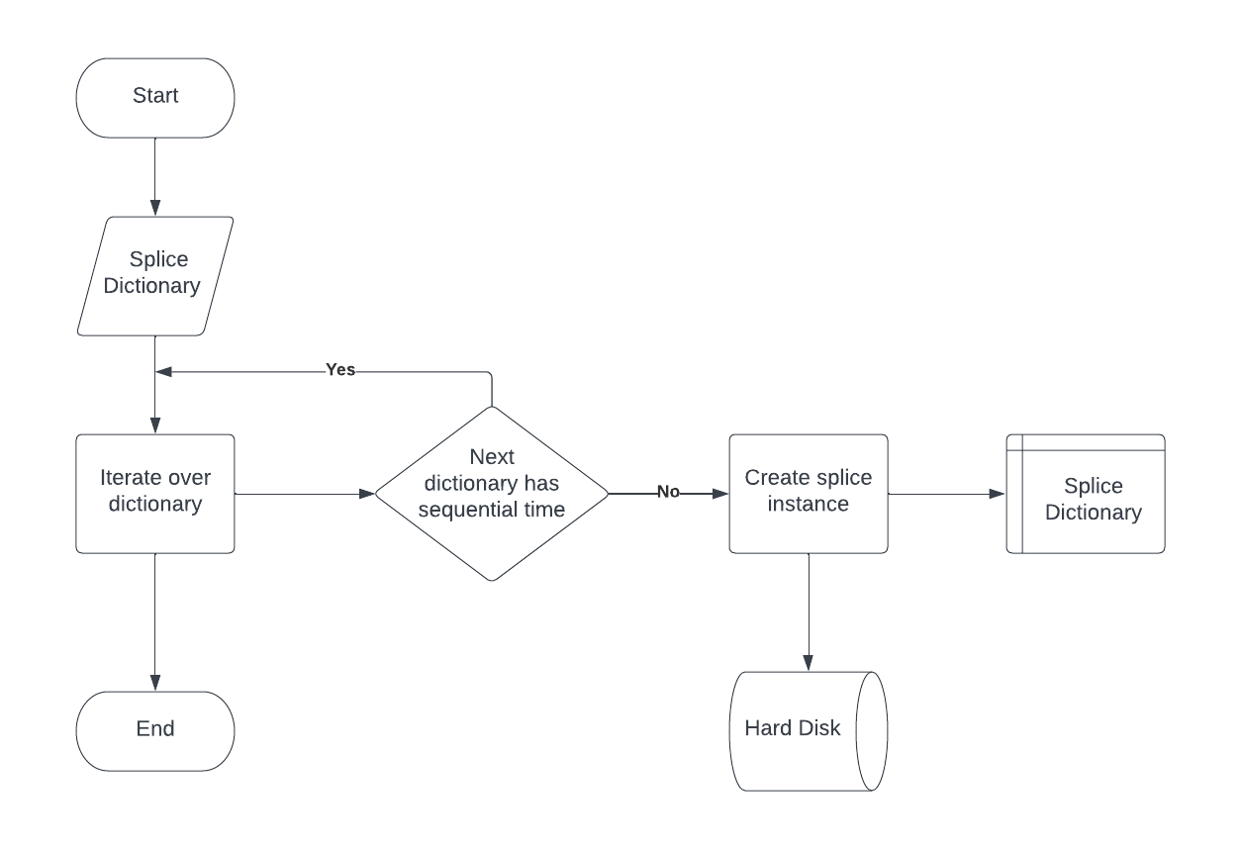

Figure 11 Video splicer flowchart

### **6.7.3 Sending Splice through TCP**

The following flowchart gives us the process overview of sending the already spliced files from the flask API. The splice request is received from the user. The file is read from the request and a tcp port is opened. The TCP connection transfers the data in chunks as long as the transferred file is remaining. The TCP connection is closed following the data transfer. The loop is then checked to see if the anymore splice files remain in the dictionary as is repeated as necessary.

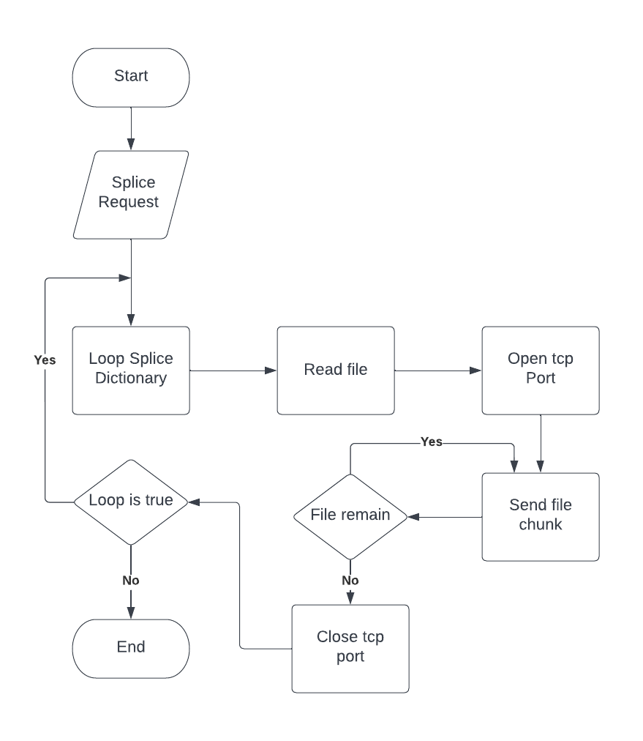

Figure 12 Splice Sender

### **6.7.4 Video Listener**

The following flowchart gives us a process overview of how the video listener process which takes in the uploaded video from the client works in both taking in the video as well as authorizing the request. It does this by opening a tcp connection to receive the video. It authenticates the video by parsing a line containing the authentication information and authenticating that with the help of the REST API. The process either terminates the connection or writes the file to a binary file based on the authentication result.

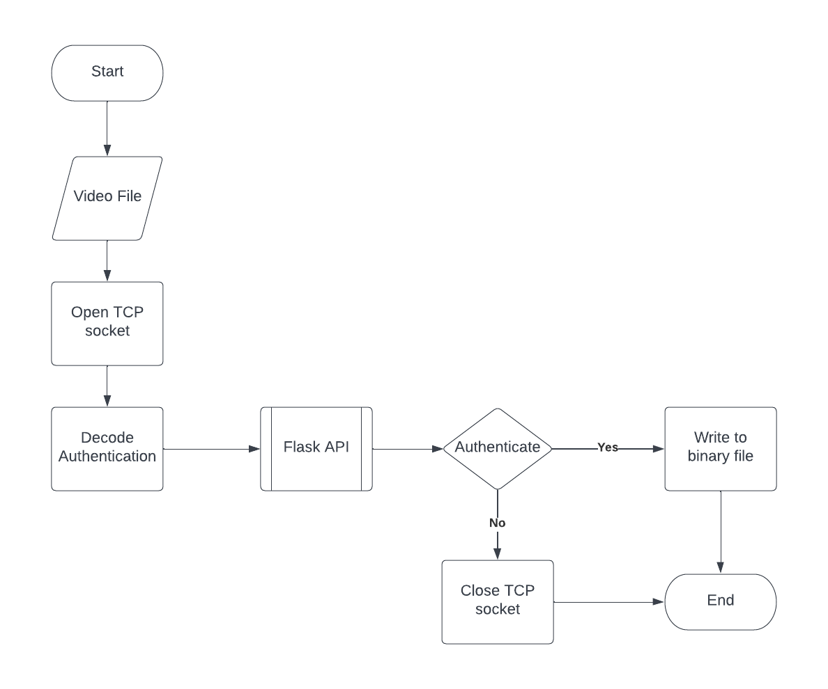

Figure 13 Video receiver flowchart

# **Implementation and Testing**

The implementation and testing phase involves all the process from setting up our development environment to implementing our product concept in terms of code as well as carrying out testing to test if our products are according to our requirements.

## **7.2 Set up Guidelines**

The process of application development consists of setting up multiple applications or tools that can help us carry out our software developments, the tools that were setup to develop the software is described below.

### **7.2.1 VS Code**

The vs code is an integrated development environment that allows us to create a C# project. It provides us with various features that allows us to manage our project throughout the development phase. The utility of visual studio however extends to debugging, managing packages through NuGet, providing us API for easy database connection as well as providing us with hot reloads for developing our frontend. It also comes with C# as well as dot net framework built in.

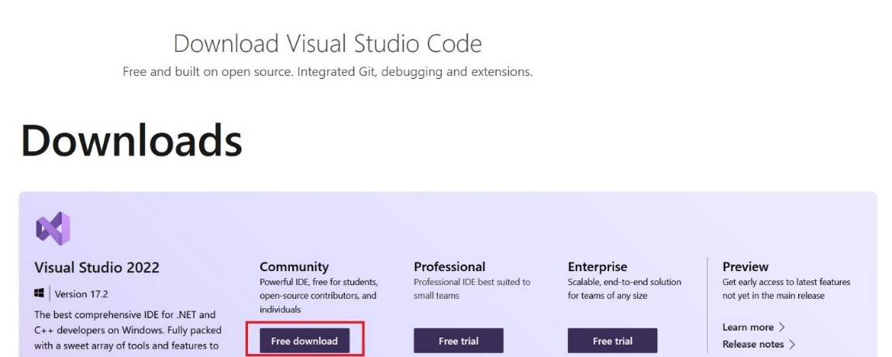

Figure 14 Downloading installation file for visual studio

With visual studio installer you can install the support for C# and dot net framework.

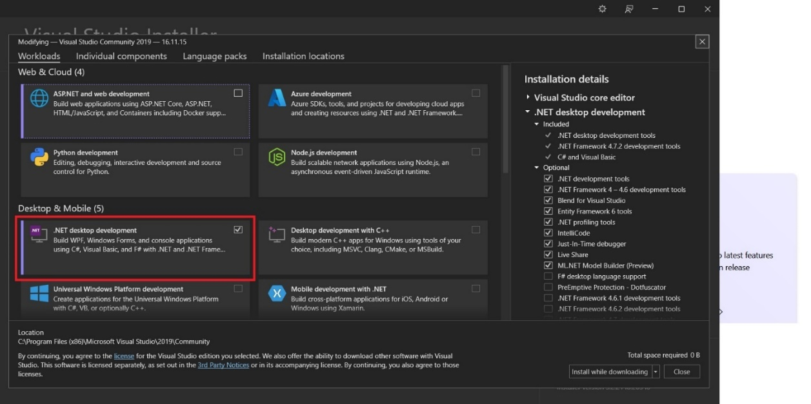

Figure 15 Installing vs support for .net development

After the installation of the dot net desktop development dependencies, we can start the development of our dot net application. However, supporting the database will require the installation of MySQL connector for dot net as well as MySQL for visual studio.

### **7.2.2 MySQL database**

The database that we have used for this project is MySQL database, this database allows us to store our data in form of tables with relations. It is also supported by SQL Alchemy relational mapper which integrates well with our flask application. We have set up MySQL in a docker and the following steps help us accomplish that goal.

### **7.2.3 Installation of Docker**

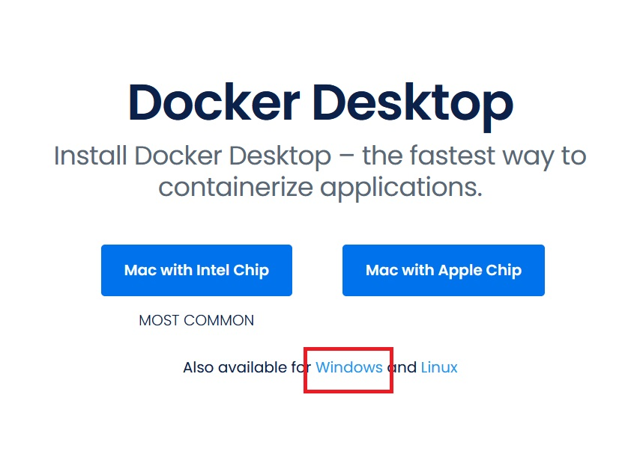

Figure 16 Installation of Docker

After docker has been installed, the Hyper-V has to be turned on.

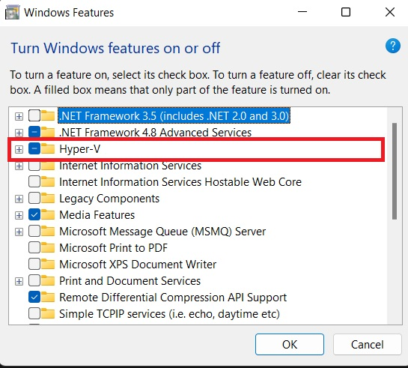

Figure 17 Enabling Hyper-V

Ultimate version of windows requires the use of shell and commands to enable Hyper-V virtualization. Along with this, the bios settings for virtualization must also be enabled by pressing boot key during boot time.



This command creates a volume for our MySQL container.



The above command will help us create MySQL container on docker. On port 3306 and also exposes that port to the host machine. It also binds the container to the above-mentioned volume so that we can save our data in the database.

Now, to create an admin account, we must go to the MySQL terminal using the following command.

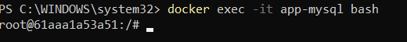

The above command executes our MySQL container in interactive mode, which means that we can access its terminal.

We login to MySQL with following command.

After docker has been set up and running, we have to setup a MySQL container through docker. For this, following commands have to be used in shell.

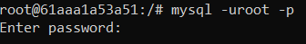

We can now create new database with the following command.



This should set up the database. Following the database, we should set up our Flask backend. This part can also be carried out through phpMyAdmin by connecting it to the above MySQL database.

### **7.2.4 Backend Setup**

For the purpose of backend development, all we need is to install python and its package manager PIP. The python’s installer adds the python location to the path variable by default.

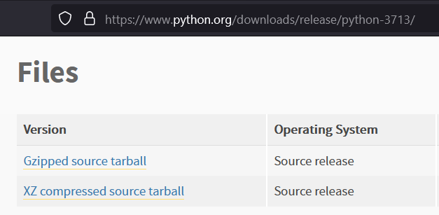

Figure 18 Python 3.7 can be downloaded from python's official site

We also must install PIP which is a package manager for python

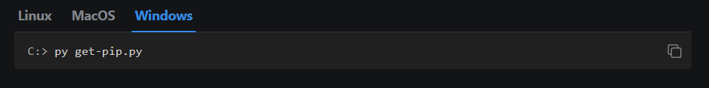

Figure 19 Installing PIP

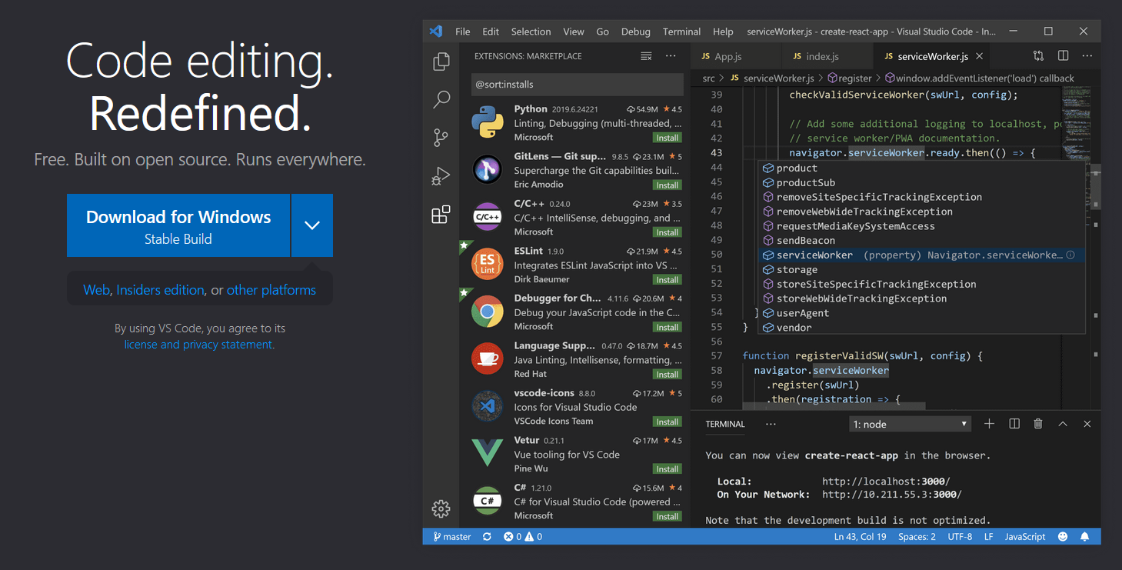

Figure 20 Installing VS Code

For writing the code we used VS Code. We also installed VS code support for python to ensure that we have better time developing our backend python code.

## **7.3 Codes**

In this section we will describe the major coding components in our project along with the screenshot. We will divide this section to front end and backend so that there is more clarity about the components.

### **7.3.1 Frontend**

The front client is written using C# language with the help of WPF framework. With WPF, we have used material design in XAML library to make use of controls with modern customization. We used the MVVM approach to develop our application, in which we segregate the frontend into model, views and view models. This allows us to achieve segregation between the actual UI of the frontend and the data and the logic that underlies it. This allows for many benefits including reusability of code as well as increased easiness in debugging and maintaining the code. This pattern is also suitable for a WPF application due to features like data binding inherently supported in WPF applications.

Below are the prominent features of the front end along with the relevant methods. The full class codes are found in the appendix section.

#### **7.3.1.1 Getting the video list**

The following command provides the list of videos to the views displayed to the user from the rest API with help of the methods available in the apiReq class. It deserializes the response from the server and provides it to the view. It is present in the GetVideoListCommand Class.

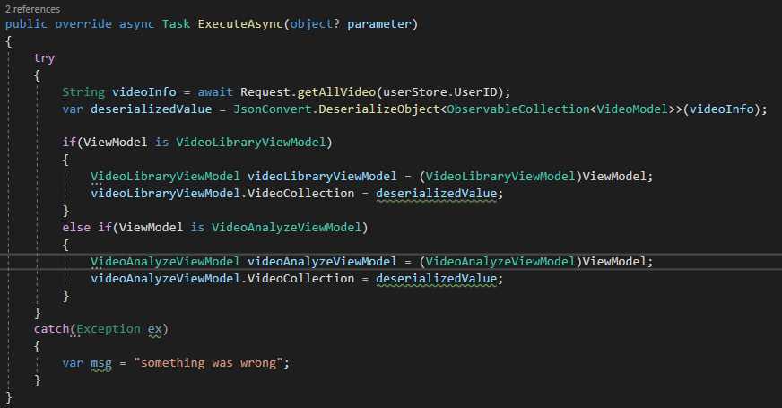

Figure 21 Method to obtain video list

#### **7.3.1.2 Logging in the user**

The following method represents the method for logging in the user. This includes the validations necessary for the process as well as the use of apiReq class to carry out the API request, deserialization, and storage of user values.

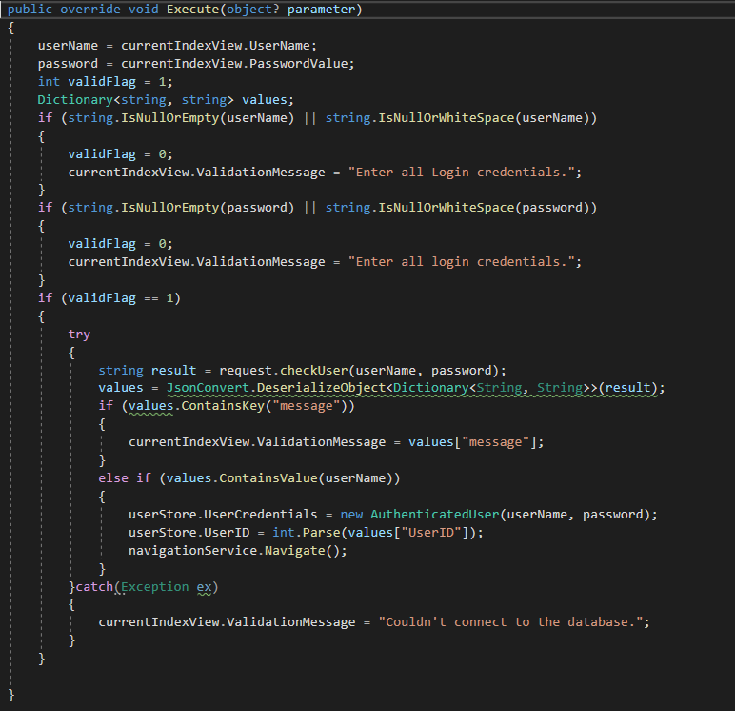

#### **7.3.1.3 Analyzing the video**

The following function excerpt shows the method responsible for analyzing as well as receiving and displaying the analyzed video to the user. It starts out with validations on if the user has selected the video, then it sends the request for the analysis. If it gets a successful analysis response, it opens of a tcp connection to receive the video as well as send a request for the rest API to send the video. It does this task parallelly and displays the splices to the user after the task has been completed successfully. This function is present in the SpliceCommand class.

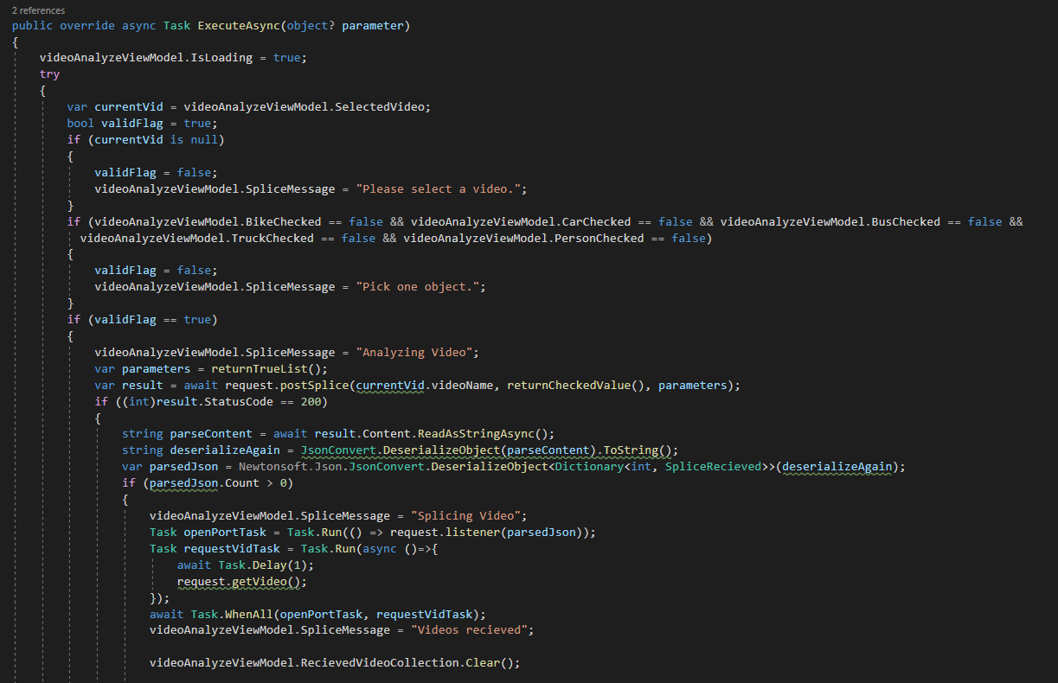

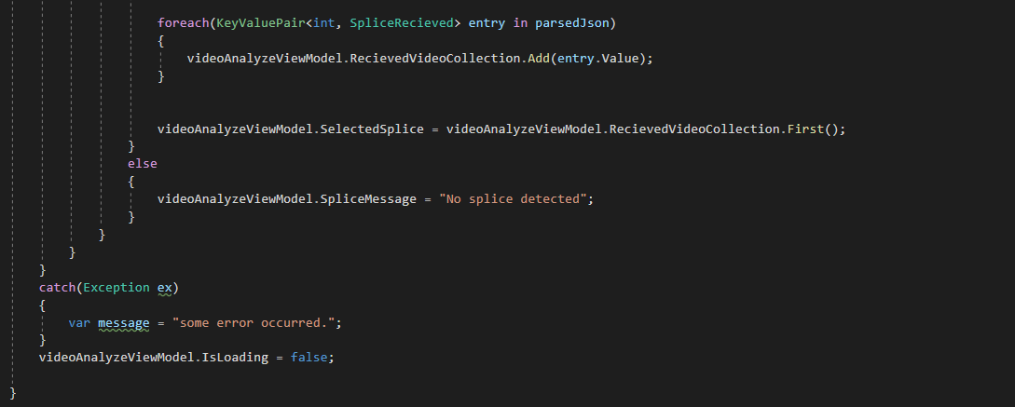

Figure 22 method to analyze video

#### **7.3.1.4 Detecting the selected video**

The following function excerpt identifies the current selected splice in the VideoAnalyze view. Based on the splice selected it sets the views to display the relevant information.

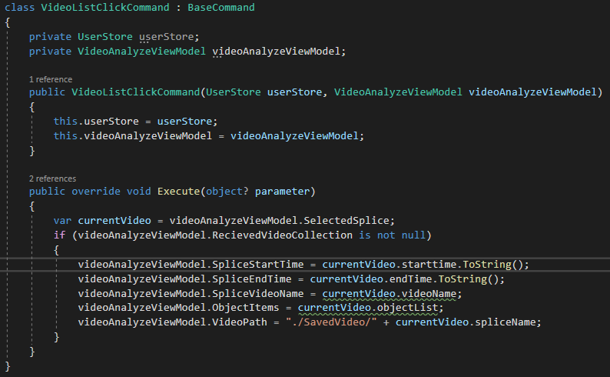

Figure 23 Command to Display info based on video selected

#### **7.3.1.5 Uploading the video**

The following method excerpt present UploadVideoCommand class, uploads the video to the backend process if the video exists in the specified file directory. It does this with the help of methods defined in the apiReq class and sends it through a TCP port connection. It displays a message if the video is successfully sent.

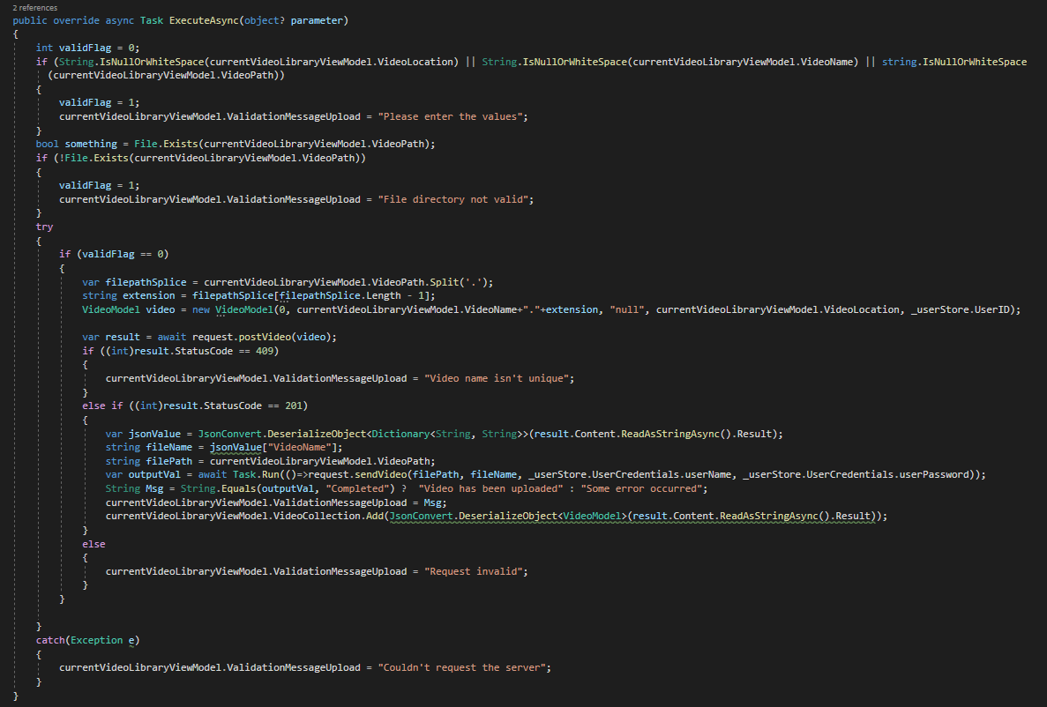

Figure 24 Method to upload the video

#### **7.3.1.6 Navigation Store**

The navigation store stores the value of the current view model and in doing so orchestrates not only the values for the current view but also the current views itself as they are bound to their respective view models.

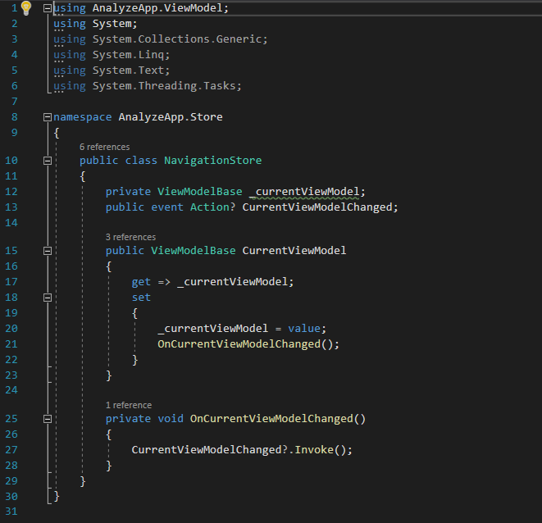

Figure Navigation Store class

#### **7.3.1.7 Navigation Service**

The navigation service obtains the navigation store and changes the current view model to a new view model based on the view model that the user is viewing.

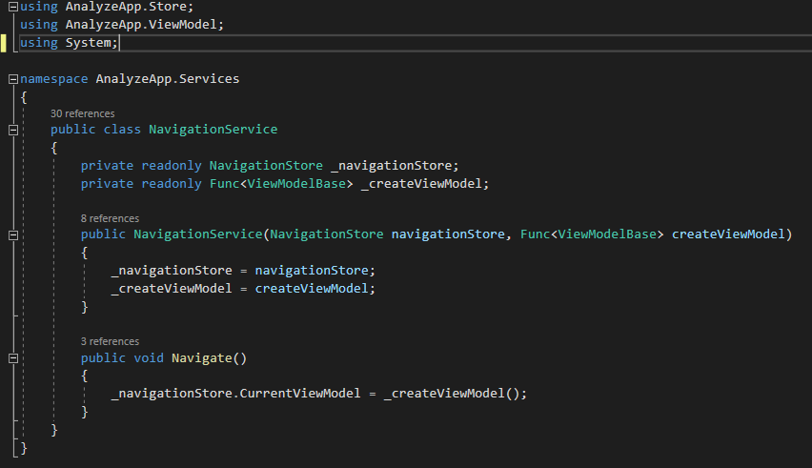

Figure Navigation service class

#### **7.3.1.8 Updating user information**

The following function excerpt shows the function which aids in updating the user information. This also includes the validation features as well as the use of http request through apiReq file to update the user information.

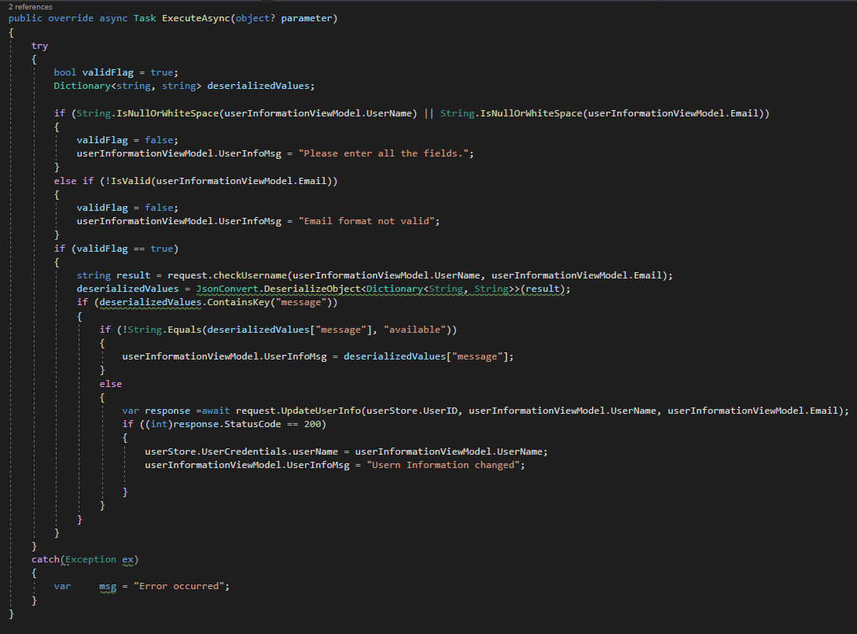

Figure 27 Function to update user information

#### **7.3.1.9 API request file**

The apiReq.cs file contains all the methods that are need for carrying out the API requests. It helps get value for the frontend from the REST API. Below shown are the methods to get all the video information, along with the method to get the user information as well as the method to check if the user exists. The apiReq methods does this with the help of http request and sending those requests against the specified URL. The URLs are tied to their respective resources in the backend. The results are the responses of the requests which are sent back to the command that used this service. The apiReq file has many more methods than that can be listed here, all of them can be found in the appendix section.

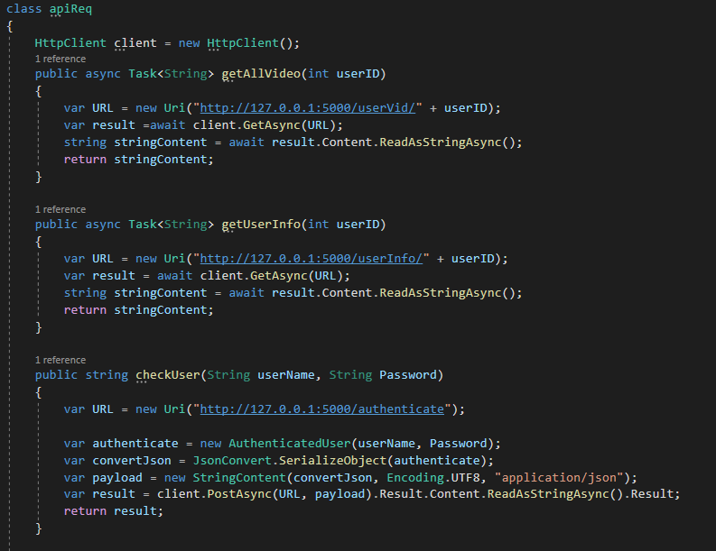

Figure 28 apiReq Class

#### **7.3.1.10 Navigation Command**

The navigation command executes the navigation service that allows us to navigate to various view models in turn changing the views as well.

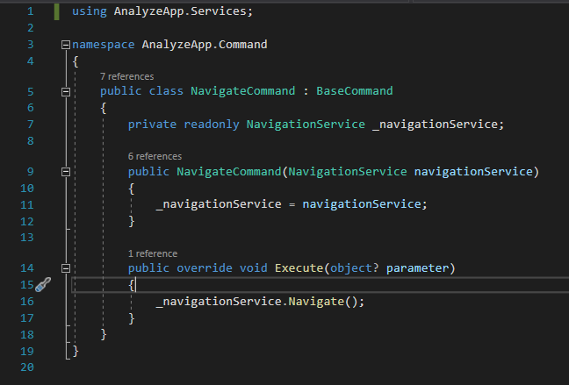

Figure NavigationCommand class

#### **7.3.1.11 Get video list command**

Used in two different this model requests the backend process for the video list of the selected user so that it can be displayed in both the video library as well as video analysis.

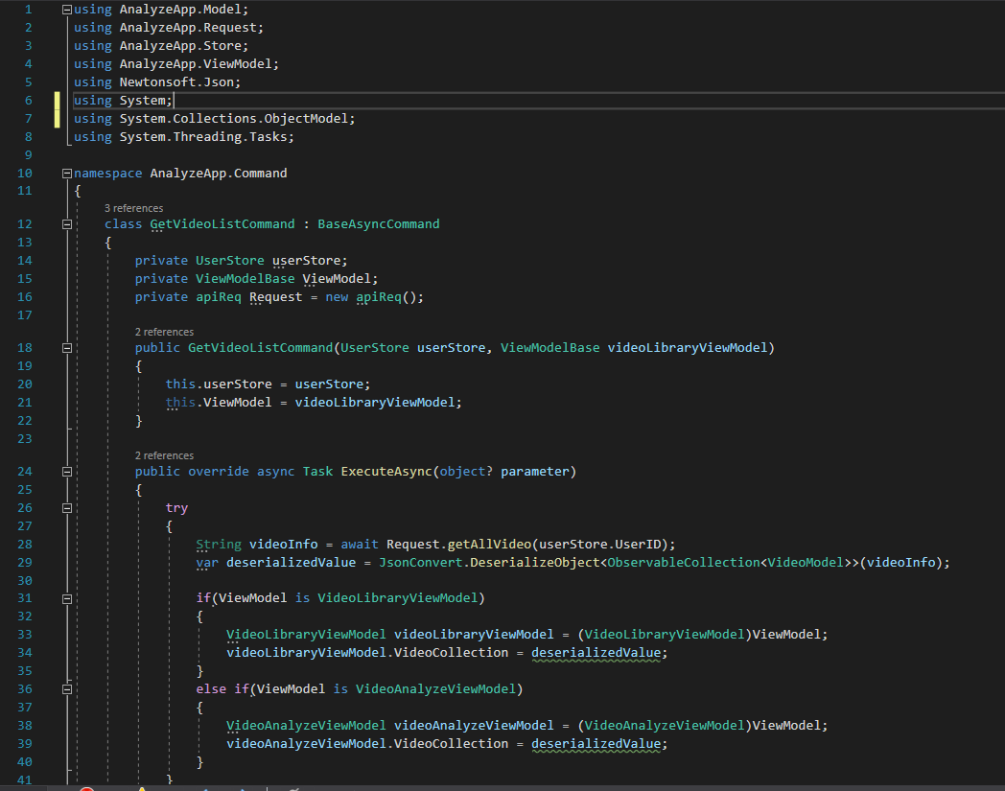

Figure Get video list command class

### **7.3.2 Backend Codes**

The backend codes include various processes that do the bulk of the processing, including processing the video with the object detection model, splicing the video as well as providing the endpoints for various API requests which allows the crud applications from the front end. The rest API is implemented with the help of flask framework. Other necessary processes are written using the python framework.

#### **7.3.2.1 Video Sender**

The video sender class has methods that opens a tcp connection with the frontend client and passes the video file to the specified client. It is used by the flask backend API.

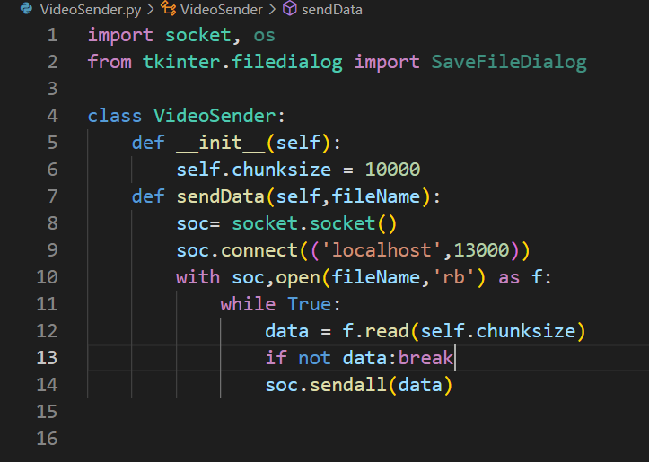

Figure video sender class

#### **7.3.2.2 Video Detector Class**

This class aids in the detection of the video. It makes the use of the object detection model required for the analysis of the video. It makes use of various parameters required for the detection of objects in the video as well sets the detection speed. It can also execute functions based on each of the detection that it has performed.

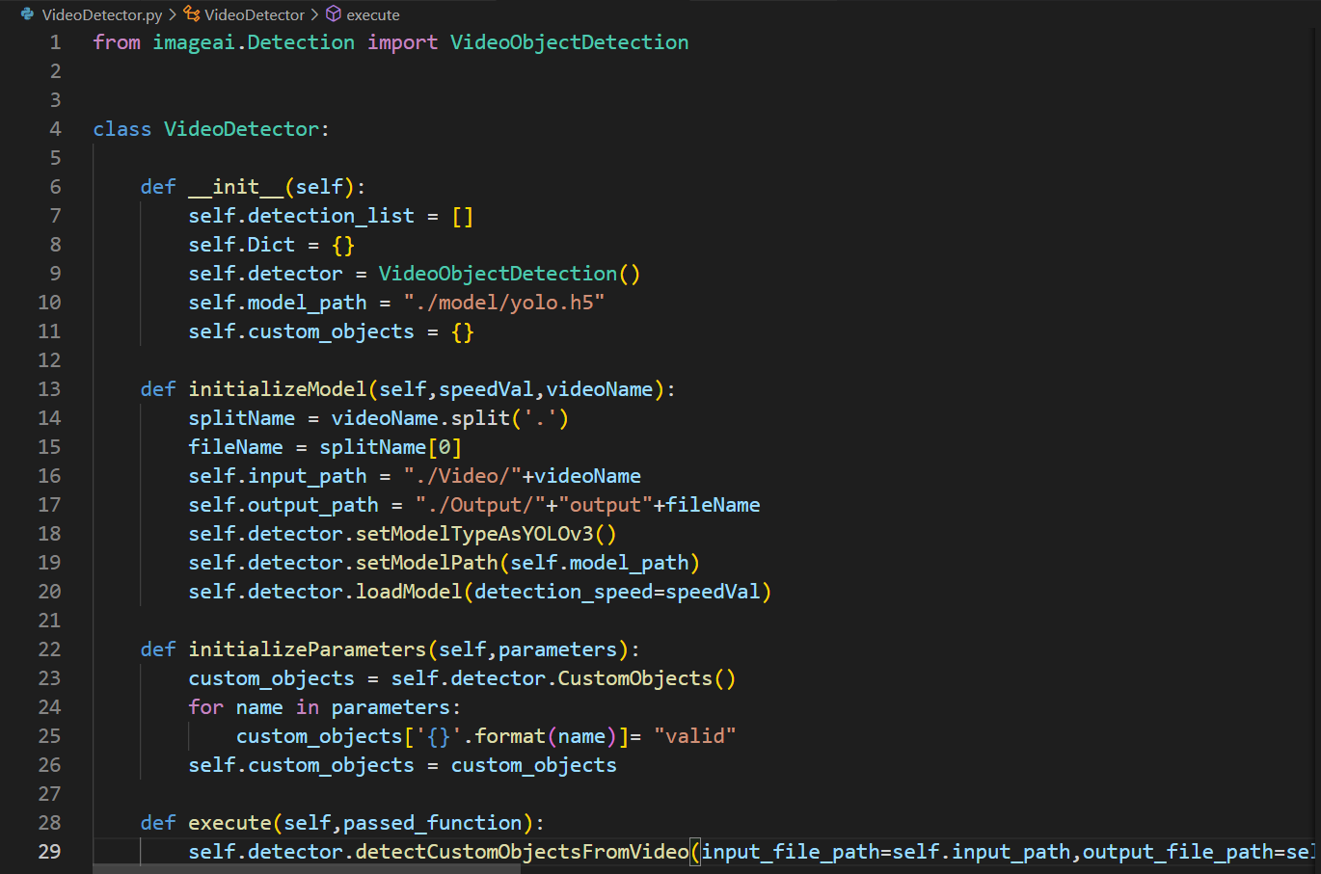

Figure Video Detector class

#### **7.3.2.3 Listener script**

The listener script listens to the port 8848 and receives the video files. It adds a layer of security by deciphering the lines with authentication information and sending an authorization request to the flask API so that only the valid requests are received.

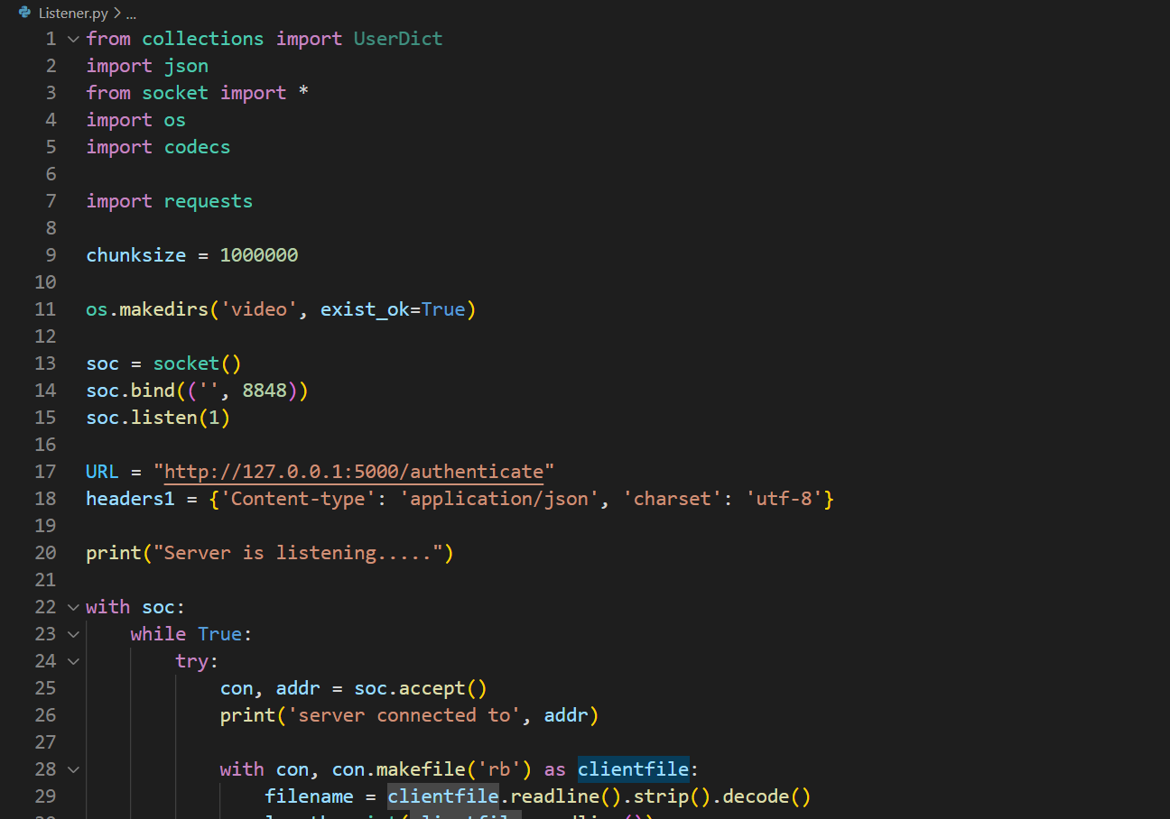

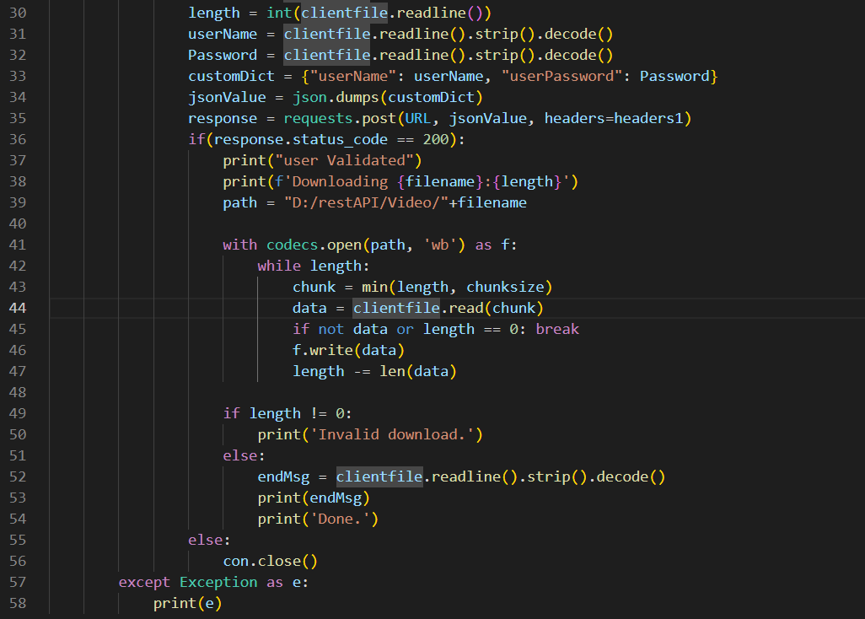

Figure Video Listener Script

#### **7.3.2.4 Video Splicer**

The video splicer class is used by the rest API to carry out the actual splicing of the videos as well as generating the splice information in form of JSON. The splices are then saved to a directory and a JSON of the splice is returned to the API so that it can be sent back to the client. It makes use of moviepy library to splice the videos and complex encoder to encode a complex object structure to a JSON.

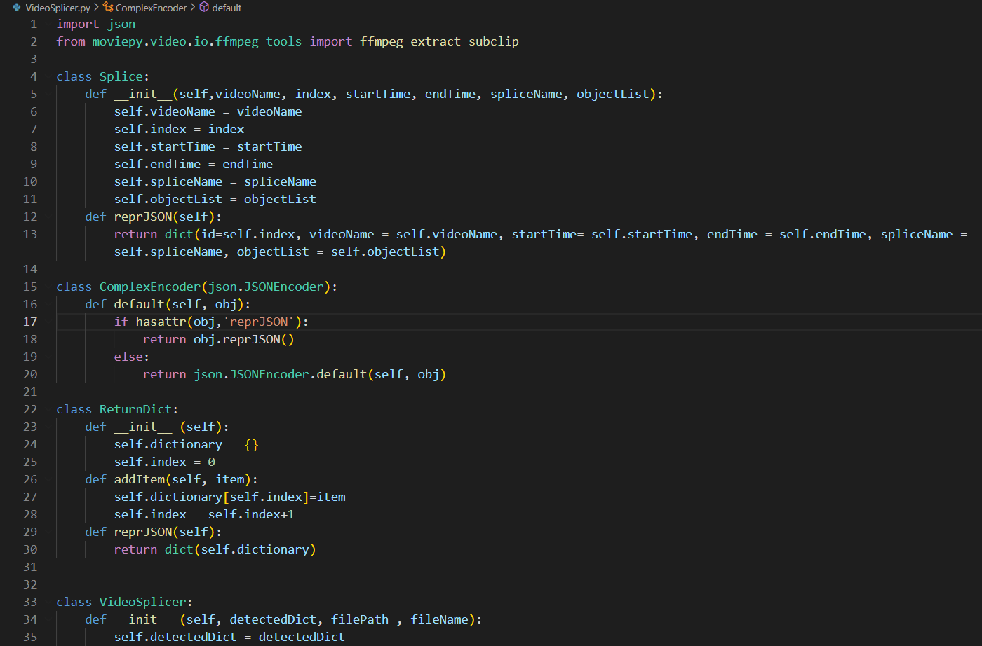

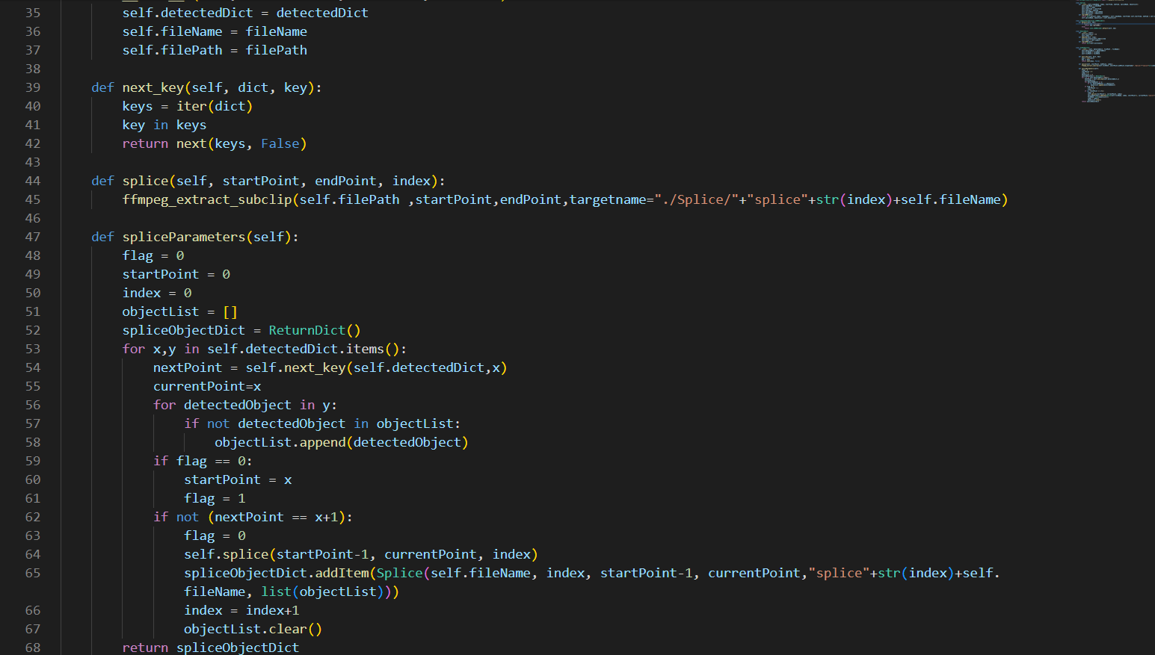

Figure Video Splicer Class

#### **7.3.2.5 Main.py the flask application**

Main.py is the flask application that provides us with a restful API that can serve the http request to our C# client. It makes the use of the aforementioned classes to serve those requests to the client. It plays a vital role in the creation of the ORM schema that we can use to interact with the database through in form of objects representing various tables. This process is a glue that holds all of our backend processes and provides the client with all of the necessary data.

The screenshot below shows the import of the required dependency modules as well as the creation of the restful api making use of a flask object. It also shows the connection being made between the sql database with help of SQL alchemy which is an ORM tool.

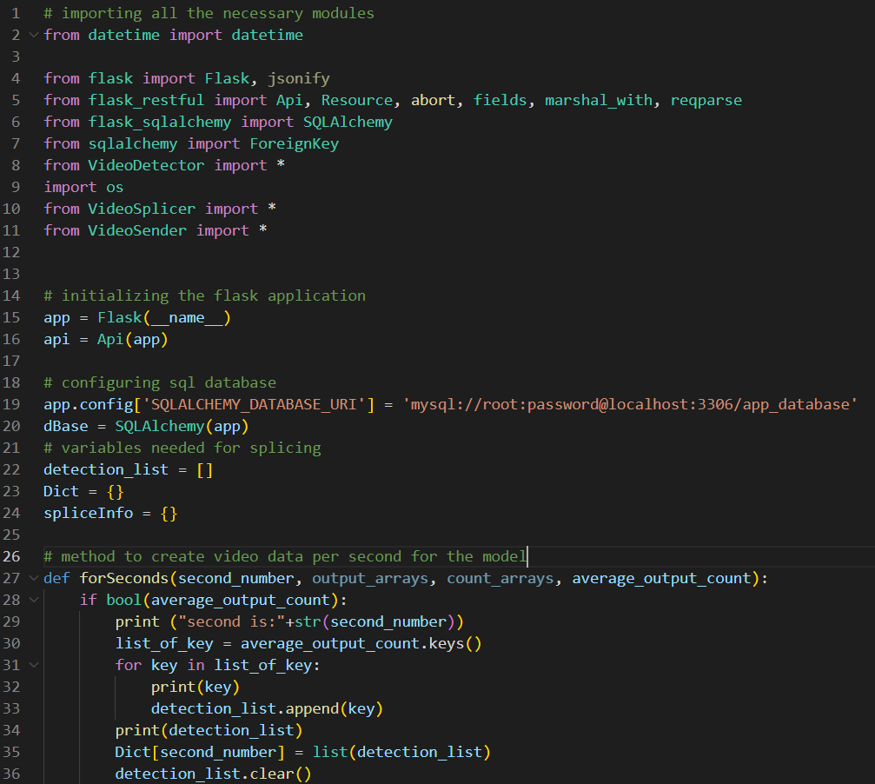

Figure 35 Importing all the dependencies as well as describing the connection

The screenshot below shows the definition of our ORM schema used to define our database structure through which we can use ORM queries to easily perform operation in our database.

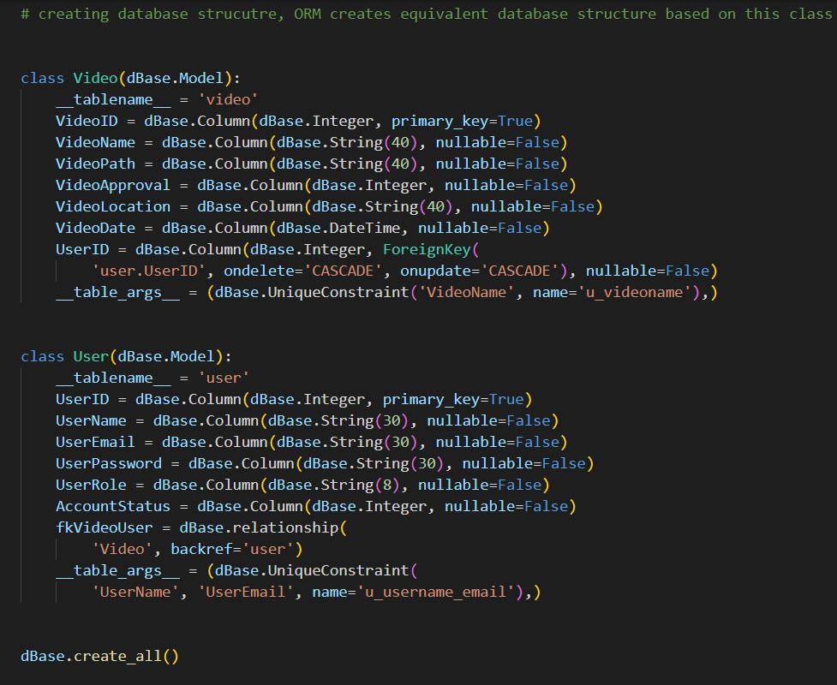

Figure 36 Declaring ORM schema

The screenshot below shows the creation of the arguments which defines a set of arguments that a resource requires to carry out certain tasks. The client side must provide these parameters so that they can carry out certain tasks.

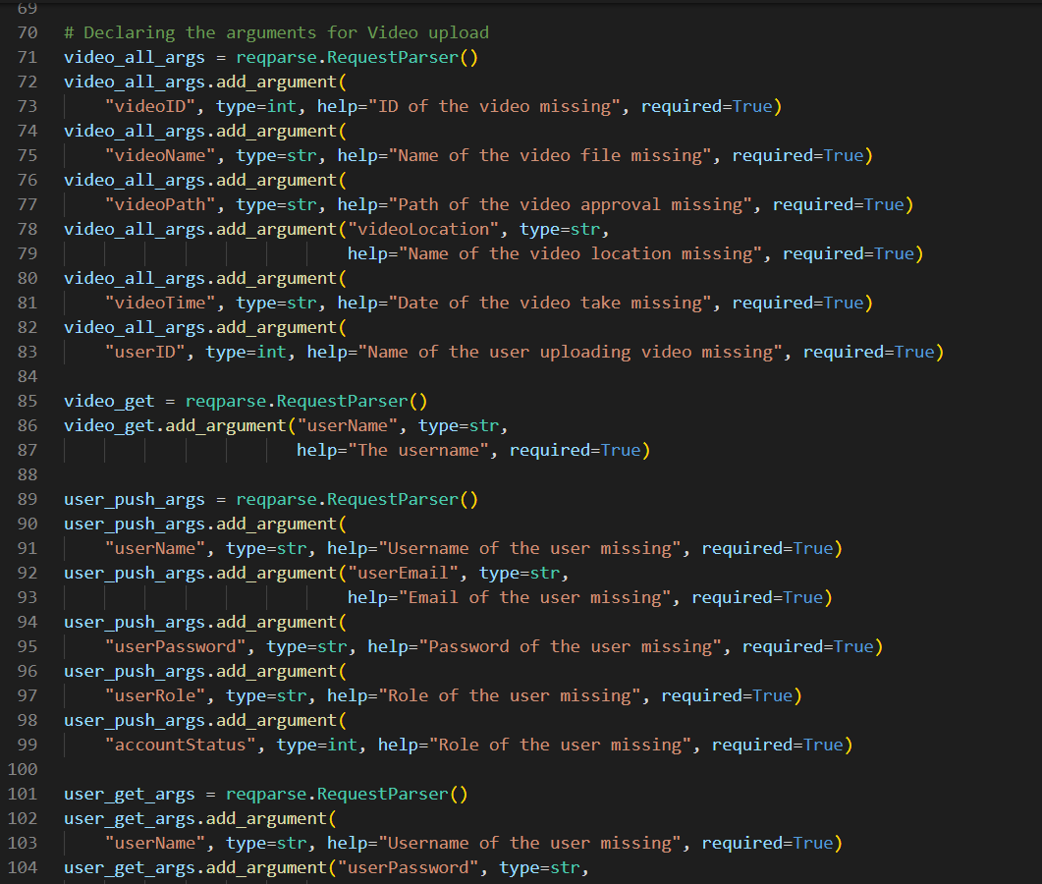

Figure 37 Creating arguments for the request

The below screen shot shows the format fields according to which the result of a request is serialized in a JSON format to be sent to the client.

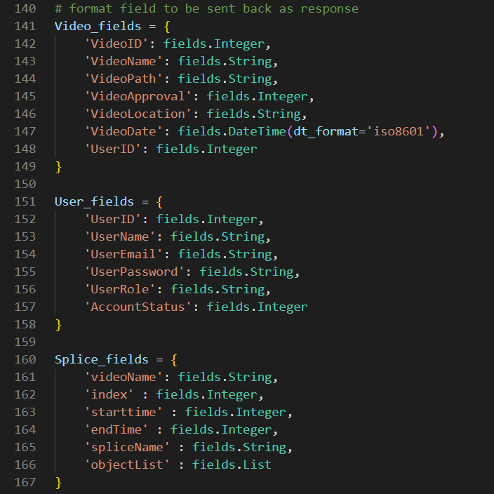

Figure 38 Creating structures for return value serialization

The below screenshots are examples of resources that can be accessed with the help of endpoints by sending requests to the API.

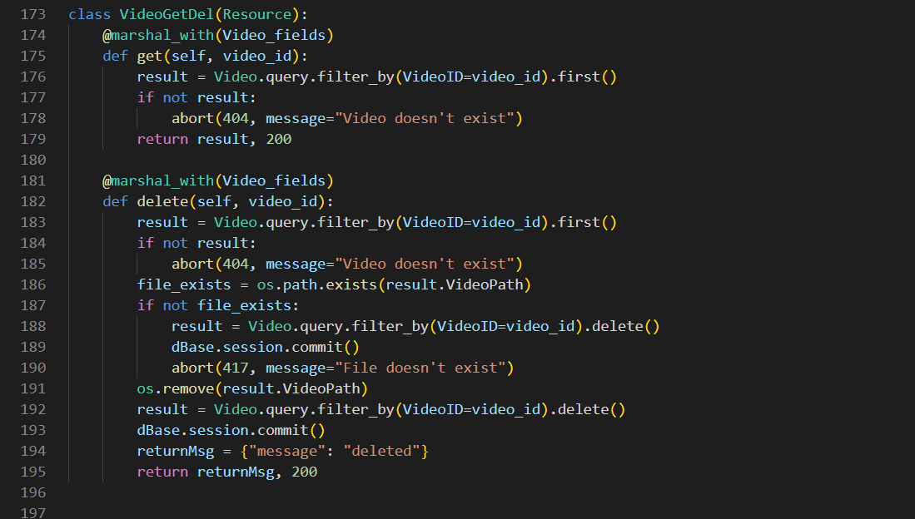

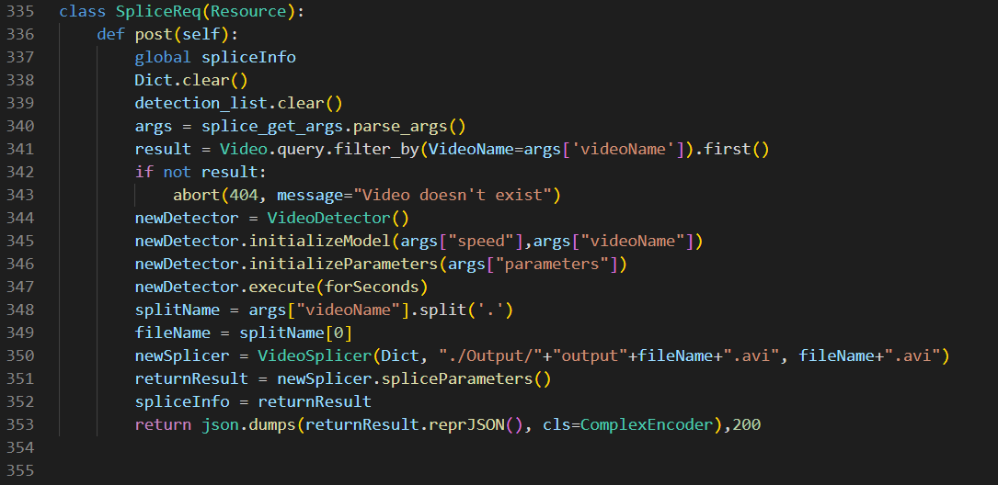

Figure 39 Declaring resources that can be used through end points

The below screenshot shows how the resources are attached to the API endpoints. These endpoints help users to make use of resource that they desire.

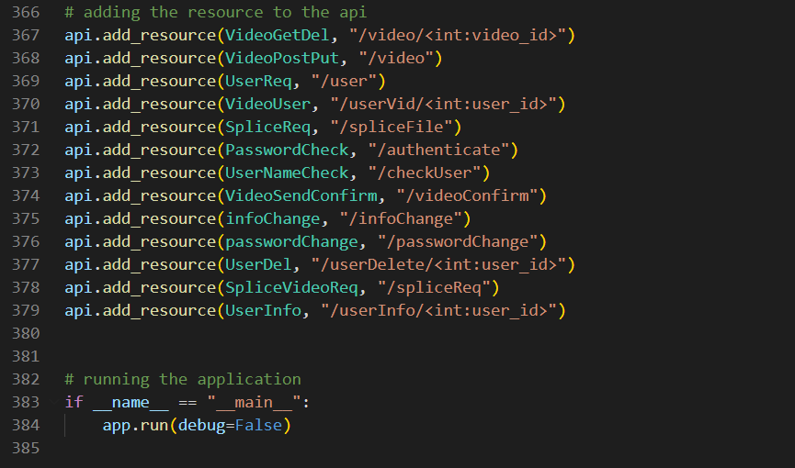

Figure 40 Attaching resources to the endpoints

These covers the major components of our codes. The codebase in its entirety can be found in the product submission in the source code zip.

## **7.4 Functional and non-functional testing**

We will sort out our testing in terms of various pages of our application. They are described in sequence below.

We will start out with the functional testing.

### **7.4.1 Index View**

#### **7.4.1.1 Empty Field Test**

Leaving the fields empty before pressing login will give a prompt telling you to enter the details.

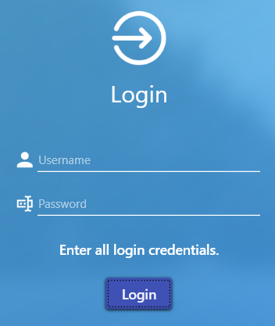

Figure 41 Empty Fields Validation

#### **7.4.1.2 Username validation**

Entering the wrong username will give the prompt regarding invalid username.

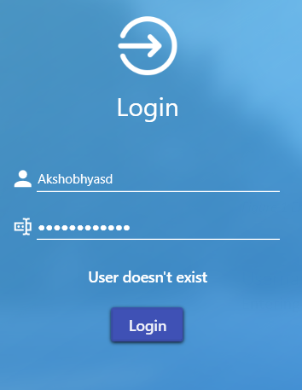

Figure 42 User doesn't exist

#### **7.4.1.3 Password validation**

Entering wrong password will give the prompt regarding invalid password.

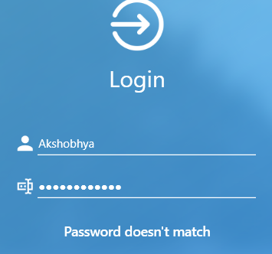

Figure 43 Wrong password entered

#### **7.4.1.4 Empty Signup fields**

Keeping any fields empty will give a prompt telling you to enter the necessary fields.

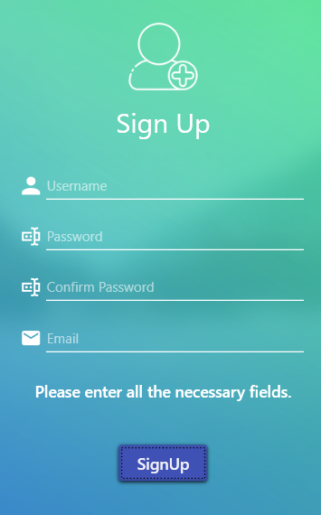

Figure 44 Empty signup fields

#### **7.4.1.5 Password not matching**

Passwords not matching will give a prompt regarding the mismatching password.

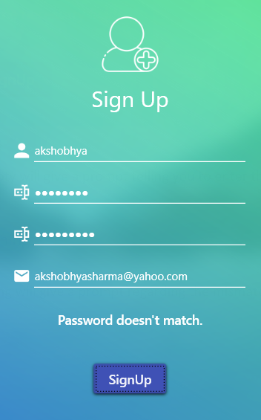

Figure 45 Mismatching password

#### **7.4.1.6 Email Format Validation**

Giving improper email format will give you a prompt.

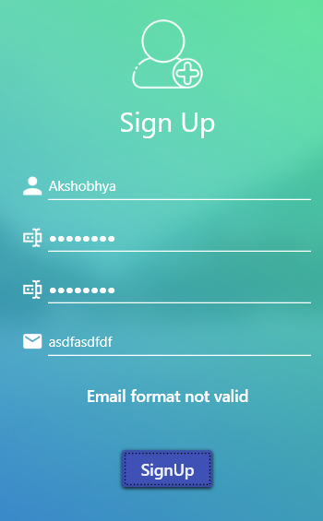

Figure 46 Invalid email

### **7.4.2 Video Library View**

#### **7.4.2.1 Video Upload validation**

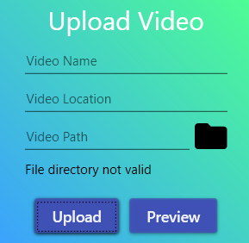

Figure 47 Invalid video path

While uploading the video, the file path is validated if it is empty or invalid.

#### **7.4.2.2 Delete Command validation**

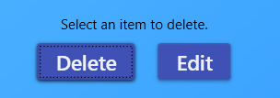

Figure 48 Delete button validation

The delete button gives a prompt when issued without selecting a video

#### **7.4.2.3 Update Model Validation**

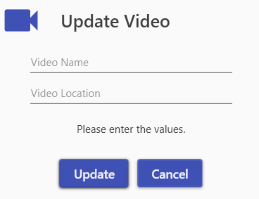

Figure 49 Empty fields prompt

Leaving update video fields empty prompts user to fill the values.

### **7.4.3 Video Analyze View**

#### **7.4.3.1 Analyze button validation**

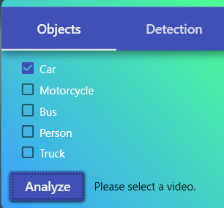

Figure 50 Analyze button message

Not selecting the video before clicking the analyze button gives the above prompt.

### **7.4.4 User Information View**

#### **7.4.3.1 Empty field validation**

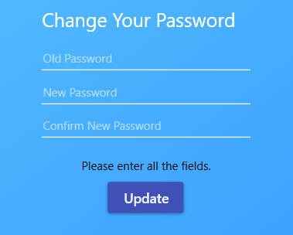

Figure 51 Empty field validation

Leaving the fields empty will give a prompt telling the fields is empty.

#### **7.4.3.2 Old Password validation**

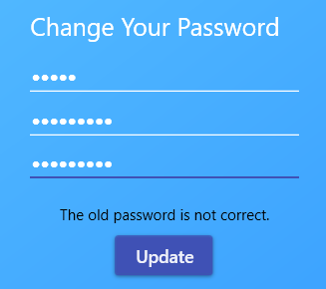

Figure 52 Old password not matching

Old password not matching gives validation message.

#### **7.4.3.3 Password Match validation**

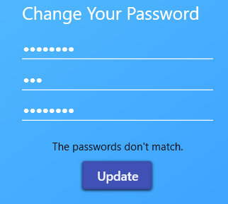

Figure 53 Password not matching validation

The new password not matching triggers the prompt.

#### **7.4.3.4 Used Email validation**

Trying to change email to an already used email.

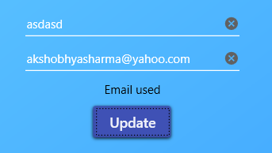

Figure 54 Used Email validation

#### **7.4.3.5 Used username validation**

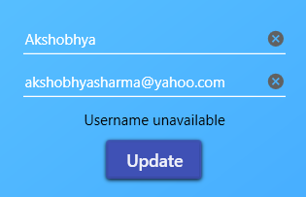Trying to change username to already used username.

Figure 55 Changing username

#### **7.4.3.6 Invalid Email validation**

Trying to change email to an invalid email.

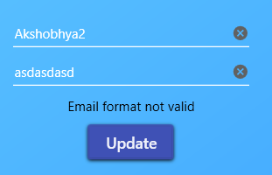

Figure 56 Changing to invalid email

### **7.4.4 Non-functional testing**

#### **7.4.4.1 Responsiveness**

Testing UI responsiveness while making API calls.

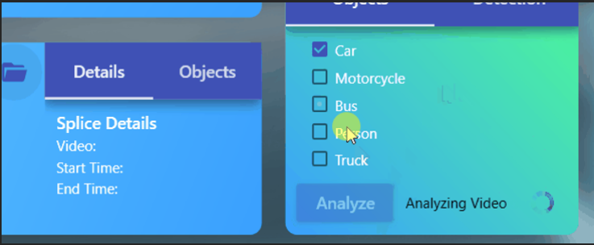

Figure 57 Testing responsiveness

#### **7.4.4.2 Tooltips**

Testing tooltips to provide more information to users.

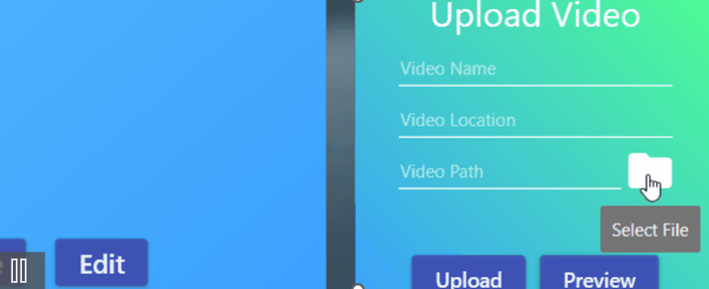

Figure 58 Testing Tooltips

#### **7.4.4.3 Testing password encryption**

Testing password encryption.

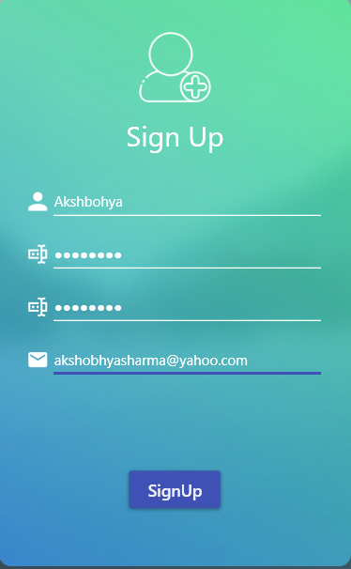

Figure 59 Inputting signup fields



Figure 60 Encrypted password in database

# **Product Evaluation**

The product evaluation is based on the product requirement analysis presented above. In this section we will note down on whether the specified requirements have been met or not.

## **8.1 Functional Requirements**

|  |  |  |  |
| --- | --- | --- | --- |
| Feature | Expected | Outcome | Evaluation |
| Login and Sign-Up interface | A login form with validations from both front end and backend. | The login form is implemented as expected, however features needing emails aren’t implemented. | Successful |
| Email features to verify and recover password. | A feature that verified email by send verification email and recovered password through email. | The feature couldn’t be implemented in time. | Unsuccessful |
| Video Upload Interface | An interface that allows the user to select, preview and upload the video to the server as well as manage them. | The interface includes all the required features for user to manage their videos. The surplus feature of streaming video already in server wasn’t implemented. | Mostly Successful |
| Video Analyze Interface | An interface that allows the user to analyze the videos stored in the server by selecting the specified parameters and obtain the result and view the splices. | The interface is also implemented with all the crucial features to carry out and view the analysis. However, the splice management feature is absent. | Mostly successful |
| User Information Interface | An interface that allows the users to view and change their details as well as delete their account. | The interface has all the necessary feature and is completely implemented. | Successful |
| Group Interface | An interface that allows the users to create group and share their contents in the group. | The interface wasn’t high in priority and couldn’t be developed in time. | Failed |

Table Functional requirement evaluation

## **8.2 Non-functional requirement**

|  |  |  |  |
| --- | --- | --- | --- |
| Feature | Expected | Outcome | Evaluation |
| Use of OOP | Use of OOP concepts where applicable. | OOP is used throughout the program except few exceptions. | Mostly Successful |
| Optimize for multiple user use | Make application to cover multiple user case scenario. | The application although capable of multiple user account creation, isn’t optimized for handling concurrent use case scenario. | Incomplete |
| Password Encryption | Encrypt password as soon as possible. | Passwords are encrypted as soon as possible after receiving from the user and before storing in the database. | Successful |
| Use of threading and asynchronous programming. | Appropriate techniques used to ensure responsive UI and efficient program sequence. | The techniques have been used to create an efficient program structure when possible. | Successful |
| Modern looking user interface | The design of the UI is modern and elegant. | A modern UI has been implemented | Successful |
| Use of tooltip | Use of tooltip, when possible, to aid users. | Tooltips have been used where possible to aid the users. | Successful |
| Easy navigation | The navigational structure must be easy to the user. | The program is a single-windowed program, and the navigational structure is simple. | Successful |

Table Nonfunctional requirement evaluation

## **8.3 Product Limitations**

The above table shows most of the product requirements in terms of expected results and actual outcomes. There were few shortcomings for this product. First of all, the features relating to email authentication as well as password recovery couldn’t be fulfilled due to time constraints, apart from that with relation to splice it would have been better to implement it as an entity in our database, as this not only breaks our REST API principles, but also hinders multiuser use case.

Apart from that, there a fundamental flaw of this application is the use of the object detection model itself. Before starting this project, I was unaware of how resource intensive the task of object detection was to your computer. A detailed analysis takes more than double the duration of the video to give the result. A quick analysis even if quicker has a lot of false positives as well as false negatives. It is clear when running the software that the backend of the software must be hosted in a powerful PC to give the user a good experience and return the result in a considerably lower amount of time.

In hindsight the use of ImageAI library although simpler, tacked on unwanted dependencies to the product. It limited the product to older versions of python, TensorFlow as well as older object detection models themselves which in turn result in older CUDA and CUDNN libraries, harming the TensorFlow integration with the GPU. Writing a custom TensorFlow or Keras codes would have enabled a more modern object detection algorithm making the process of detection more efficient.

Lastly the use of WPF framework and C# language for frontend isn’t fully leveraged as the bulk of the processing is done in the backend. Since the object detection tasks are better suited for backend anyway, it would probably have been a better choice to implement a web-based frontend solution as it would have met our needs perfectly.

In terms of coding, features like generic data type could have been to drastically reduce the codebase. Further design patterns like factory design pattern could have been used in the fronted as well to manage the dependency according to our need. In terms of the backend code the REST API code has been heavily overloaded, this code could have been dissected and managed even better.

## **8.4 Product Potential**

The product in its current form showcases the possibility of the object detection in deciphering a video into multiple splices based on the user requirements. It showcases an application structure that could be made around this concept using various technologies like http, tcp, REST API, etc.

This base of this application however allows us to easily integrate other features including group features due to the object-oriented nature of the code. Other object detection features like object tracking could be implemented so that the videos could analyzed statistically as well and provide the users with some statistical information. The use of object tracking could also make this application better suited for traffic analysis purpose.

The frontend of C# and WPF could also be leveraged to carry out the video splicing process in the user side to alleviate the server load.

# **Project Management and Evaluation**

The project management was carried out by using Microsoft Project and various tools that it offers. It helps us break our project down into a structure of multiple achievable goals so that we can achieve a desired end result with time. Microsoft Project offers us various tools to help us accomplish that. The uses of these tools are described below.

## **9.1 Project management tools**

### **9.1.1 Timeline**

The timeline gives us a brief overview of the time breakdown of the project. It is beneficial throughout the course of the project in helping us understand the progression of our project in a quick glimpse. It has not only the deadlines of the final product but also the deadlines of the individual stages of the project development. With this information the use of timeline can help in the management of the time resource for the project.

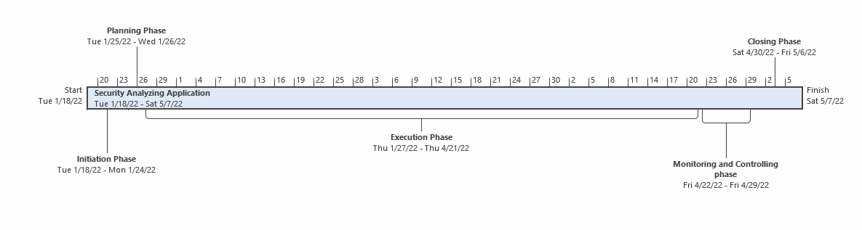

Figure 61 Project Timeline

### **9.1.2 Gantt Chart**

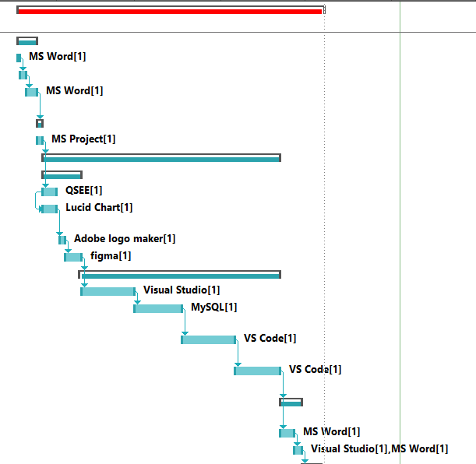



Figure 62 Gantt Chart

The Gantt chart shows the sequence in which the project was completed along with the resources used in the project. It is based on the task sheet and can be useful to gauge the time requirements of different stages of the project. It can show us valuable information on which area of the project requires the bulk of the resource commitment to complete.

### **9.1.3 Task Sheet**

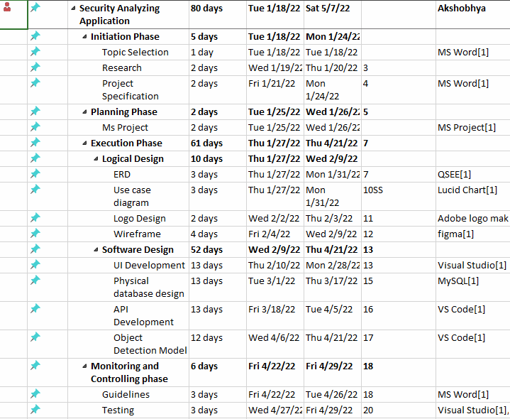

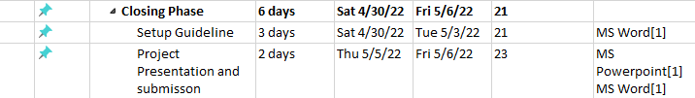

Figure 63 Gant Chart

The task sheet is an accurate map of the date allocated for each stage in the product development. It further dissects the substage of the main five stages of product development into distinct phases of time. It gives us a precise timeline of the project and also aids in the creation of Gantt chart as well. It is also used to assign the resources we have used in each of the stages. In this way the task sheet provides a detailed view of multiple aspect of our project plan.

### **9.1.4 Resource Sheet**

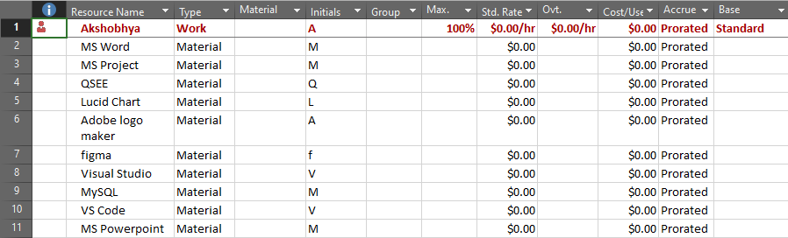

Figure 64 Resource Sheet

The resource sheet shows us the collection of all the resources we have used in our project along with their type. It can be essential to gauge the resource requirement need for the completion of the project as well as calculate their cost. It will help us plan and track the economy of our project.

## **9.1.5 Project Evaluation**

The project made use of the agile methodology along with the above project planning tools. The use of agile did result in a functional product in the end, but the lack of resource planning due to an extremely product driven approach was very costly.

In hindsight, an additional planning regarding technologies used could have served better for the product development. There are cases where a better technology could have been adopted in time by proper planning of already known technologies. For example, the frontend could have used a browser-based technology like electron as browser-based development was already used in previous semesters and the time taken to learn WPF technology could have been invested in learning technology like TensorFlow.

However, the use of product-based approach although slightly detrimental in terms of documentation as well as planning, did result in a usable end product. The product is completed and offers most of the functionalities that were expected.

# **Conclusion**

The development of the project has resulted in some interesting findings about the project undertaken. The most vital of the discovery was the resource consumption of the object detection algorithm. In the application structure that we have created this was the biggest bottleneck. In the table below we can see the time taken for each of the analysis in a 14 second video. The object detected time shows total time of the splices sent back by the model. The quick analysis although fast almost takes as long as the video time to perform the analysis, and even in this relatively shorter time compared to other detection modes, it loses 3 second worth of detection making it unreliable. This demonstrates that the model wouldn’t be viable unless hosted in a cloud environment of some sorts where the resources demanded by the model can be easily met.

|  |  |  |
| --- | --- | --- |
| Analysis | Object Detected Time | Time taken |
| Quick | 8 seconds | 13 seconds |
| Normal | 11 seconds | 41 seconds |
| Detailed | 11 seconds | 58 seconds |

Table Conclusion test

A future project of this nature could use some amendments. To rectify the above problem, we could make use of newer more efficient algorithms. This would be less intensive on the computing resource as well as allow us to use newer libraries as we would be freed from the dependencies of the older algorithm. The future project of the same nature could use cloud services to host the backend process to bring out the best performance of the model. The model could be further customized for only the necessary objects for our project which are vehicles. I would also make use of a browser-based technology for the frontend as the frontend is relatively light on resource usage. This would also make the project more accessible through web.

In future more efficient algorithms would definitely improve the performance of this type of applications. There could also be development of better suited GPUs which would allow the algorithm to use more resource. Platforms like amazon web service, Microsoft azure also offer services for machine learning based clouds (Microsoft, 2022). Developments of such platforms must also be observed for hosting this type of solution.

# **Appendix**

# **11.1 Bibliography**

Alom, Z., Alom, M. Z., Taha, T. M., Yakopcic, C., Westberg, S., Sidike, P., . . . Asari, V. K. (n.d.). The History began from AlexNet: A Comprehensive Survey on Deep Learning Apporaches.

Alzubaidi, L., Zhang, J., Humaidi, A., Al-Dujaili, A., Duan, Y., Al-Shamma, O., . . . Farhan, L. (2021). Review of deep learning: concepts, CNN architectures, challenges, applications, future directions. *Journel of Big Data*, 1-74.

Aurelien, G. (2017). *Hands-on machine learning with scikit-learn & TensorFlow.* Sebastopol: O'Riley Media.

Brush, K., & Silverthorne, V. (2022, 5 27). *What is Agile software development?* Retrieved from techtarget: https://www.techtarget.com/searchsoftwarequality/definition/agile-software-development

Fukushima, K. (1988). Neocognition: A hierarchical Neural Network capable of visual pattern recognition. *Neural Networks*, 119-130.

He, K., Zhang, X., & Ren, S. (2016). Deep Residual Learning for Image Recognition. *Proceedings of the IEEE Conference on Computer Vision and Pattern Recognition*, 770-778.

Huang, G., Liu, Z., Maten, v. L., & Weinberger, K. Q. (2017). Densely Connected Convolutional Networks. *Proceedings of the IEEE Conference on Computer Vision and Pattern Recognition* , 4700-4708.

Kann, k., Yu, M., Schutze, H., & Yin, W. (2017). Comparative Study of CNN and RNN for Natural Language Processing.

*kinesense-vca*. (2022, 4 2). Retrieved from www.kinesense-vca.com: https://www.kinesense-vca.com/product/kinesense-advanced-analytics/

Krizhevsky, A., Sutskever, I., & Hinton, G. E. (2012). ImageNet Classification with Deep Convolutional Neural networks. *Advances in Neural Information Processing System*.

Leecun, Y., Bottou, L., Benigo, Y., & Haffner, P. (1998). Gradient-Based learning applied to document recognition. *Proceedings of the IEEE*, 2278-2324.

Microsoft. (2022, 6 5). *Azure Machine Learning - ML as a Service*. Retrieved from Azure Microsoft: https://azure.microsoft.com/en-us/services/machine-learning/#product-overview

Nguyen, H. H., Ta, T. N., Nguyen, N. C., & Bui, V. T. (2021). YOLO Based Real-Time Human Detection for Smart Video Surveillance at the Edge. *2020 IEEE International Conference on Communication and Electronics*.

Pathak, A. R., Pandey, M., & Rautaray, S. (2018). Application of Deep Learning for Object Detection. *ScienceDirect*, 1706-1717.

Redmon, J., Divvala, S., Girshik, R., & Farhadi, A. (n.d.). You Only Look Once: Unified, Real-Time Object Detection.

Ren, H., Xu, B., Wang, Y., Yi, C., Huang, C., Kou, X., . . . Zhang, Q. (2019). Time-Series Anomaly Detection Service at Microsoft. *Applied Data Science Track Paper*.

*senstar*. (2022, 3 27). Retrieved from www.senstar.com: https://senstar.com/products/video-analytics/

Shin, H.-C., Roth, H. R., Gao, M., Lu, L., Xu, Z., Nogues, I., . . . Summers, R. S. (2016). Deep Convolutional Neural Networks for Computer-Aided Detection: CNN Architectures, Dataset Characteristics and Transfer Learning. *IEEE Transactions On Medical Imaging*, 1285-1298.

Silver, D., Huang, A., Maddison, C. J., Guez, A., Sifre, L., & Driessche, G. v. (2016). Master the game of GO withe Deep Neural Networks and Tree Search.

Simonyan, K., & Zisserman, A. (2014). Very deep convolutional network for large-scale image recognition.

Szegedy, C., Ioffe, S., & Vanhoucke, V. (2016). Inception-v4, Inception-ResNet and the Impact of Residual Connections on Learning. *Proceedings of 31st AAAI Conference on AI*.

Szegedy, C., Ioffe, S., & Vanhoucke, V. (2016). Inception-v4, Inception-ResNet and the Impact of Residual Connections on Learning. *Proceedings of the 31st AAAI Conference on AI*.

Szegedy, C., Liu, W., Jia, Y., Sermanet, P., Reed, S., & Anguelov, D. (2015). Going Deeper with Convolutions.

Wallach, I., Dzamba, M., & Heifets, A. (2015). AtomNet: A Deep Convolutional Neural Network for Bioactivity Prediction in Structure-based Druge Discovery.

Warren, M., & Walter, P. (1943). A logical calculus of the ideas immanent in nervous activity. *The bulletin of mathematical biophysics*, 115-133.

Yamashita, R., Nishio, M., Do, R. K., & Togashi, K. (2018). Convolutional neural networks: an overview.

Zeiler, M. D., & Fergus, R. (2013). Visualizing and Understanding Convolutional Networks. *European Conference on Computer Vision*, 818-833.

## **11.2 Feasibility Study**

Feasibility study is very important before the start of the project. It helps identify the viability of the project from a multidimensional perspective. It can help us understand the viability of the product for an organization. The feasibility study can be divided into following subdivisions.

### **11.2.1 Technical Feasibility**

The technical resources required for the development of the product is manageable. The hardware required for the development is available and the software required for the development is also available. Further technical skill is required for the development of the project like learning C# frontend technologies, learning libraries for implementing the machine learning codes as well as learning python language may be tight on margin.

### **11.2.2 Operational Feasibility**

The product should be easy to operate and maintain if the OOP concepts are used for the project. The object detection model may also need to be hosted in a cloud environment which may not be viable for the demonstration but is clearly more viable for operation.

### **11.2.3 Economic Feasibility**

Most of software need for the development of this project is free software, the development of the product doesn’t come with any licensing fees. Only the economic costs incurred maybe in form of hardware repairs if any damage occurs. For operation however, a subscription of cloud space may require some more economic investment.

### **11.2.4 Legal Feasibility**

The use of open-source free software makes it so that we won’t have to worry about any future litigation. We haven’t used any user data apart from the ones given by the user for the functionality of the application. The user can easily delete their video files on demand. No additional data have been stored. Due to this, we shouldn’t face any legal burdens, however more consultations may be required if the product is taken to real world operation.

### **11.2.5 Schedule Feasibility**

The schedule for the development is around 3-month period. Due to this, meeting all the functional requirements of the application may not be feasible especially due the number of newer technologies that are required. However, the meeting the core functionality of the application is probably viable.

## **11.3 Software requirements specification**

The software requirement specification includes description on various aspect of software development so that the context of the product being developed can be better understood. These details are explained under different subtopics below.

### **11.3.1 Purpose**

The purpose of the software is to analyze a given video file and retrieve the splices from the video that matches the parameters given by the users with the help of an object detection model. This model is wrapped around a backend service and a frontend client for a user is created to access that service in a client server architecture.

### **11.3.2 Intended Audience**

The original intention for the product was for security professionals, however the application could easily be adapted to carry out statistical analysis if an object tracking algorithm is also implemented.

### **11.3.3 Intended Use**

The client is intended for the use of the customers with it providing the users the access to all the required service. The backend must be restricted from the user access. The backend should only be meant for the developers either for upgrading or maintaining the software.

### **11.3.4 Scope**

The scope of the project revolves around the detection of vehicles and pedestrians. There is also an interface for the user to log in and upload videos as well as manage their account information.

### **11.3.5 Definitions and Acronyms**

**CNN** – Convoluted Neural Network

**DNN** – Deep Neural Network

**REST** – Representational State Transfer

**API** – Application Programming Interface

**MVVM** – Model View View Model Architecture

**Model** – An element of the MVVM architecture, defines the objects relating to the entities we need in our application

**View** – An element of the MVVM architecture, deals with the definition and rendering of the front end, primarily based on XAML with few C# codes as well

**ViewModel** – An element of the MVVM architecture, deals with the definition of the component which supplies models to view so that required data can be rendered to the view, also has command instances so that various functionalities can be carried out using the controllers present in the view.

**NuGet** – Packages available for a C# application to extend its functionalities

**JSON** – Java Script Object Notation; a technology useful in transferring information in the responses and requests

**Serialize** – Converting an object to a JSON format which can be easily converted back into objects in another language

**Deserialize** – Converting an object from JSON to an object of a particular language

### **11.3.6 Product Functions**

**Functional Requirements**

|  |  |  |
| --- | --- | --- |
| No. | Requirements | Priority |
| A | **Login and Sign-Up Interface** |  |
| A1 | Login and Sign-Up Forms to collect data | High |
| A2 | Validation of unique fields | High |
| A3 | Server-side validation | High |
| A4 | Validations to ensure valid fields | Medium |
| A5 | Email Verification | Medium |
| A6 | Remember the password | Low |

|  |  |  |
| --- | --- | --- |
| No. | Requirements | Priority |
| B | **Video Upload Interface** |  |
| B1 | Form to collect video information and path. | High |
| B2 | Video Player to preview video | Medium |
| B3 | List of Video to preview videos stored in the server | High |
| B4 | Model to update video information | Medium |
| B5 | Stream video from the server to preview saved video | Low |
| B6 | Validations to ensure proper fields while updating and uploading video | High |

|  |  |  |
| --- | --- | --- |
| No. | Requirements | Priority |
| B | **Video Analyze Interface** |  |
| B1 | List view from which displays the videos stored in the server | High |
| B2 | Button to click the listed video and select it for analysis | High |
| B3 | Check boxes that allow user to select type of vehicles | High |
| B4 | Check boxes that allow user to select vehicle color | Low |
| B5 | Radio button for the user to select the pace of analysis | Medium |
| B6 | Panel for users to view analysis result | Medium |
| B7 | Video player for user to preview analysis result | High |
| B8 | List for user to select video splice | Medium |
| B9 | Button for user to navigate to video folder. | Low |
| B10 | Option for user to manage the analyze splices | Low |
| B11 | Option for users to share their splices | Low |

|  |  |  |
| --- | --- | --- |
| No. | Requirements | Priority |
| C | **User Information Interface** |  |
| C1 | Form for user to change their user information | High |
| C2 | Validation in the form for user information | High |
| C3 | Server-side validation for user information form | Medium |
| C4 | Panel for user to see their account information | Low |
| C5 | Option for user to delete their account. | Low |

|  |  |  |
| --- | --- | --- |
| No. | Requirements | Priority |
| D | **Group Interface** |  |
| D1 | Functionality to create groups | Low |
| D2 | Form to add specific user to a group | Low |
| D3 | Interface to share splices with users in a group | Low |

**Non-functional Requirements**

|  |  |  |
| --- | --- | --- |
| No. | Requirements | Priority |
| A1 | Make use of OOP, when possible, to ensure scalability if desired in future. | Medium |
| A2 | Adding support for multiple languages | Low |
| A3 | Optimizing feature for multiple users at the same time | Medium |
| A4 | Providing features for accessibility | Low |
| A5 | Providing dark and light theme | Low |
| A6 | Use of threading, to make application efficient | High |
| A7 | Password security features to ensure account security | High |
| A8 | Easily navigable user interface with intuitive tools. | High |
| A9 | Use of tooltip to make using the app easier. | Medium |
| A10 | Modern looking user interface. | Medium |

### **11.3.7 Operating System overview and software system**

The operating system used in this project is Windows 11. The use of this operating system is straightforward not only because we are developing a windows application with a WPF framework, but it is also the preferred environment for the development in a C# language, especially the frontend. More information on the software usage can be found in the **Review of the technology** section.

Apart from the operating system there were other crucial platforms required for the development of the product. It includes the visual studio, visual studio code as well as docker, again a more detailed explanation on these topics can be found in the Review **of the technology** section.

## **11.4 Project Management: Work Breakdown Structure**

The work breakdown structure includes all of the tools used during the project management section.

### **11.4.1 Timeline**

The description of this tool can be found in the **project evaluation section**.



Figure 65 Project Timeline

### **11.4.2 Gantt Chart**

The description for Gantt Chart can be found in the **project evaluation section**.





Figure 66 Gantt Chart

### **11.4.3 Task Sheet**

The task sheet description can be found in the **project evaluation section**.





Figure 67 Gant Chart

### **11.4.4 Resource Sheet**

The task sheet description can be found in the **project evaluation section**.



Figure 68 Resource Sheet

## **11.5 Record Sheet**

This section gives a list of all the meetings that have been recorded throughout the course of the project development.

**11.5.1 Meeting 1**  


Figure Group meeting 1

### **11.5.2 Meeting 2**

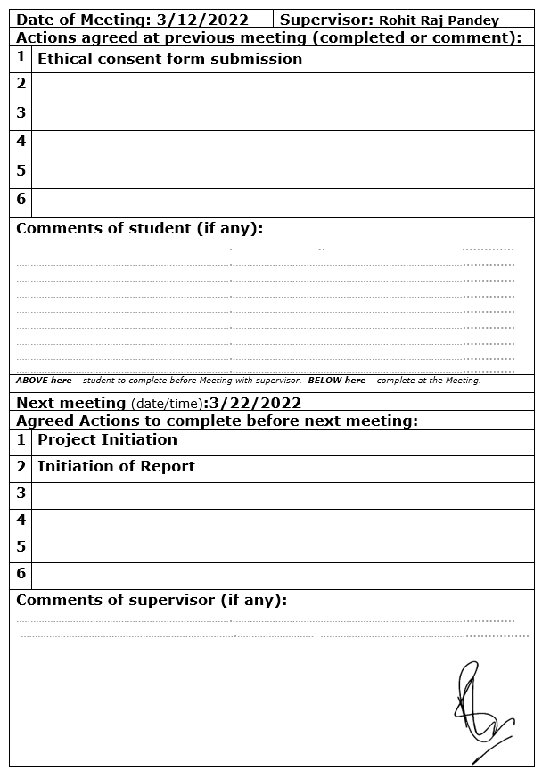

Figure Group meeting 2

### **11.5.3 Meeting 3**



Figure Group meeting 3

### **11.5.4 Meeting 4**

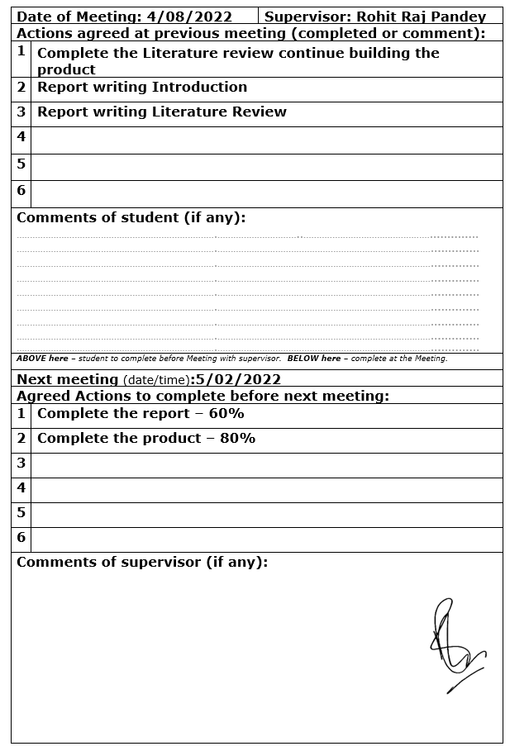

Figure Group meeting 4

### **11.5.5 Meeting 5**

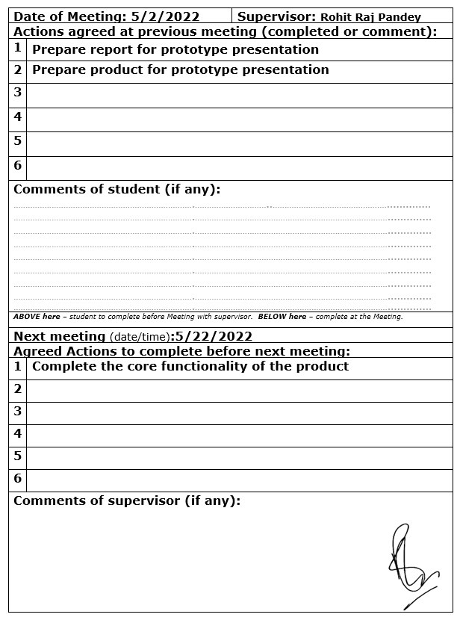

Figure Group meeting 5

### **11.5.6 Meeting 6**

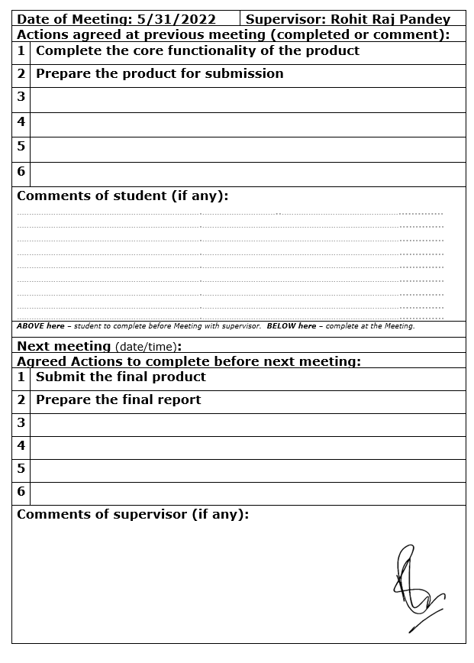

Figure Group meeting 6

## **11.6 Ethical Consent Form**

This section gives the screenshot of the ethical consent form filled before the development of the application. The development of this project doesn’t have any of the risk factor listed in the risk checklist, therefore for this project, only stage one ethical form will suffice.

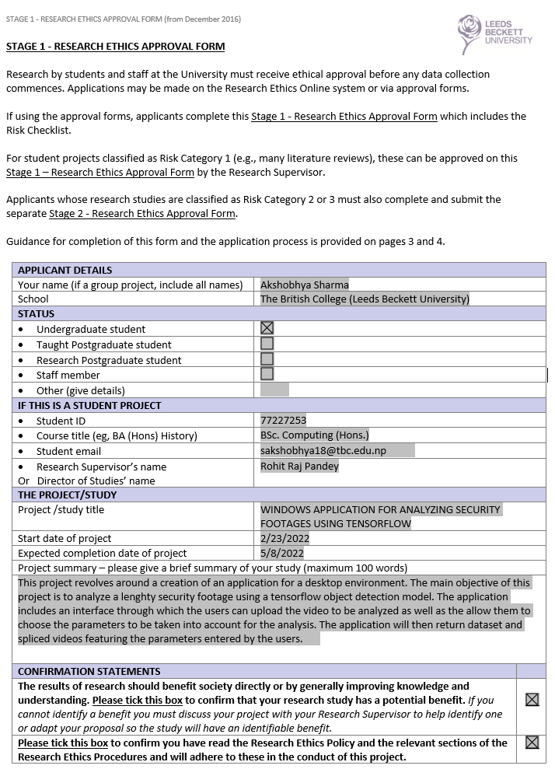

Figure Ethical consent part 1

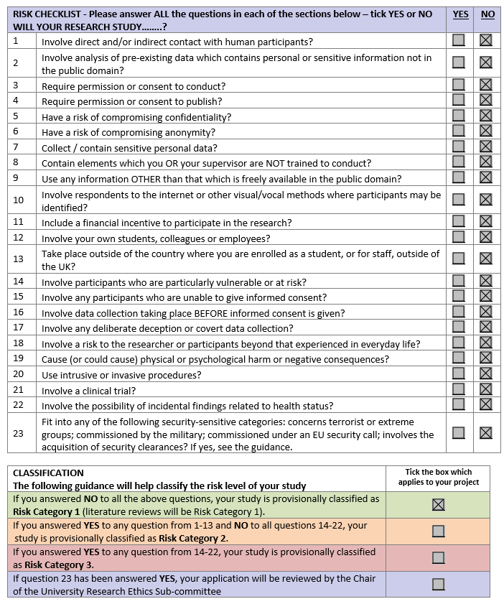

Figure Ethical consent part 2



Figure Ethical consent part 3



Figure Ethical consent part 4

## **11.7 Codes for functions shown**

This section shows the screenshots of the relevant class according to the functions explained in the codes section. Due to the size of the codebase, only those that matches the above-mentioned conditions have been included.

### **11.7.1 Get Video List command class**

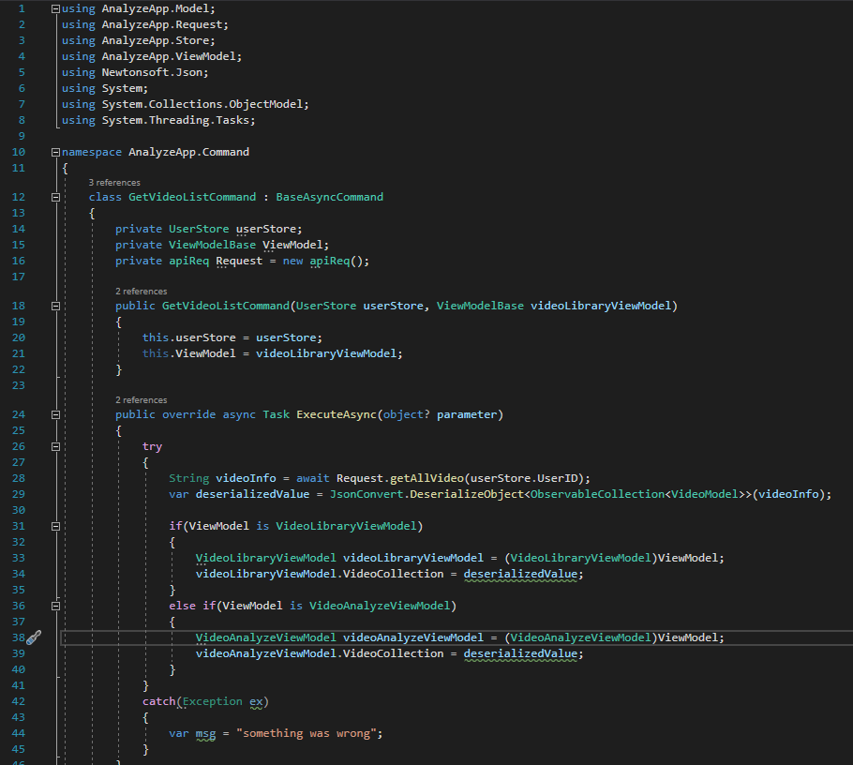



Figure 79 Getvideolistcommand class

### **11.7.2 Login Command Class**

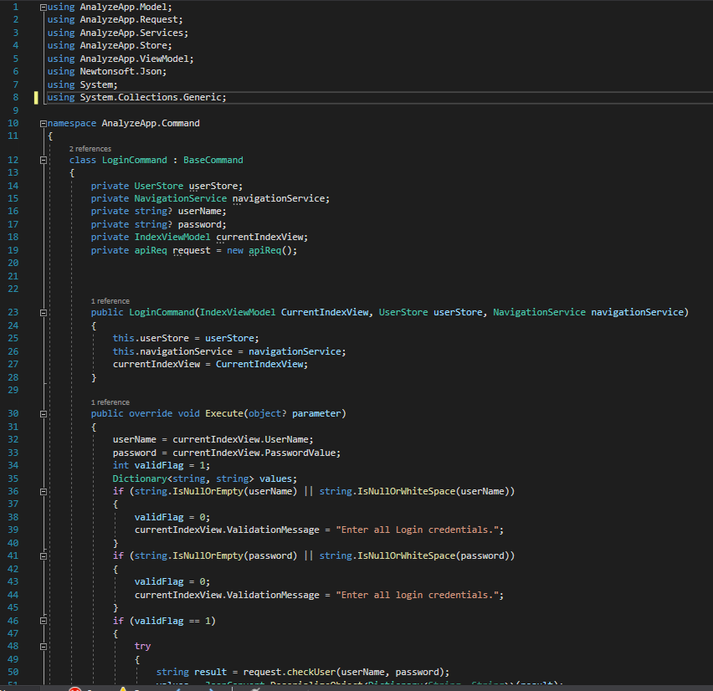

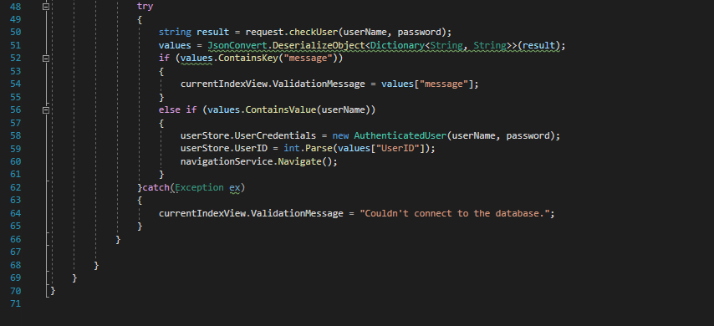

Figure 80 Login command class

### **11.7.3 Splice command class**

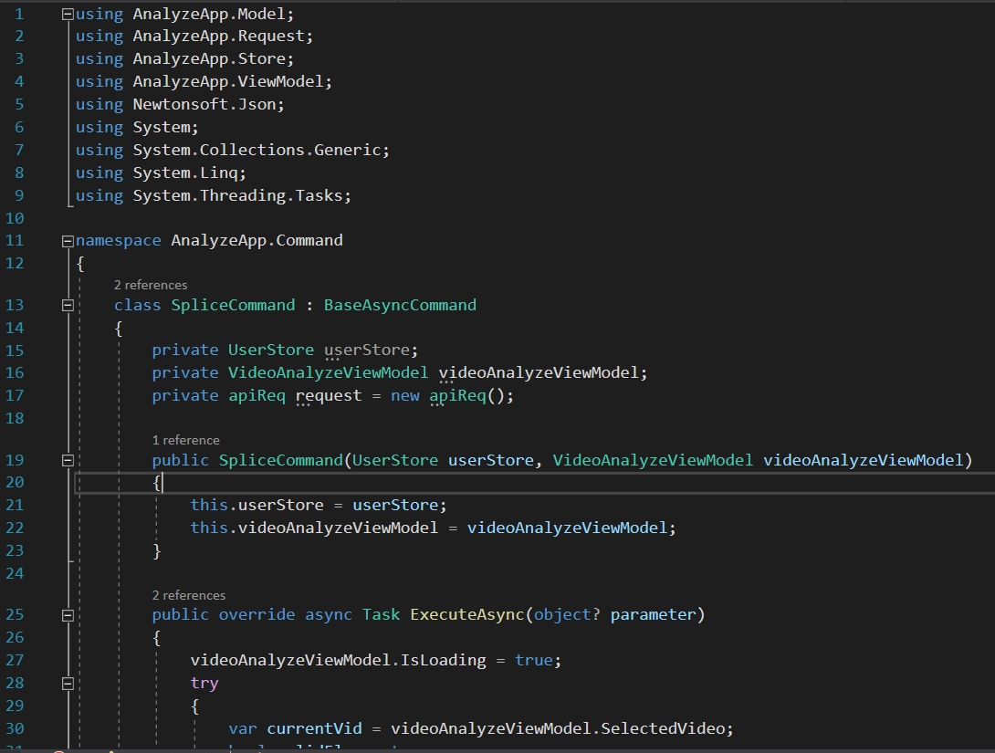

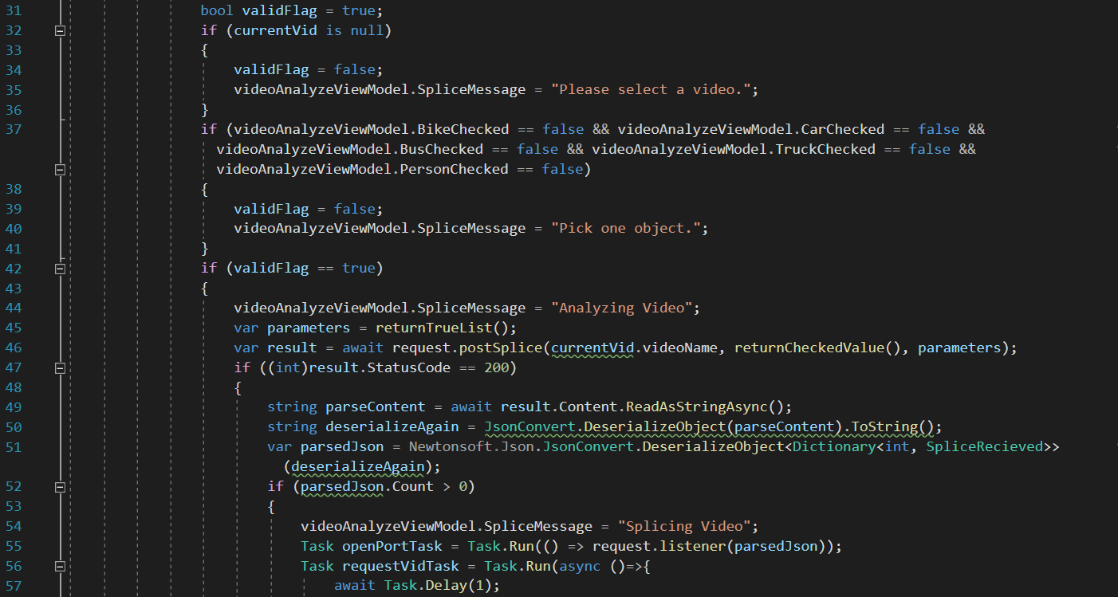

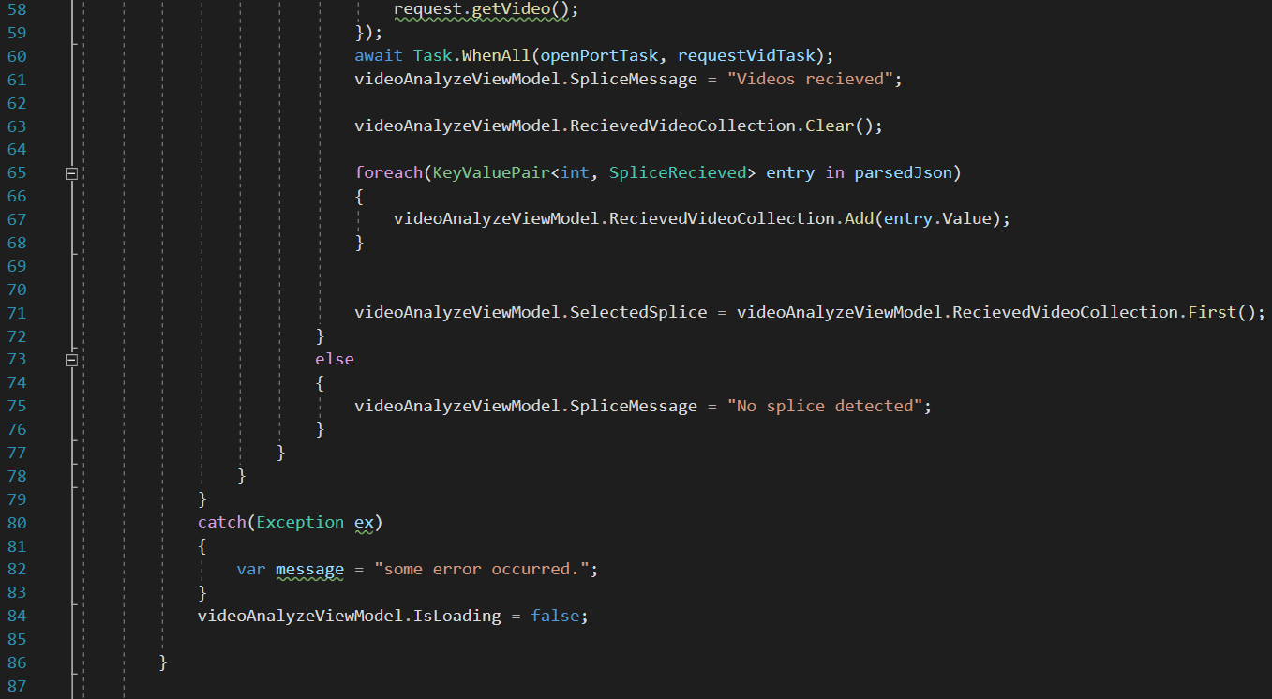

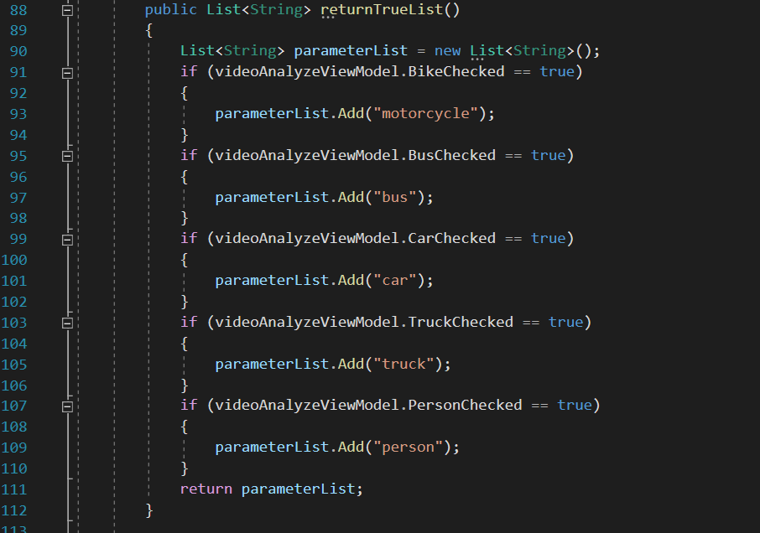

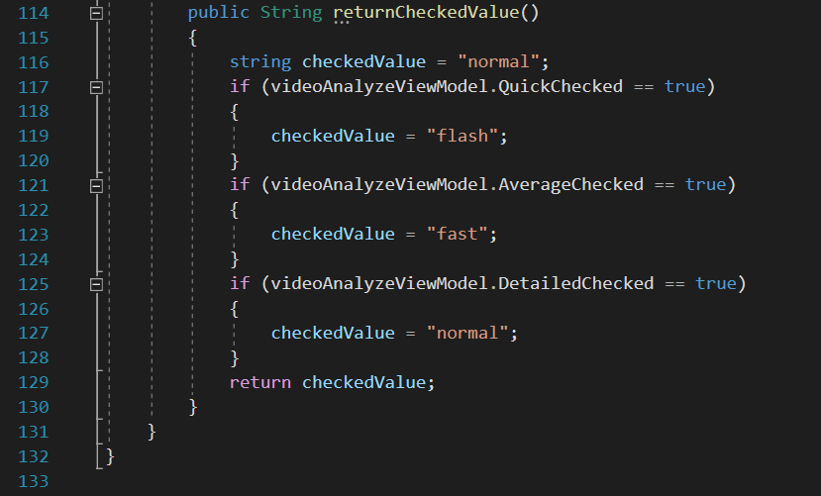

Figure 81 Splice Command

### **11.7.4 Upload Video Class**

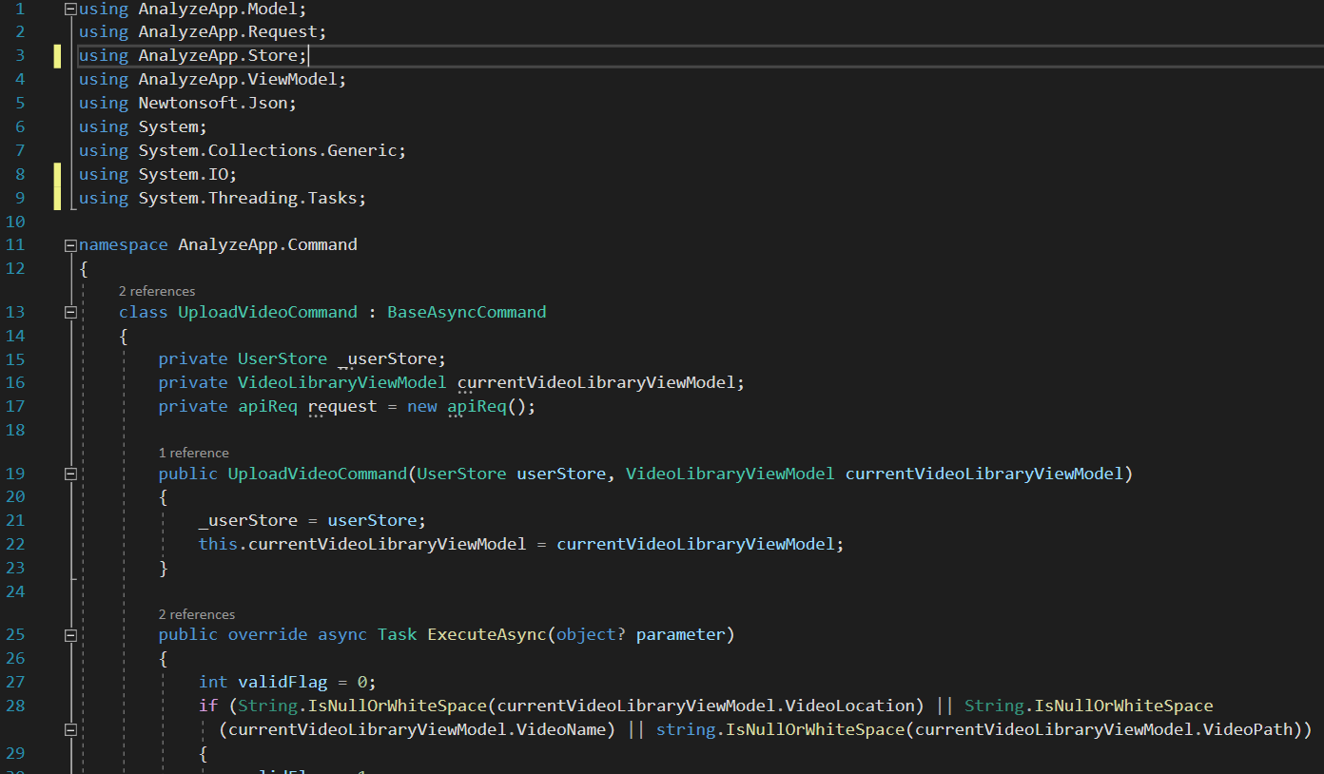

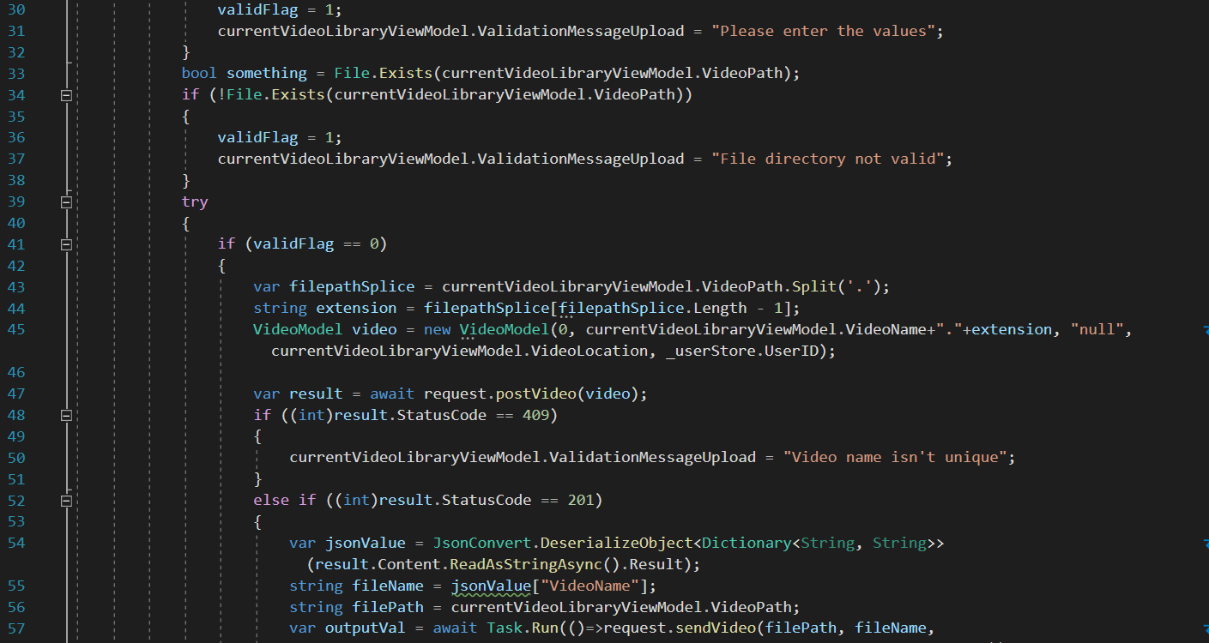

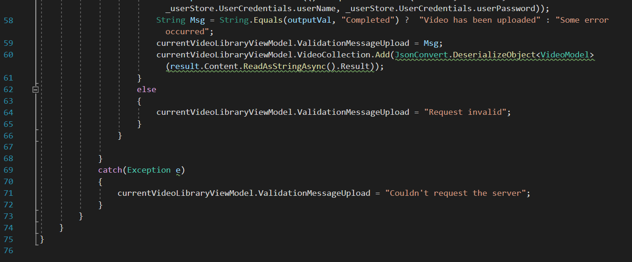

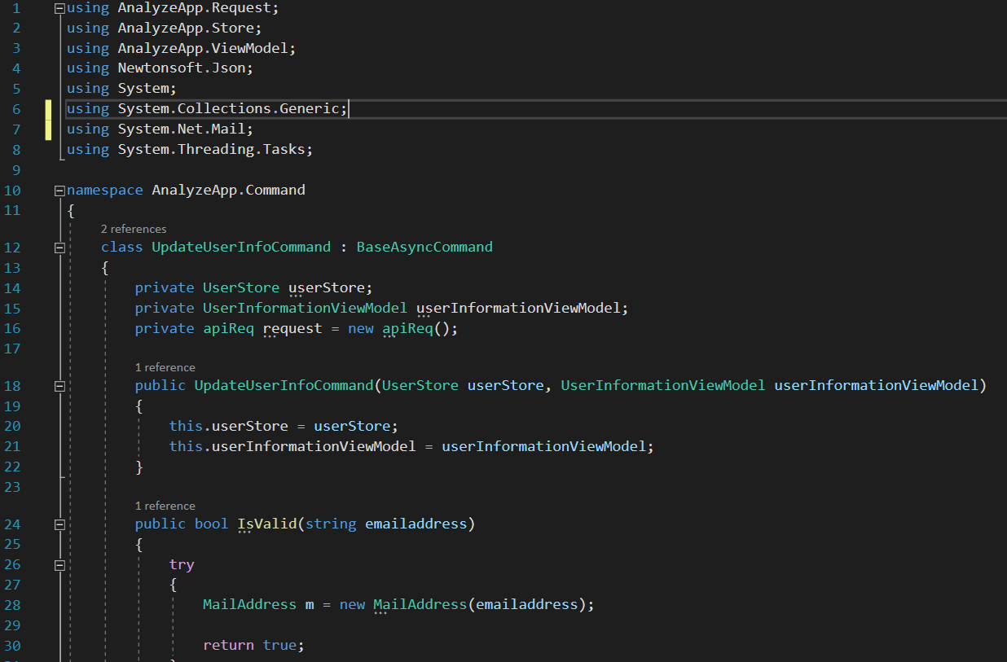

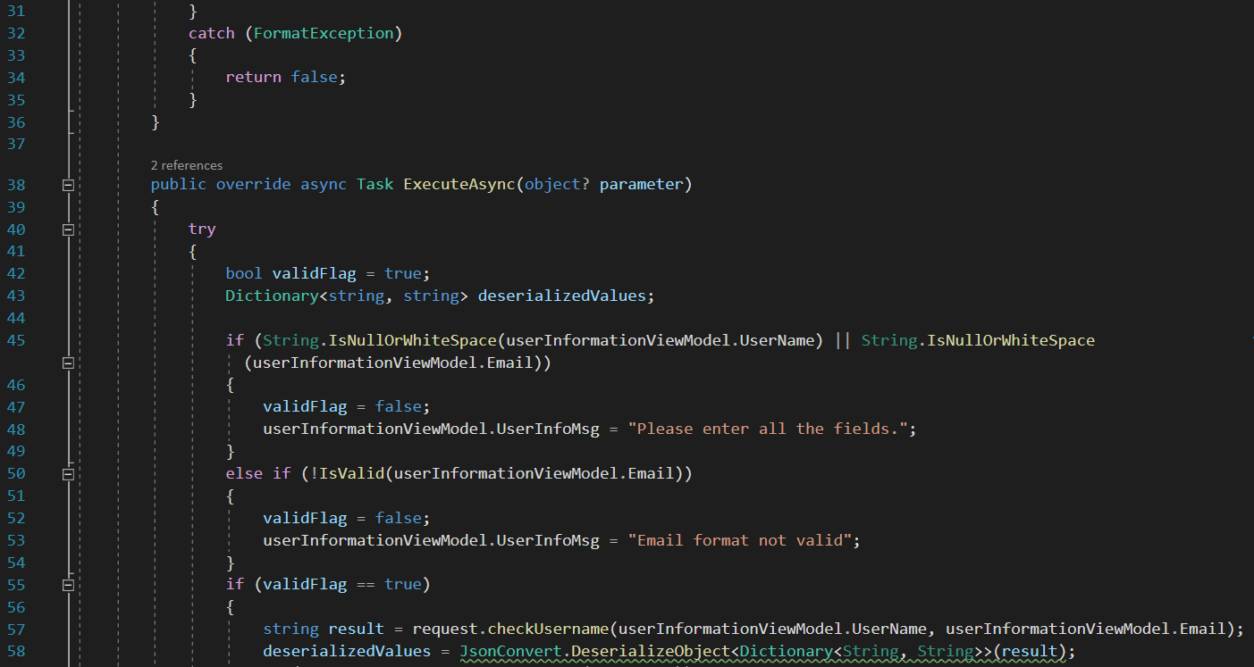

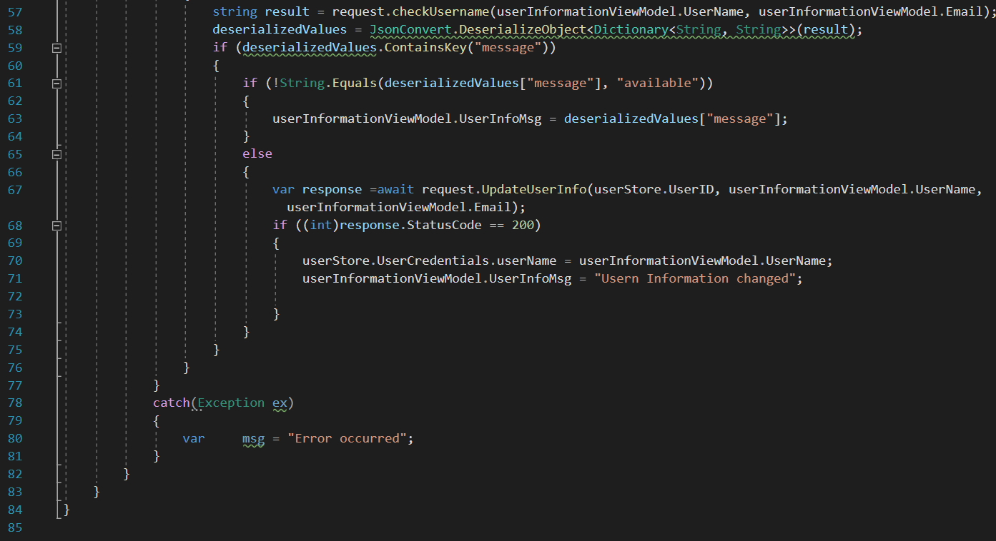

Figure 82 Upload Video Class

### **11.7.5 Backend API Resources**

#### **11.7.5.1 REST API Resources**

Following are the codes of the resources defined in our REST API.

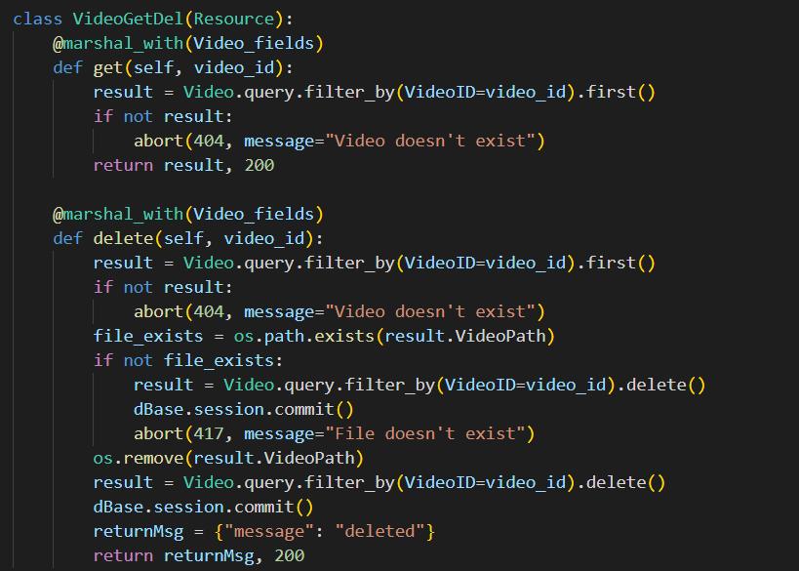

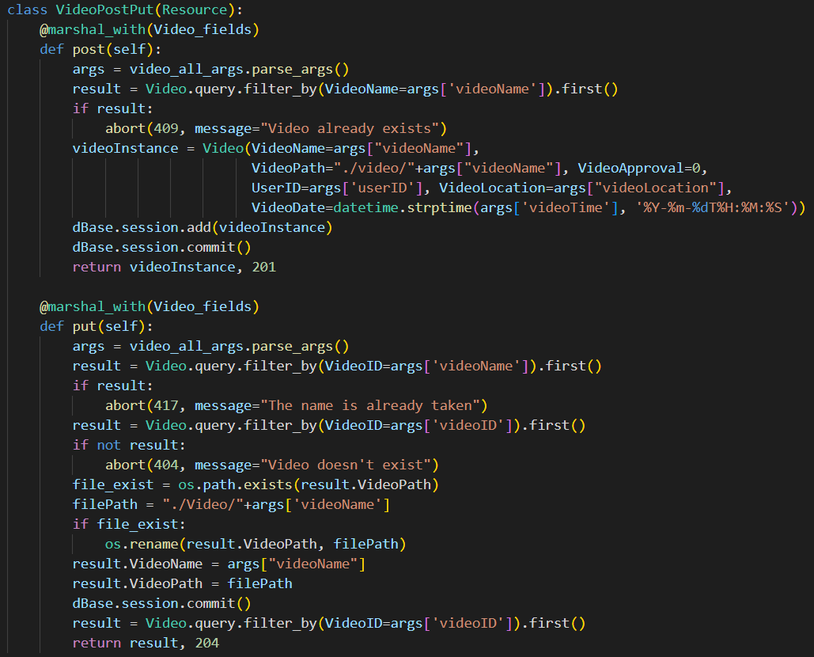

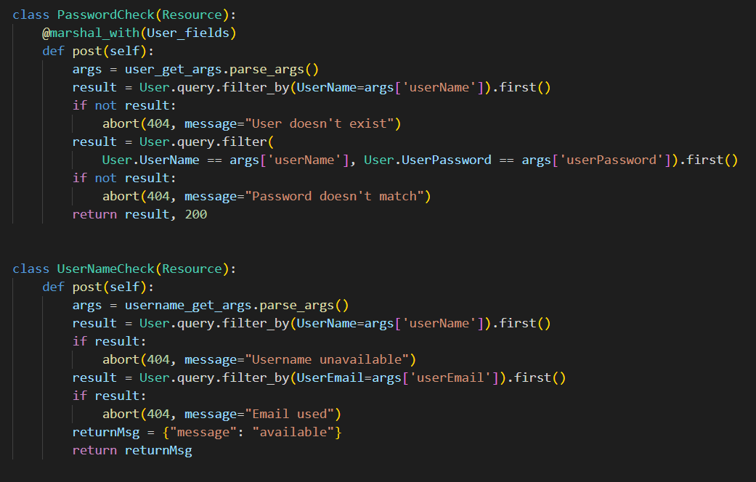

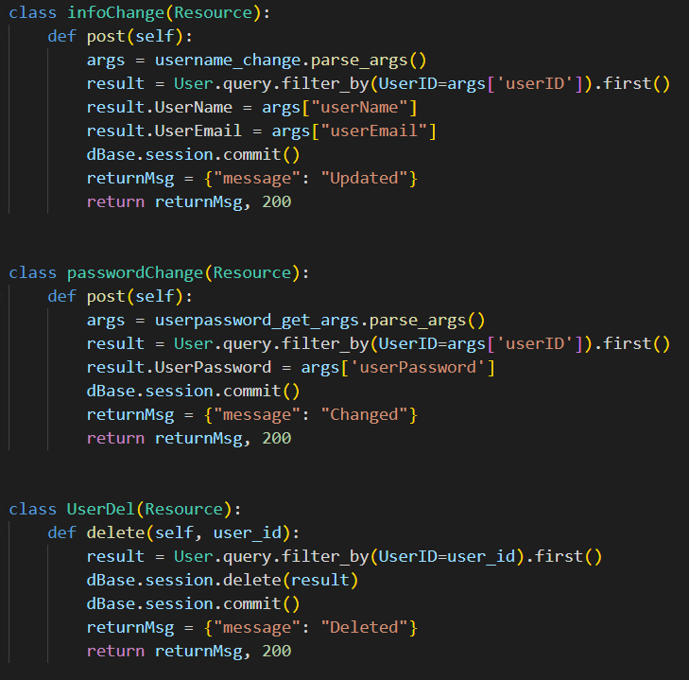

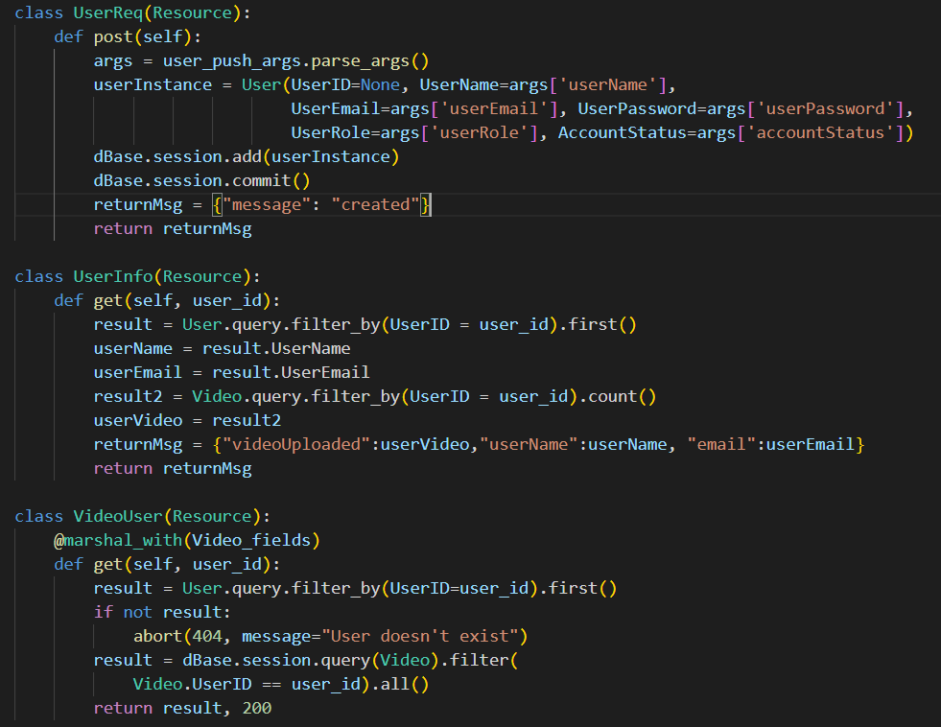

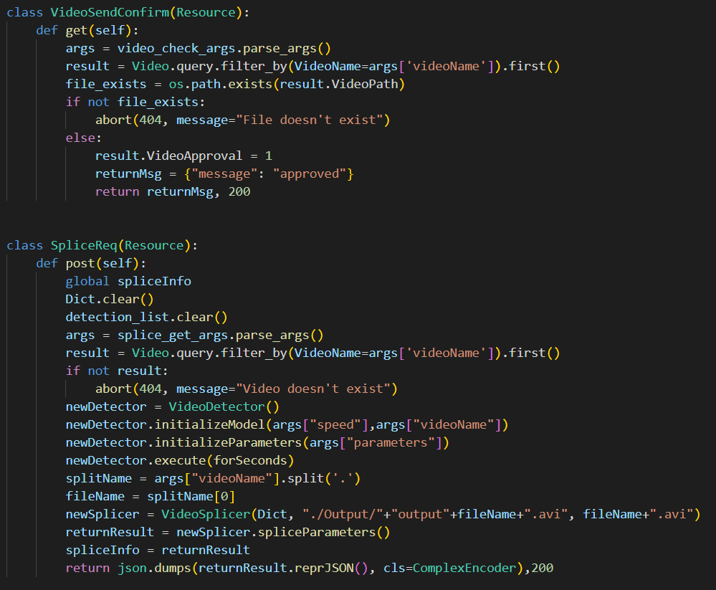

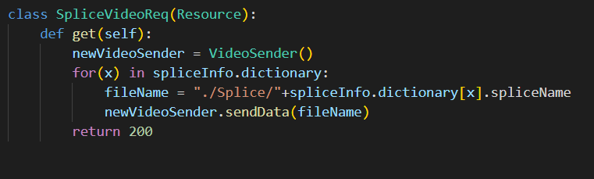

Figure Backend Resources

#### **11.7.5.2 Resource End points**

Following is the screenshot of the endpoints we can use to access those restpoints.

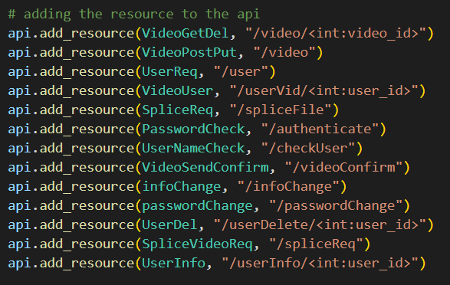

Figure Resource End Point

## **11.8 User Guideline**

### **11.8.1 Prerequisites**

Before using this guideline for using the application, there are some prerequisites for the application to function. They are:

* Setup of the backend portion of the code running flask application.
* Setup of front-end desktop WPF application.
* Setup of MySQL database.

All of these processes are covered in detail in the Installation guideline manual. Only after the fulfillment of these steps, can the application function properly and you can proceed to using the application.

### **11.8.2 Index Page**

The index page is the entry point of the program. This page of the application allows the user to access the application via their user credentials if they already have one or allow them to create one if they don’t.

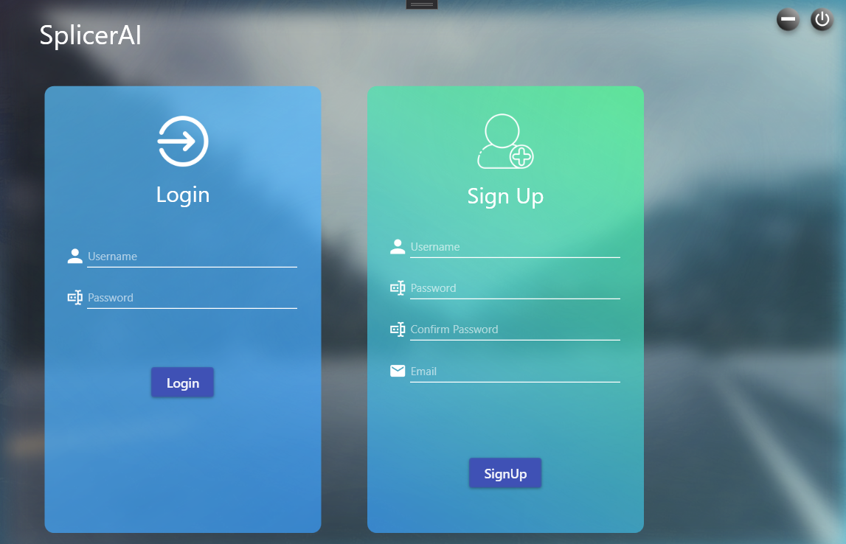

Figure 85 Fig Index Page

#### **11.8.2.1 Sign Up**

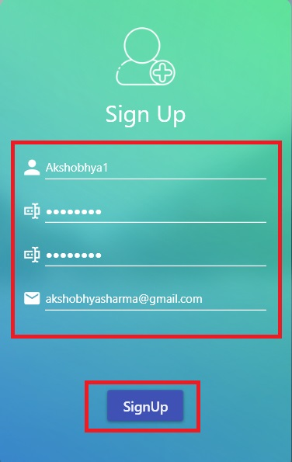

Figure 86 Sign Up section

Fill all the signup fields with valid information and press the SignUp button to create a new account. If every information has been correctly input, a new account should be created.

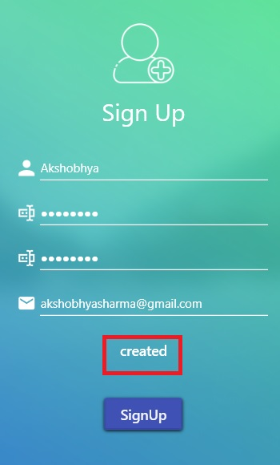

Figure 87 Account Creation

#### **11.8.2.2 Login**

Following the creation of the account you can use the credentials to log in.

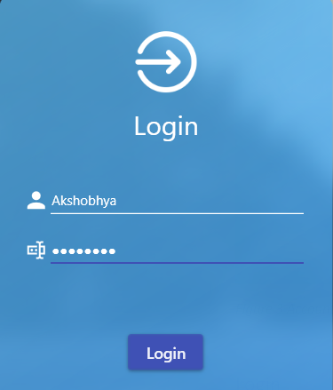

Figure 88 Inputting the created credentials to log in

#### **11.8.3 Video Library View**

After logging in, you will be greeted with a video Library page. This page has all the functionalities for uploading video to the server.

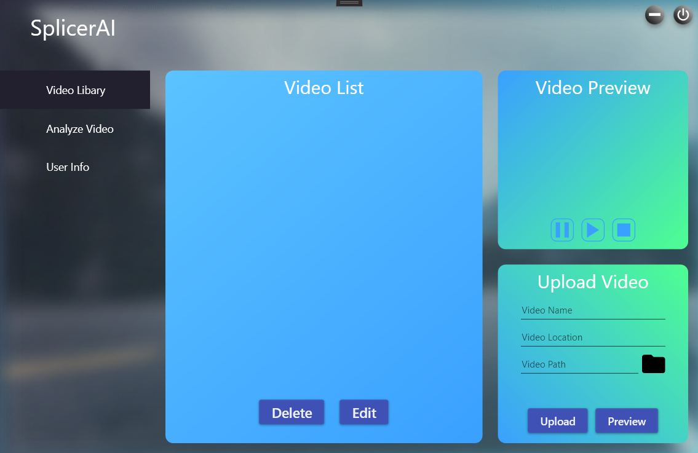

Figure 89 Video Library Page

#### **11.8.3.1 Upload Video Panel**

The first section to understand of the page is Upload Video panel.

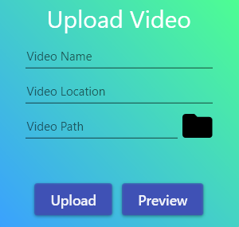

Figure 90 Upload Video Section

This is the interface that allows you to upload the video to the server. You need to provide all the information to accomplish that. The video name and location can be input by keyboard. For selecting the file, you can click the folder icon.

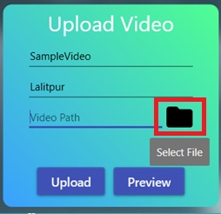

Figure 91 Upload the File

Clicking this button will give you a file selection prompt.

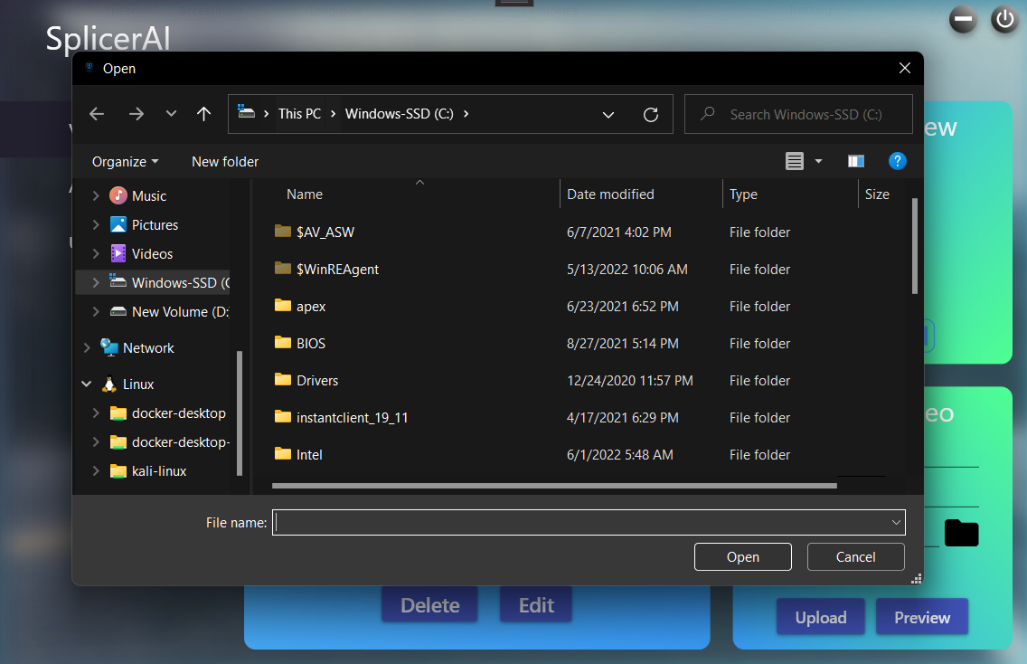

Figure 92 File selection prompt

After selecting the file, you can click the preview button to ensure that you have the correct file.



Figure 93 Preview button

This button is relevant to the next panel of this page, which is Video Preview Panel. The video preview panel allow you to preview the selected file in the panel above.

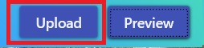

Figure 94 Upload Button

The next button in the Video Upload panel is the upload button, which is self-explanatory. This button is used to upload a valid video file to the backend process.

#### **11.8.3.2 Video Preview Panel**

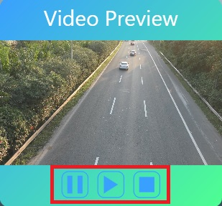

Figure 95 Video Preview Panel

After clicking the preview button, the video preview panel should be playing a video if you have given a valid path. The controls of the video preview panel are straightforward.

* The play button is for playing the video from a paused state or after the video has been refreshed through stop.
* The pause button is for pausing a playing video.
* The stop button is for stopping and resetting the frame of the video the first frame.

#### **11.8.3.3 Video List Panel**

The upload button is very relevant to this panel. Once a valid video has been uploaded to the server, you will see them in the video list panel.

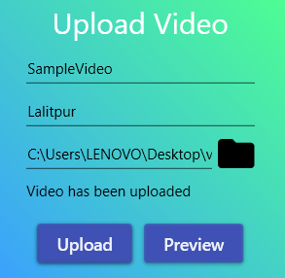

Figure 96 Upload of video

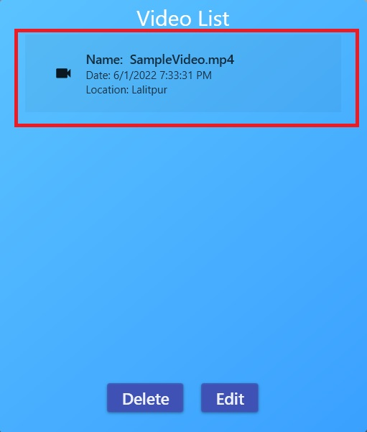

Figure 97 Uploaded video in video list panel

The Video List Panel provides you an overview of all the videos you have stored in the server. It also allows you to delete as well as edit their information. It also allows you to select a video from the list. The highlighted video are actually exposed to the buttons present in the Video List Panel.

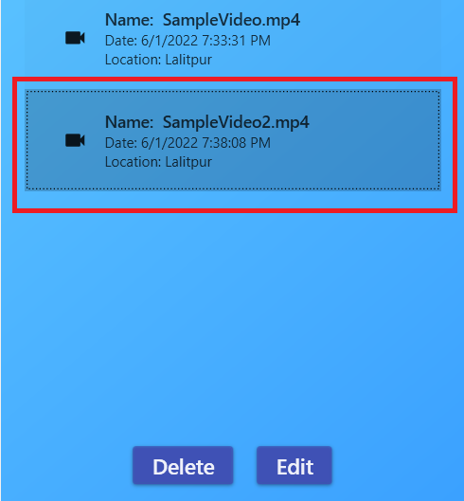

Figure 98 Selected Video

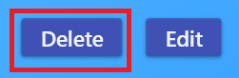

Figure 99 Delete Button

The delete button allows you to delete the selected video. Deleting the video will remove the video from the List as well as the database and from the backend directory, so be careful with this button.

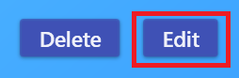

Figure 100 Edit Button

The edit button meanwhile can be used to make changes to video information. After clicking the edit button, you can change the information of the selected video.

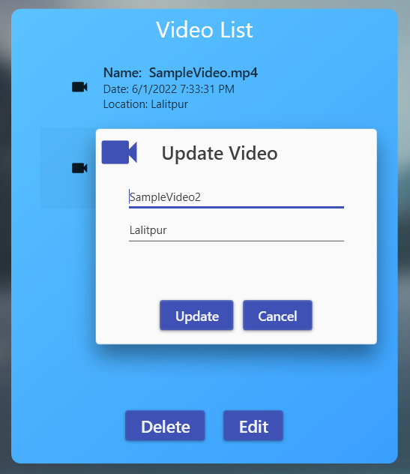

Figure 101 Video Information update model

The video update model provides you with forms from which you can change your video information.

### **11.8.4 Navigation Bar**

Before moving on to the next page, we must first provide information about an important part of our UI which is the navigation bar. The function of the navigation bar is simple. You simply click the relevant navigation item to navigate to the desired page.

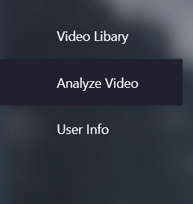

Figure 102 Navigation Bar

### **11.8.5 Analyze Video View**

The analyze video page is the most important page of the entire application. This is the page where the magic happens. This page allows you to select one of the videos that you have uploaded to the server and get splices out of those videos according to the analysis parameters that you have set. Let’s dissect the elements of the page one by one.

#### **11.8.5.1 Video Selector Panel**

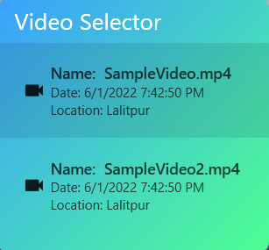

Figure 103 Video Selector Panel

The video selector panel is like the video list from the video library. You can highlight one of the videos by click it and that video will be selected for the analysis.

#### **11.8.5.2 Parameter Selector Panel**

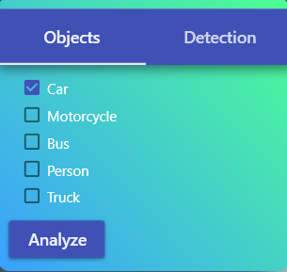

Figure 104 Parameter selector Panel

The parameter selector panel allows you to specify the parameters for the analysis. The first tab shown above allows you to select the vehicle types, one or all.

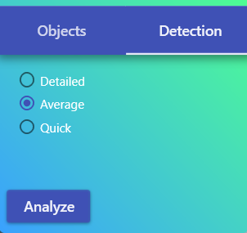

Figure 105 Detection tab

The second tab of the parameter selector allows you to select the speed of analysis. Although the quick and average settings are faster in terms of detection time, the result provided by detailed analysis is unparalleled. The quick analysis although very quick may also provide you with false positives in the analysis.



Figure 106 Analyze button

After selecting the video and the parameters you can click the analyze video. An indicator will appear showing that the backend is busy with the analysis.



Figure 107 Spinner showing the backend analysis.

After the analysis is complete the videos splices will appear in the video splice panel.

#### **11.8.5.3 Video Splice Panel**

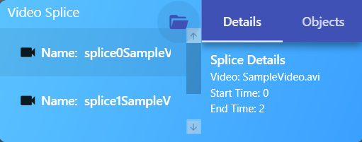

Figure 108 Video Splice Panel

The video splice panel has two sections, one is another list box, where you can select an item just like the previous list boxes. These are the splices that the backed has detected using an object detection model, using the parameters that you provided.

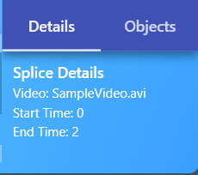

Figure 109 Video details tab

The video details tab provides the splice information like the duration in which the splices were detected from the video as well as the splice names.

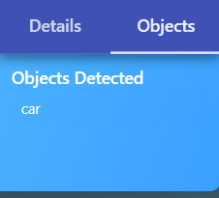

Figure 110 Objects tab

The object tab gives you information about which objects were detected in the given splice. Beware that this will be based on the number of object types you have selected in the objects tab of Parameter selector panel.



Figure 111 Folder Button

The splice viewer although functional may not provide enough functionalities to view the analyze splice properly. This button opens the directory with the videos for you so that you can use your preferred video player to play the video. However, this will require an analysis to take place first.

#### **11.8.5.4 Splice Viewer**

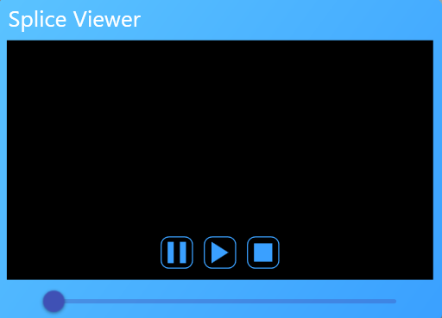

Figure 112 Splice Viewer Panel

The splice viewer panel allows you to view the splices. The controls are very straightforward.

* Play button

The play button allows you to play the video.

* Pause button

The pause button allows you to pause the video.

* Stop button

The stop button allows you to stop the video and reset it.

* Slider

The slider allows you to take the video position to the specific one that you want.

If the video slider is maxed out, you can either take the slider to the beginning or stop the video and use the play button next.

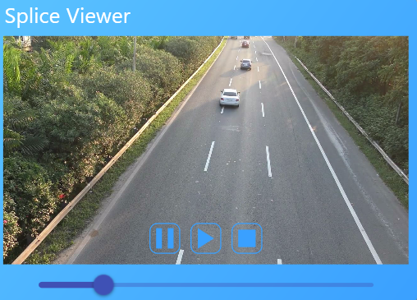

Figure 113 The video player in action

### **11.8.5.5 User Info View**

The final page for us is the user info view. This page consists of 3 panels.

#### Change details panel

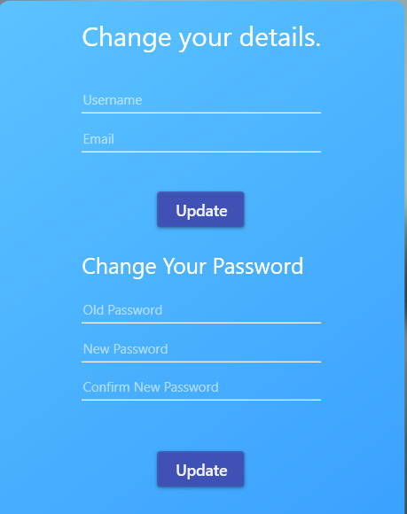

Figure 114 Change details panel

The change detail panel allows you to change your details. Just enter all the details for the relevant section and you will be provided with details on if those details are valid, you can enter them until they are to change the details.

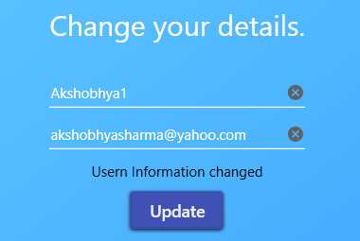

Figure 115 User information changed

The same instruction applies for changing your password.

#### **11.8.5.6 Account Info Panel**

The account info panel provides you with basic information about your account.

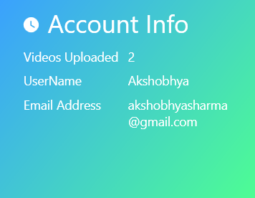

Figure 116 Account Info Panel

#### **11.8.5.7 Remove Account Panel**

The remove account panel allows you to remove your account. You have to be careful with this account though as you will also lose all of your videos if you remove your account.

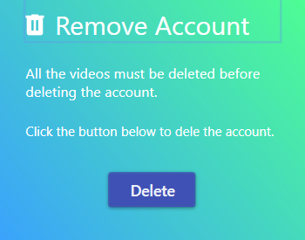

Figure 117 Delete account panel

The delete account button removes your account. After account removal, you will be redirected to the index page.